How to add the extension field in Excel: (Eg., Supplier Invoice)
Pre-requisite:
Add the extension field via Adaption Mode and add the field in Inbound Services as per below screenshot:
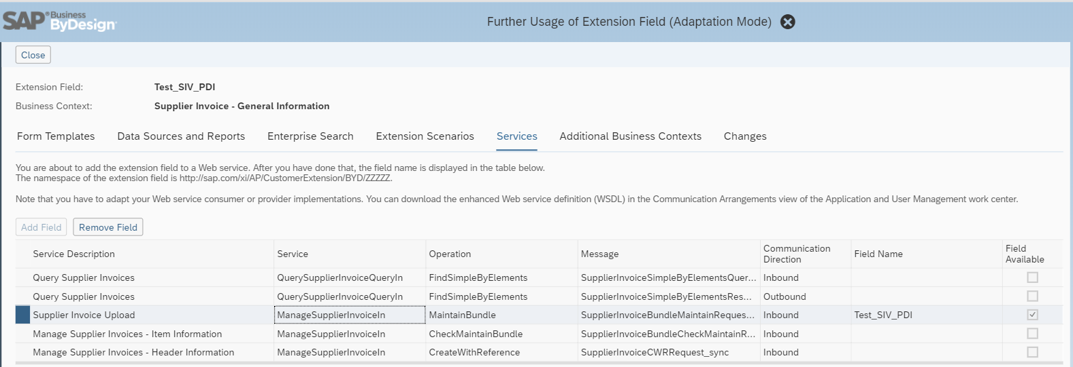
Steps to follow to add extension field in Excel:
In the below case, we have took the header extension field ‘Test_SIV_PDI’ as example.
- Goto Supplier Invoicing – Invoices and Credit memos
- Download the excel template from ‘Import from Microsoft excel’ option as per below screenshot
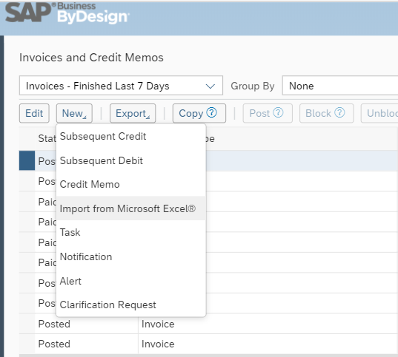
- Once the file is downloaded, open the file location and rename the .xlsx to .zip. This will automatically convert the excel file to zip and open it with your preferred zip tool.
Xml file location: NewSupplierInvoices_US_EN.zip\xl
- Extract the xml file to specified folder and edit the same using Notepad ++
- We need to add the field as part of the structure as below.
<xs:element minOccurs="0" maxOccurs="1" name="Test_SIV_PDI" type="xs:string"/>
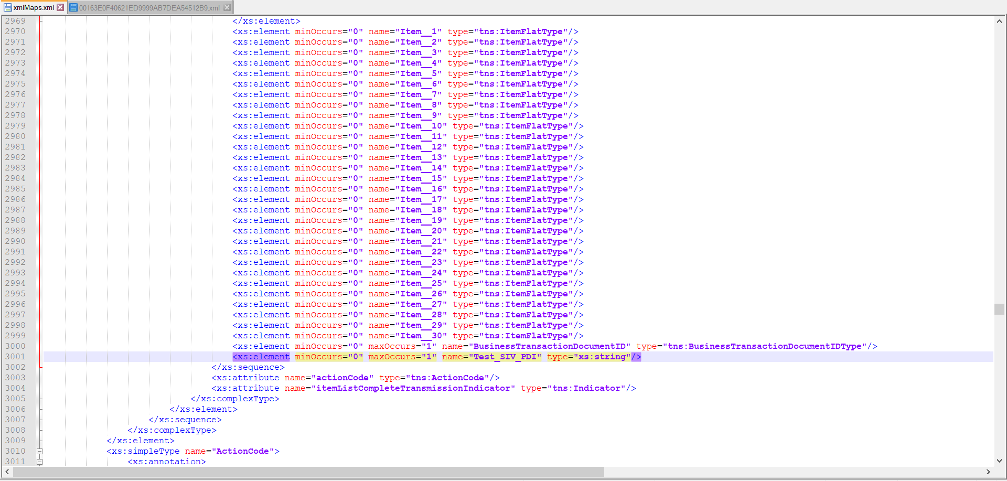
- There is one more change in the xmlMaps.xml necessary, in the transformations section.
<xsl:template match="Test_SIV_PDI"> <xsl:element namespace="http://sap.com/xi/AP/CustomerExtension/BYD/ZZZZZ" name="Test_SIV_PDI"> <xsl:value-of select="."/>
</xsl:element>
</xsl:template>
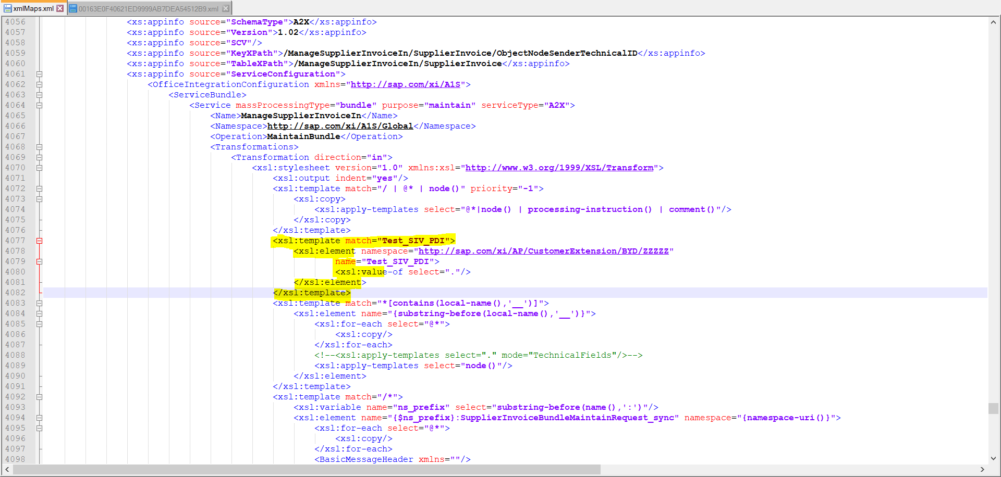
- Replace the xml in that zip and rename it from .zip to xlsx
- Open the excel file and goto Developer->Source. You would be able to see extension field in xml maps ‘SAP_BYD_MAIN’.
Note: If you were unable to see, select it from the drop-down list.
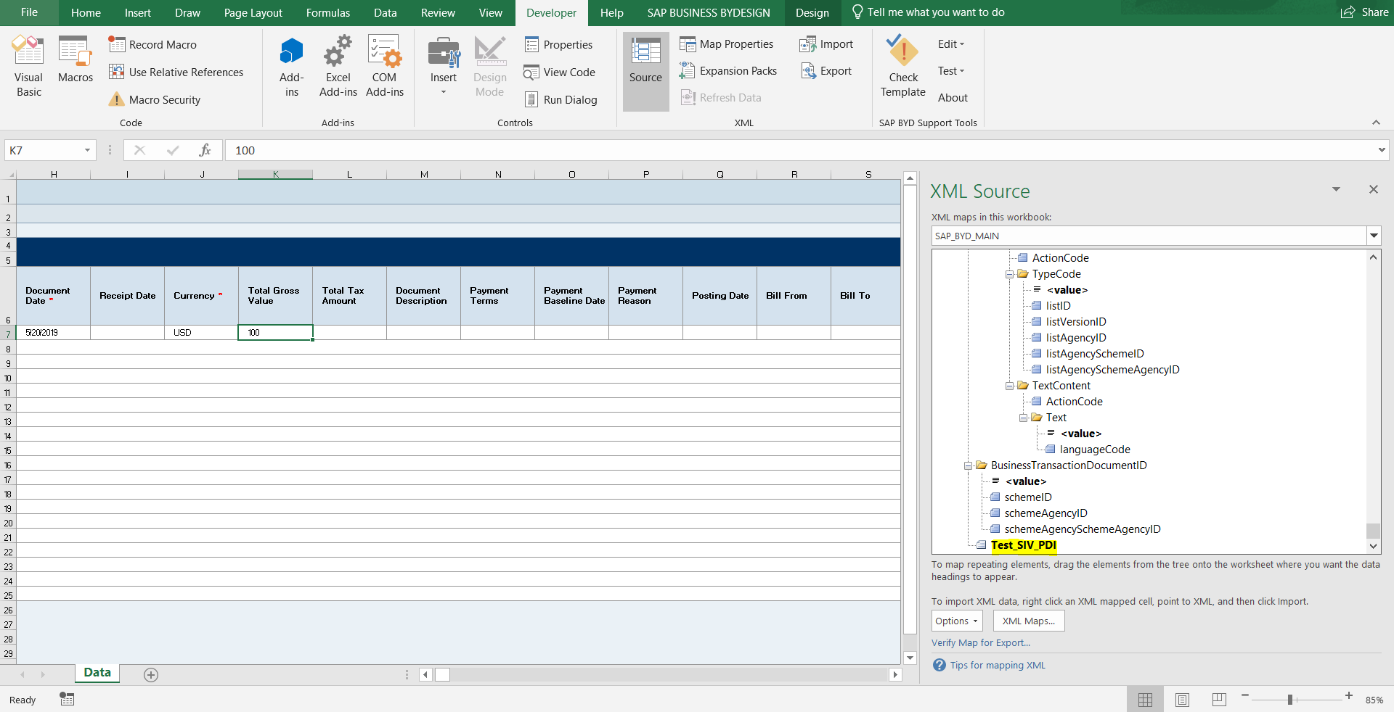
- Insert a column in your excel and do drag & drop this field to that column to bind this field.

