Question/Issue
- A customer wants to change a label in a specific locale. Is it possible to do? And how is it possible?
Solution
- There are two possible way to go through: Text and replacement or Tier 3 language
- Admin tools > Text Replacement > select the desired language and check if there the desired label is present. Then type on the right the replacement:
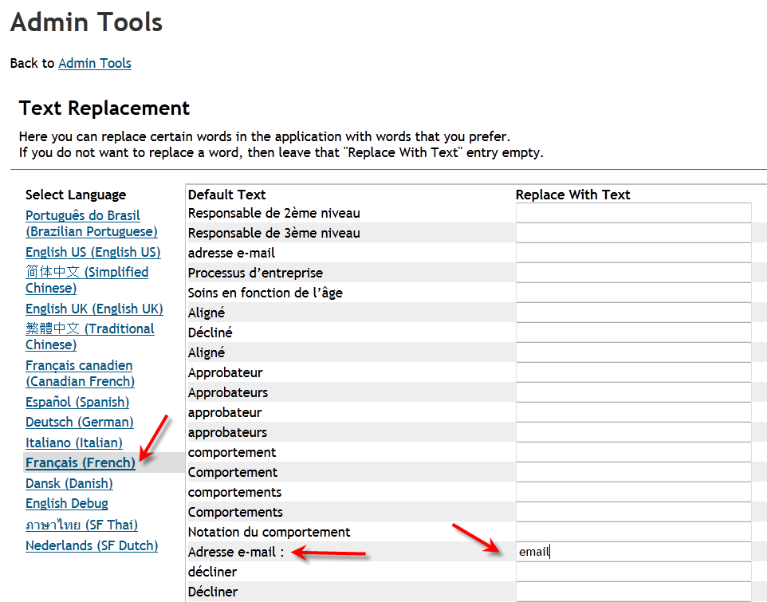
- If the text and replacement is present, this is the preferred way because the customer has the control over it. However there is a limited number of labels available in each locale (the number can be different from language to language)
- For any other label change it is possible to use the tier 3 language feature. For this it is required a ticket to Customer Success.
- In provisioning > Import/Update/Export Language Packs:
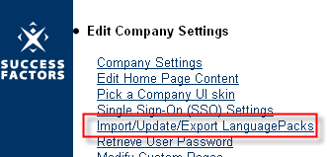
There is all the language pack activated.
REMEMBER: language packs are charged, so these cannot be enabled if not included in the customer’s contract.
There are two ways to find what key has to changed.
SEARCH THE TEXT in the complete pack
Download the main language pack (select the language and click download):
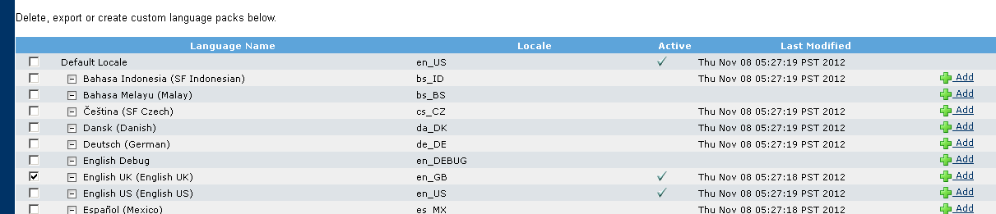
…
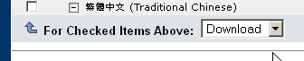

Open the downloaded csv file with a plain text editor that supports UTF-8.
Search for the text that is asked to be changed. For example:
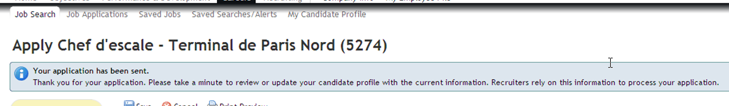
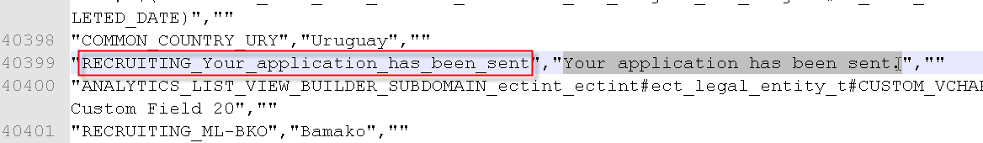
…
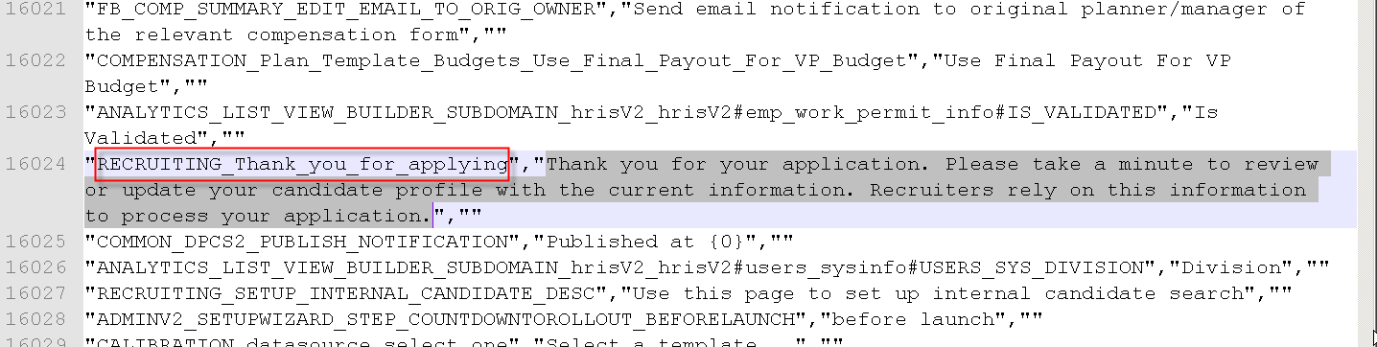
And take note of the key (in this example RECRUITING_Your_application_has_been_sent and RECRUITING_Thank_you_for_applying).
Note that if this key will be used in any other part of the application, this will be visible in all these places.
USING ENGLISH_DEBUG
If English debug is not enabled in provisioning > Company settings, enable it.
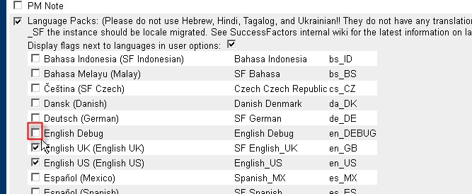
Do this ONLY in the TEST instance. And if the language was disabling, remember to disable it again when you have done with this procedure.
It could take some time before this is actually enabled.
Login in the test instance and change the Language to English Debug:
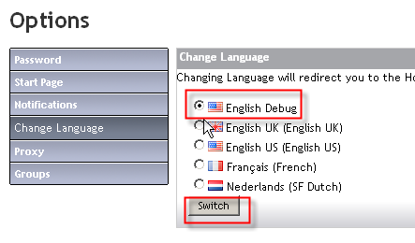
Then search for the label that must be replaced. For example Home:
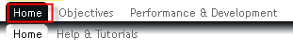
The key to search is:
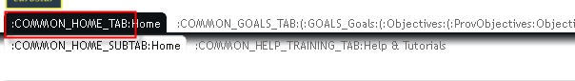
Go to search the key in the downloaded csv file, for example COMMON_HOME_TAB:
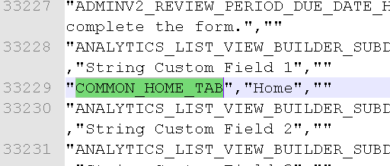

ADD a custom dictionary
If there is not yet a new dictionary go to add a new one in Provisioning > Import/Update/Export Language Packs. Give any name you want.
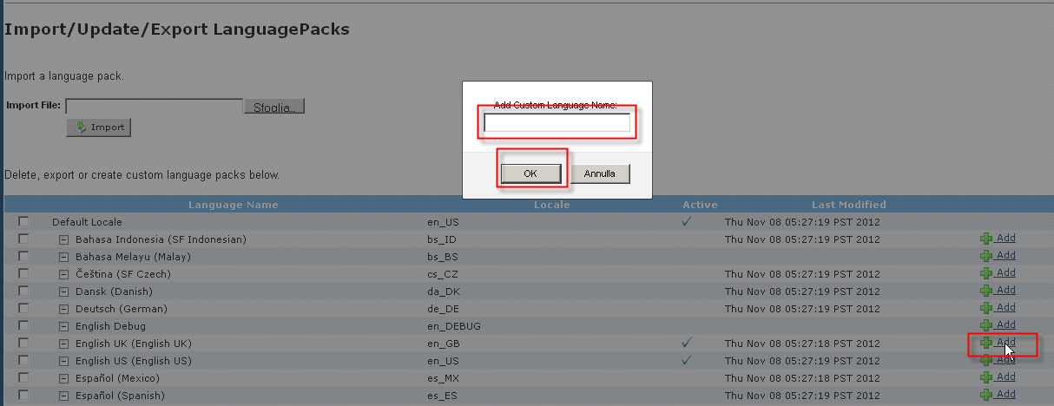
Note: English GB and English US are also possible starting from b1210 (before it was not possible for these languages).
If the language pack already existed, download it and make a copy as backup (so in case of problems you can immediately restore the backup).
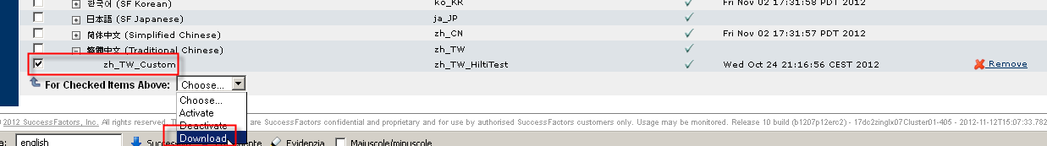
Note that the downloaded csv file has a wrong header which is preventing from wrong uploads:
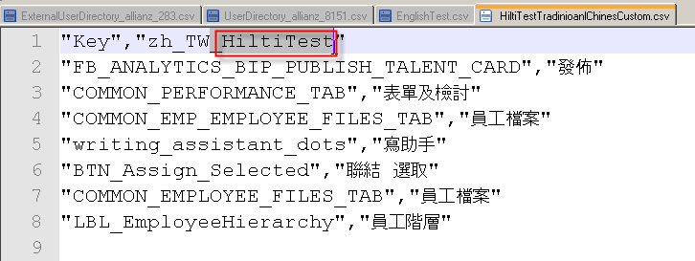
The header must have the exact name of the locale, so in the example replace
"Key","zh_TW_HiltiTest" with "Key","zh_TW " in the first row.
Then make any modification.
WARNING: be sure to switch to UTF-8 in case the editor is not automatically set on.
The custom language pack must contain only 2 columns (and not 3 as in the complete one).
For example:
"Key","en_GB"
"RECRUITING_Thank_you_for_applying","Insert here any text the customer wants"

And for example for the hom:
"Key","en_GB"
" COMMON_HOME_TAB ","New home label"

WARNING: Do NOT change the complete csv file and try to upload it. Only make changes on the added custom language packs.
- There is a limit to the total number of keys that can be replaced per language. This can be increased in provisioning > Import/Update/Export Language pack
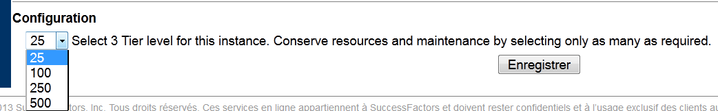
- Last note: if in tier 3 language a labels is changed and the same label is also available in the text and replacement, any try to change from the text and replacement will not work. This is because the tier 3 language has more priority than the text and replacement. If the customer is not able to change in the text replacement (the same text is always present after saving), there are two solutions:
  - Change in the tier 3 with the new text
  - Remove from tier 3 language the line with that key and let the customer to change in the text and replacement

