Stock overview of part SW1-024, showing one batch (identified stock ) item

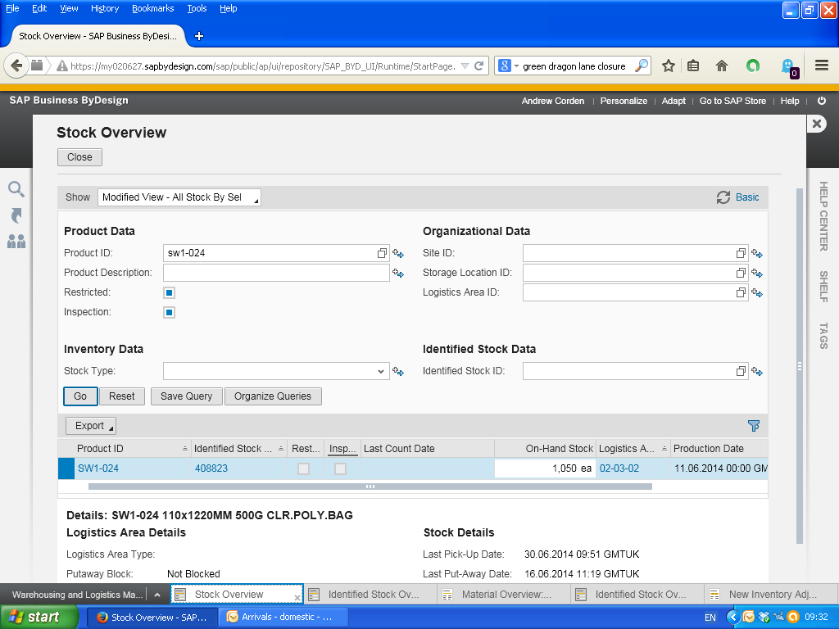

Identified Stock Overview of part SW1-024 