1. If the series color can be the same, you can create one single series as below (Value X:B2-B21,Value Y:C2-C21,Size:D2-D21).  Alert may help add different color for each bubbles.

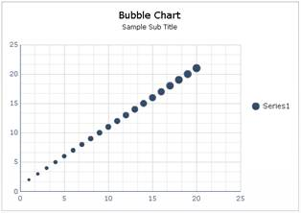

1. If keep five different colors for different bubbles, you can group the data with formula and add five series.

