- Report Transfer: Download Report xml files
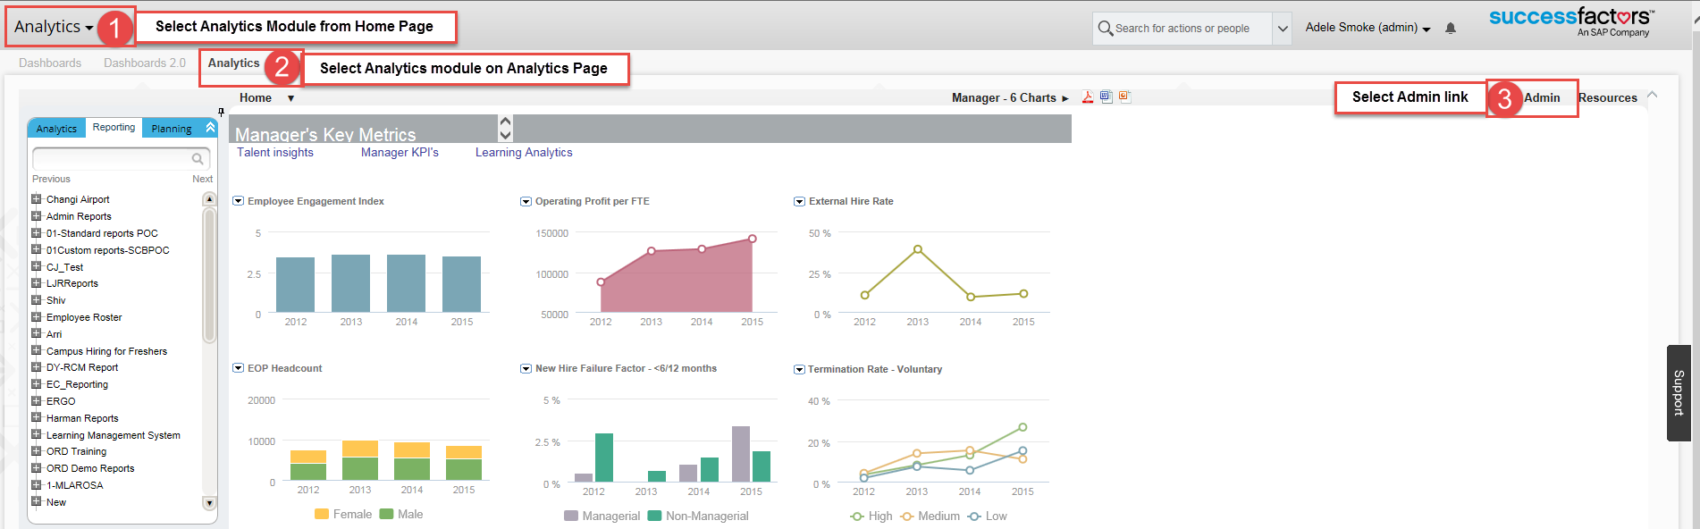
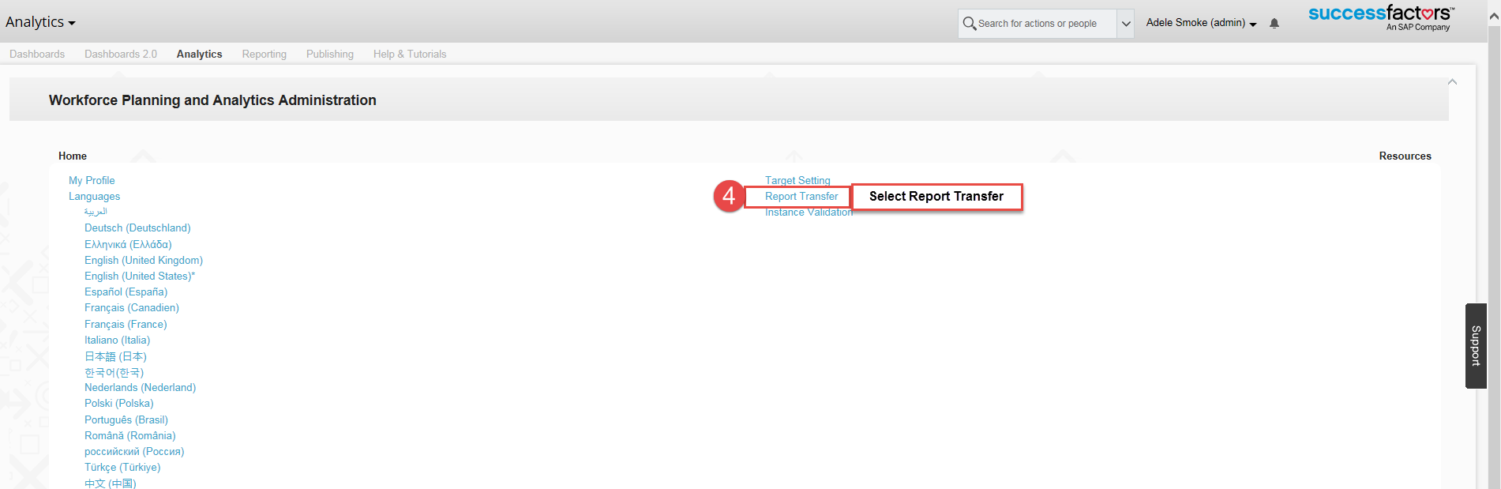
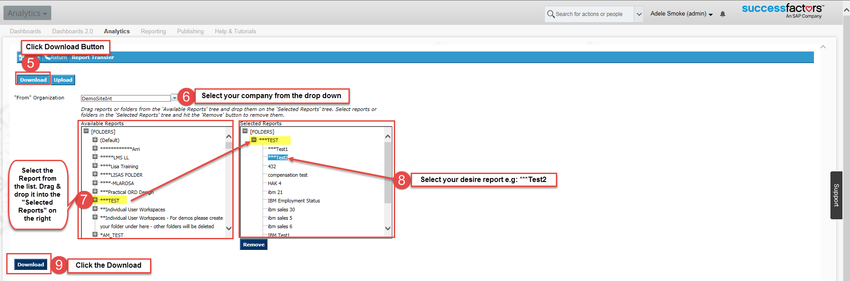
- Report Transfer: Upload Report xml files
