Below is the username as “sf-admin” shown below:
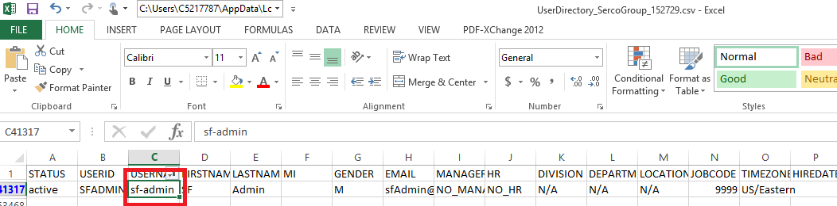

The jobs that are configured to execute has the job owner name is “SFADMIN” which is not valid as shown in below screenshot:
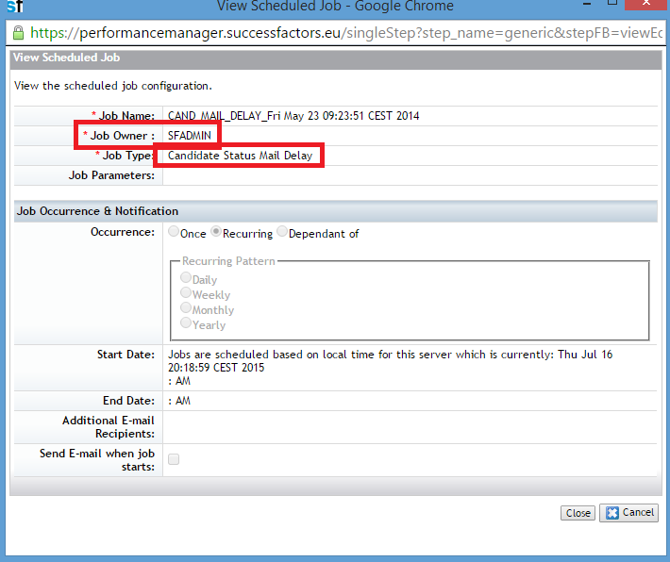
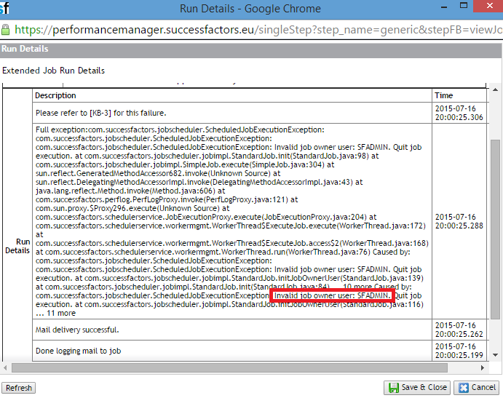
The same is for sync all external job postings as shown below: