- Create a new 24-hour time format pattern
References > Calendar & Time > Date Format Patterns > Add New (link)
Date Pattern ID: HHmm (this can be anything)
Description : 24 hour format (this can be anything)
Pattern Type: Time
Pattern: HHmm

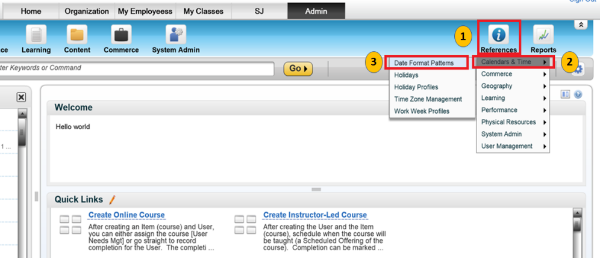

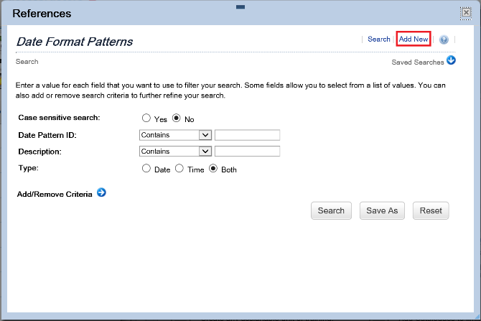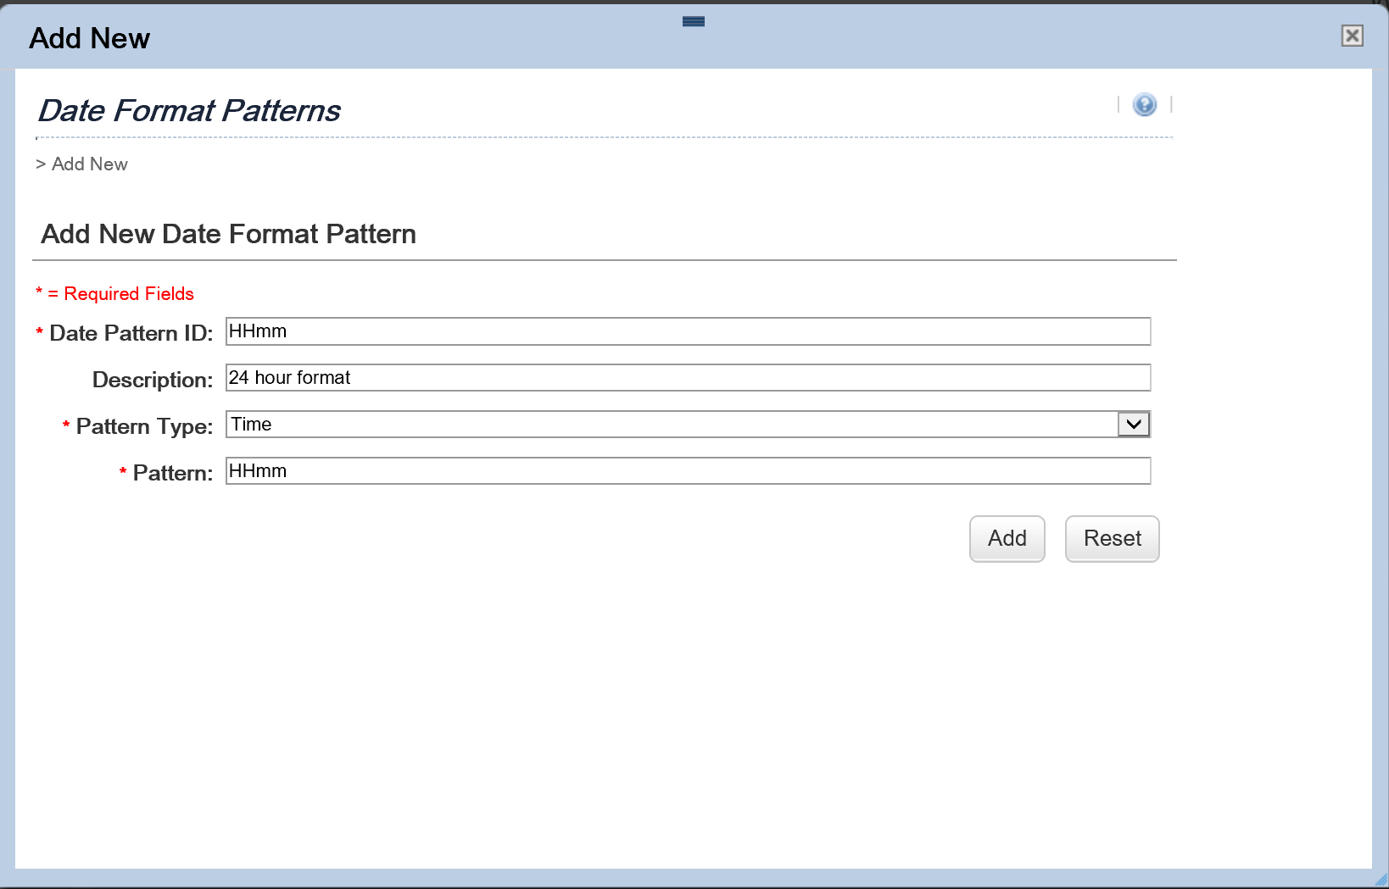

- Add the time format pattern to the Locale: French Canadian
References > Geography > Locales
Search for the French Canadian Locale and Edit it
Go to the Time Pattern tab and click on the “add one or more from the list” if the 24 format is not yet there

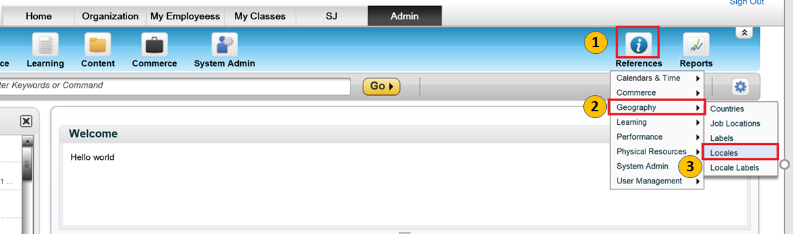

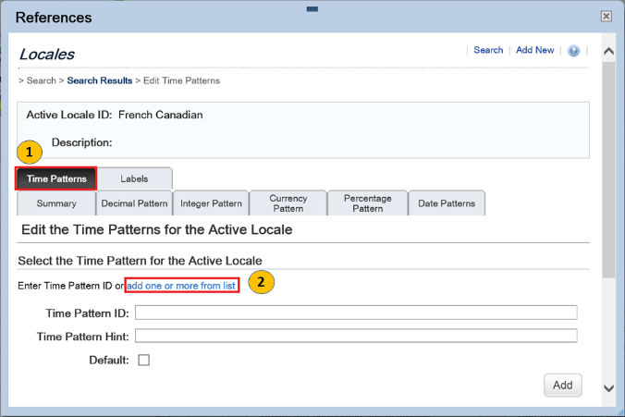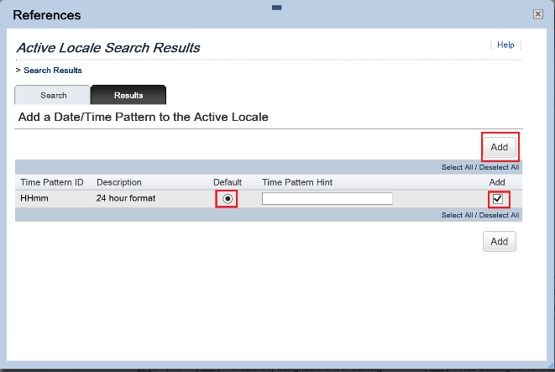

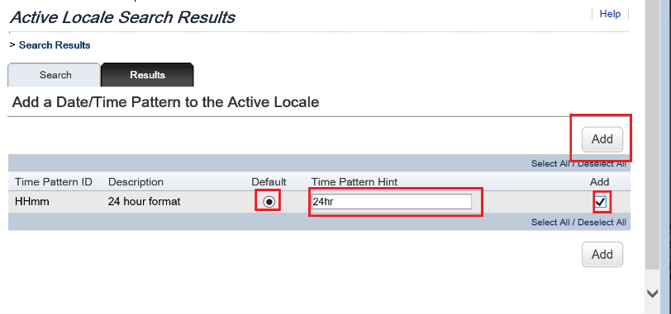

- USER SIDE > PREFERENCE (OPTIONS AND SETTINGS)
Choose the 24 hr format pattern
