“Add New Employee” option not available in admin tool

Symptom:
“Add New Employee” option not available in admin tool even after RBP are given to user

Environment: EMPLOYEE CENTRAL: Hire

Scenario:

Add new employee option not available in admin tools

RBP for the user
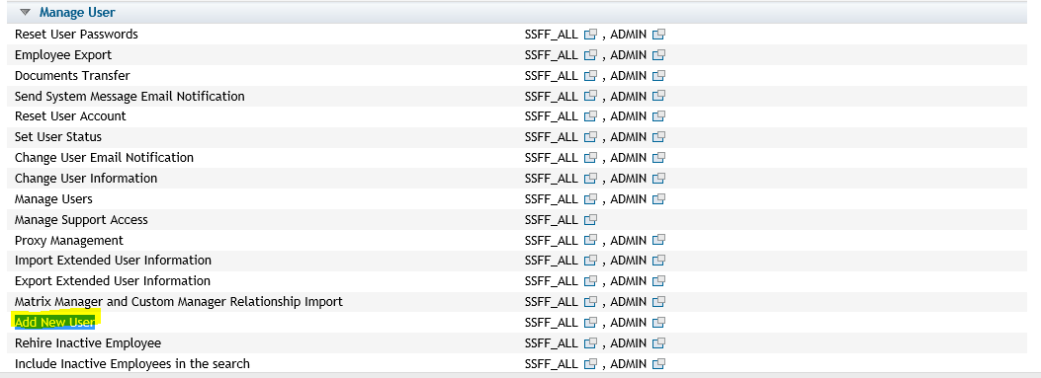

Resolution: -

The issue is due to the fact that Succession data model is not configured with the Hire action field, which is responsible for “Add New Employee” option in admin tools.
Please add the below configuration to SDM
<hris-action id="hireAction"></hris-action>
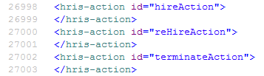

Association “toDepartmentApprenticeDetail” is in active state which is causing issue. This is the new feature planned in future release and as of now should be in inactive state.
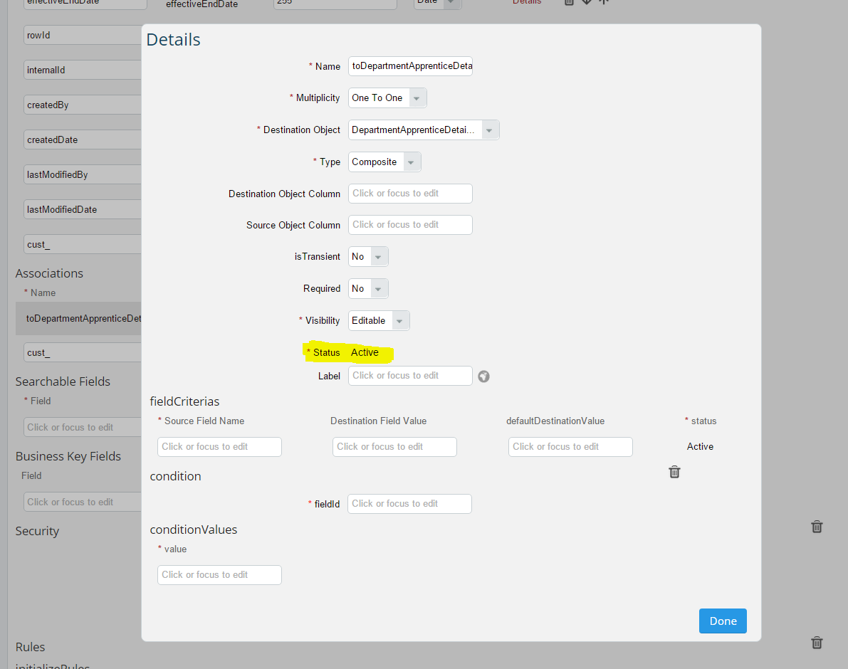

Resolution:

Provisioning switch for Apprentice Management (delivered in new feature in b1508) is turned off.
As part of the Apprentice Management implementation the GO Department was extended with a composite one-to-one association to GO DepartmentApprenticeDetail.
Once we try to activate this inactive GO Department, which is not possible because GO DepartmentApprenticeDetail is not a valid GO since Apprentice Management is not turned on in Provisioning.
As long as GO Department is active, changes to the object definition are possible. But if the object is inactive, it is no longer possible to activate it.
At the same time it is not possible to deactivate or delete the association.

Steps undertaken for resolution:

1. Activate the "Enable Apprenticeship management" in Provisioning.
2. Activate the department object from the configure object definition.
3. Disable the “Enable Apprenticeship management “in Provisioning.
4. Now you can observe the “toDepartmentApprenticeDetail” also becomes inactive.
