External Learning User Configuration

Data Model Configuration
Following hris-elements are required In Succession Data Model as per sap help guide
https://help.sap.com/viewer/DRAFT/0bbc2f10849d4ead870477a29921746a/1911/en-US/6277ee427bcf4dcf9351e676ec858076.html
hris-element | hris-field
personInfo
employmentInfo
personalInfo | first-name
 | last-name
 | middle-name
emailInfo | email-type
 | isPrimary
 | email-address
phoneInfo | phone-type
 | isPrimary
 | country-code
 | area-code
 | phone-number
 | extension
homeAddress
* HrisSaveEntityData supports read of above entities except personInfo, and only supports write of personalInfo, emailInfo, phoneInfo and homeAddress. For more details please check OFB API - HrisSaveEntityData.
Here is one example of the Succession Data Model:
<hris-element id="personInfo">
</hris-element>
<hris-element id="personalInfo">
<label>Personal Information</label>
<hris-field max-length="128" id="first-name" visibility="both" required="true">
<label>First Name</label>
</hris-field>
<hris-field max-length="128" id="last-name" visibility="both" required="true">
<label>Last Name</label>
</hris-field>
<hris-field max-length="128" id="middle-name" visibility="both">
<label>Middle Name</label>
</hris-field>
</hris-element>
<hris-element id="homeAddress">
<label>Home Address</label>
</hris-element>
<hris-element id="phoneInfo">
<hris-field max-length="100" id="phone-type" visibility="both">
<label>Phone Type</label>
<picklist id="ecPhoneType"/>
</hris-field>
<hris-field max-length="32" id="country-code" visibility="both">
<label>Country Code</label>
</hris-field>
<hris-field max-length="32" id="area-code" visibility="both">
<label>Area Code</label>
</hris-field>
<hris-field max-length="100" id="phone-number" visibility="both" required="true">
<label>Phone Number</label>
</hris-field>
<hris-field max-length="32" id="extension" visibility="both">
<label>Extension</label>
</hris-field>
<hris-field max-length="1" id="isPrimary" visibility="both">
<label>Is Primary</label>
</hris-field>
</hris-element>
<hris-element id="emailInfo">
<hris-field max-length="38" id="email-type" visibility="both">
<label>Email Type</label>
<picklist id="ecEmailType"/>
</hris-field>
<hris-field max-length="100" id="email-address" visibility="both" required="true">
<label>Email Address</label>
</hris-field>
<hris-field max-length="1" id="isPrimary" visibility="both">
<label>Is Primary</label>
</hris-field>
</hris-element>
<hris-element id="employmentInfo">
</hris-element>

Picklist Configuration

Check out SAP Help guide
- Checking Picklists for Learning Extended Enterprise
- Required Picklist Example for Extended Enterprise
- Creating MDF Picklists for External Learners (Recommended)
- Creating Legacy Picklists for External Learners

External Learning User Feature Switch
To enable External Learning User feature, please go to Provisioning -> Company Settings and check "Enable External Learning User (This feature enables external persons to self-register as a user and log in to access Learning)".
This features requires “Enable Generic Objects”, “Role-based Permission (This will disable Administrative Domains)” and “Enable the Attachment Manager”.

RBP Configuration

How to grant permissions to External Learning User
(1) Go to Admin Tools -> Manage Permission Roles, there is a new button “Create New Role For External User”.
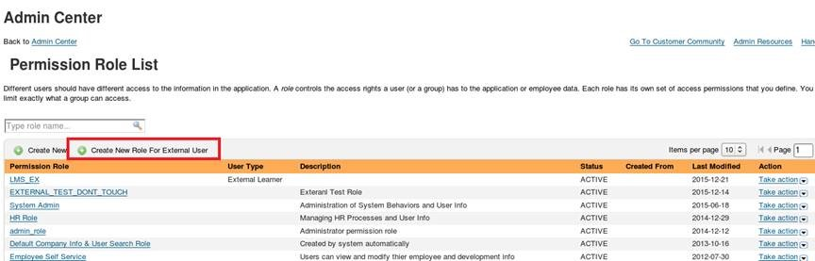
(2) Click button “Create New Role For External User”, select “External Learner” as User Type.
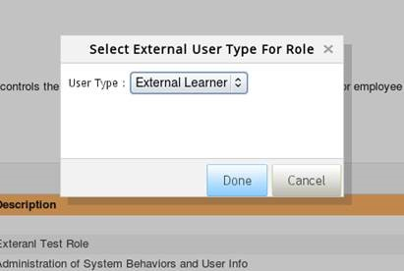
(3) Click “Done” and it will go to “Permission Role Detail” page. “User Login” and “Learning Access Permission” are required to External Learning Users.
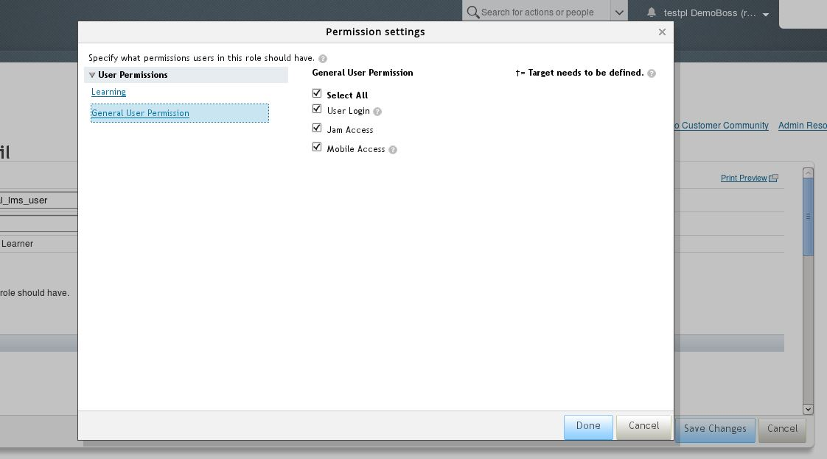
(4) Grant the role to “Everyone(External Learner)”.
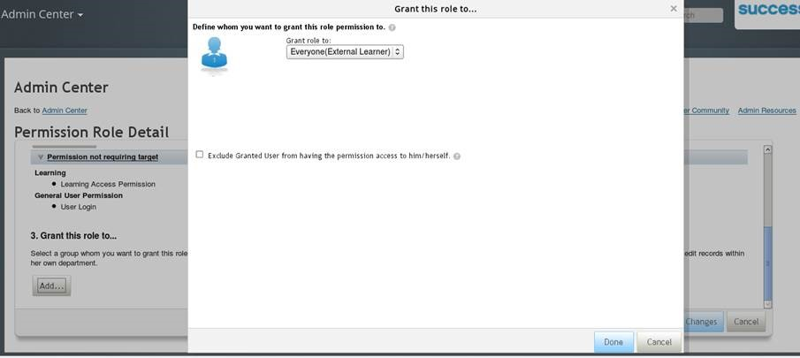
(5) Click “Save Changes” button on “Permission Role Detail” page.

How to include External Learning User to the target population
Right now we can manage External Learning User in admin tools Reset User Password and Reset User Account. Here are the steps to include External Learning User in the target population of the corresponding permissions.
(1) Select "Company Info Access -> User Search", "Reset User Account" and "Reset User Password" permissions.
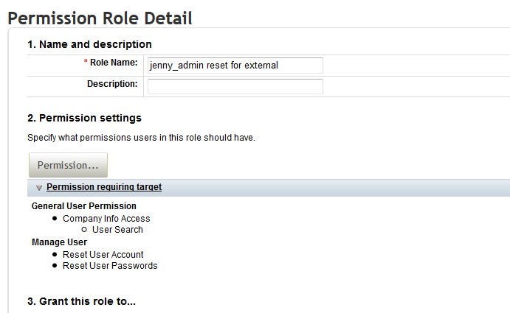
(2) Select "Add For External User Type" button.
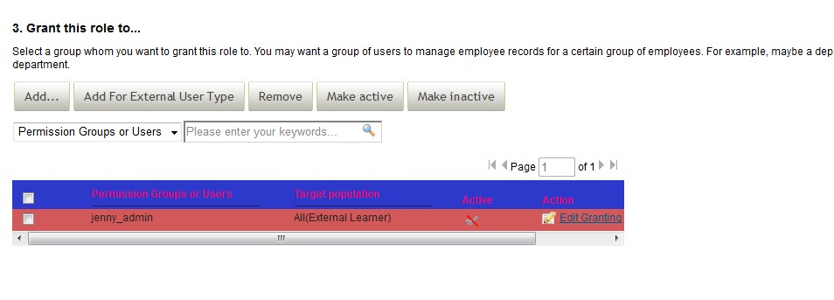
(3) On the popup window, select User Type "External Learner".
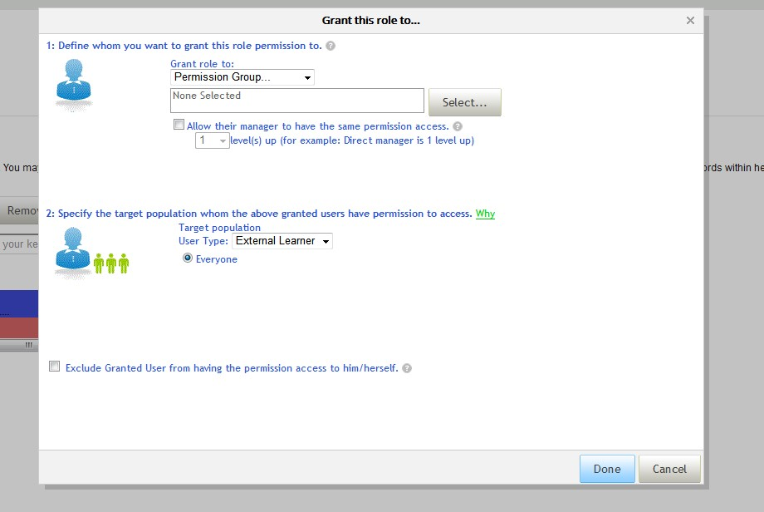
(4) Click “Save Changes” button on “Permission Role Detail” page.

Manage External Username Patterns
To avoid the username conflicts between internal user and external user, customer can reserve some username patterns to be used by internal users only and external users cannot use those patterns. Here are the steps to setup those patterns.
(1) Grant "Manage External Username Patterns" permission to admin user.
(2) Go to Admin Center -> Update Iser Information -> Restricted External User Name/User ID Patterns.
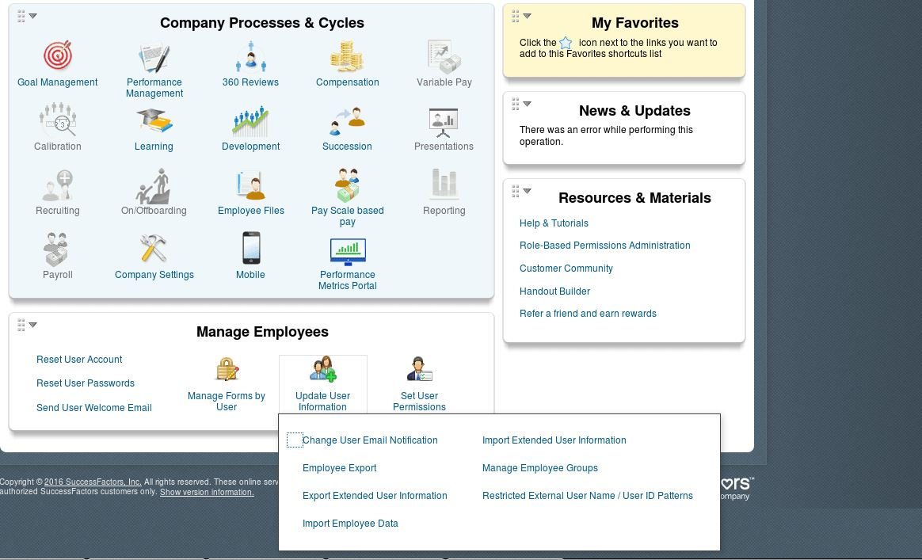
(3) On the page, we can define up to 3 patterns that cannot be used by external users. There is description to the patterns on the page.
