Creating a Dashboard Based off a Live Office Connection

Purpose:
Live Office is a common data connection type used in dashboards. This type of connection allows a dashboard to be created based off of data in a pre-existing Web Intelligence Document or a Crystal Report.

Overview:
This walk through consists of steps to create a simple Web Intelligence document, create a Live Office connection to the created Web Intelligence document, and connecting the Live Office connection in Dashboard Design (Xcelsius).

Create a Webi Document
- Open the Web Intelligence Rich Client.
- Log into the BI Platform
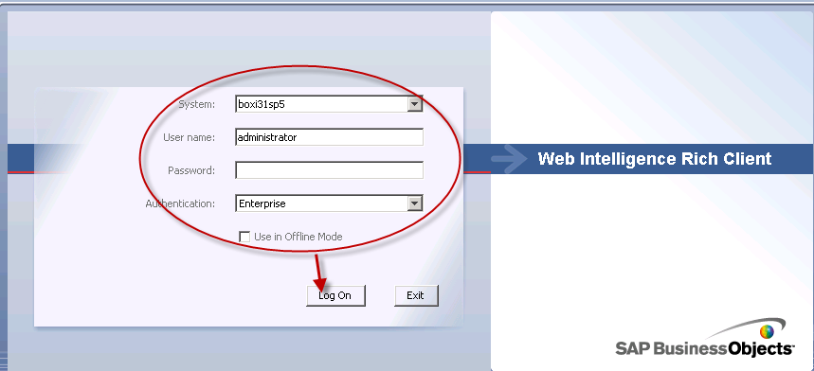
- Click on Create a new document based on a data source icon.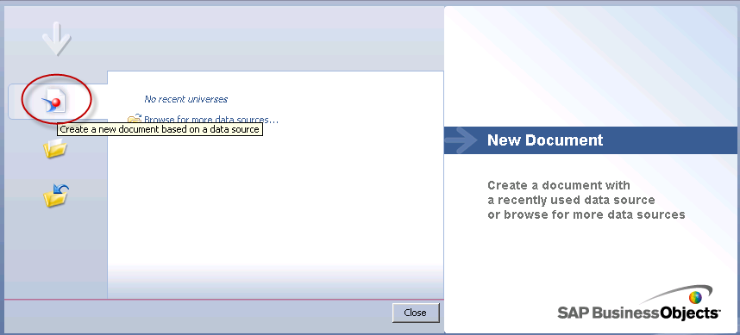

- Select “Universe” and click “Next”
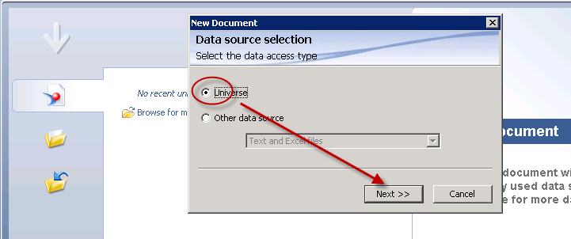
- Select the Universe to be used for the document and click “OK”.
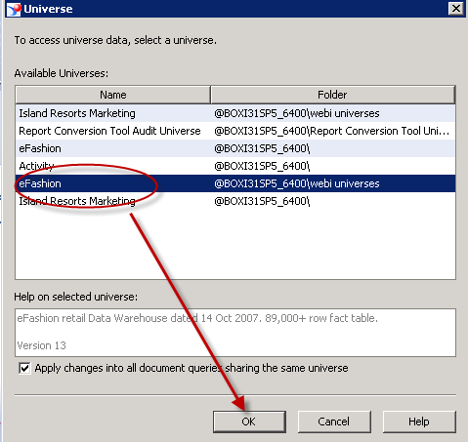

- Create and run query.
Note: This example includes a single parameter.
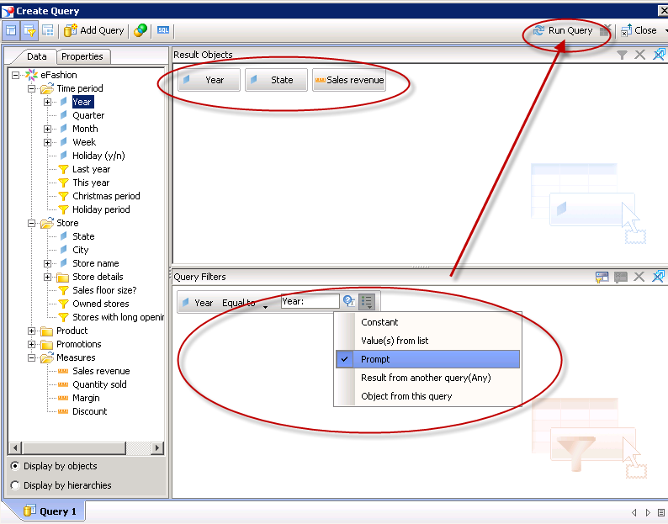

- Supply parameter information and “Run Query”.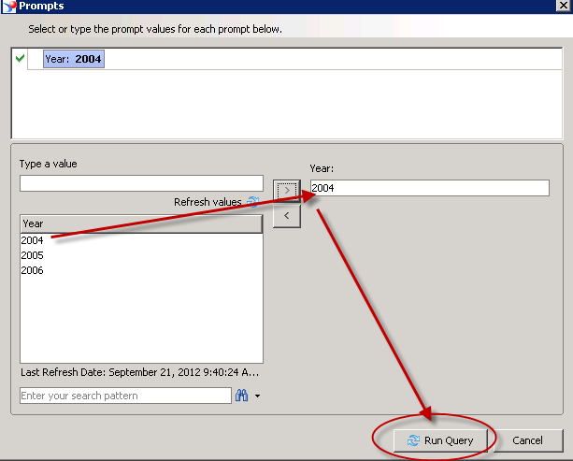

- View and review the results.
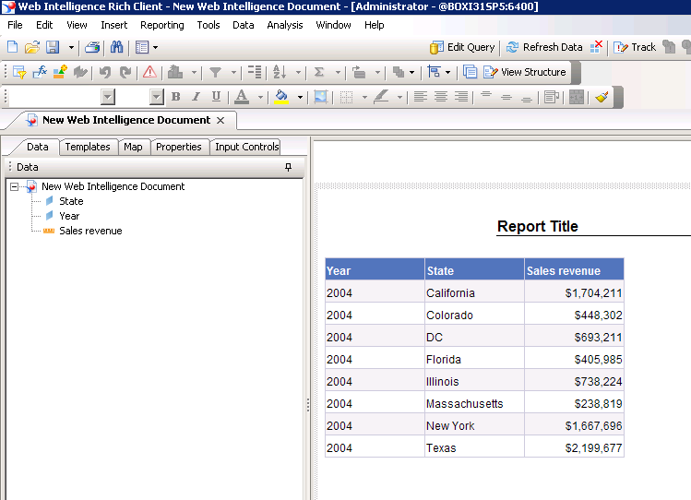

- Export document to CMS.

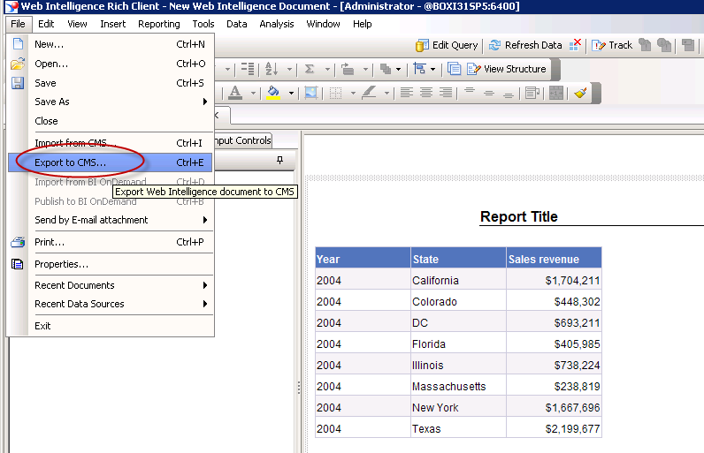

- Select a location on the BI Platform for the document.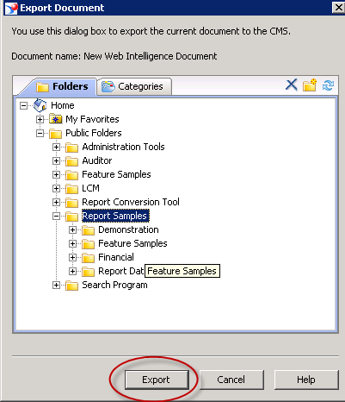

- Ensure the export completed successfully and click “Close”.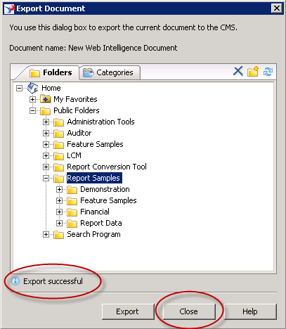
- Exit the Web Intelligence Rich Client
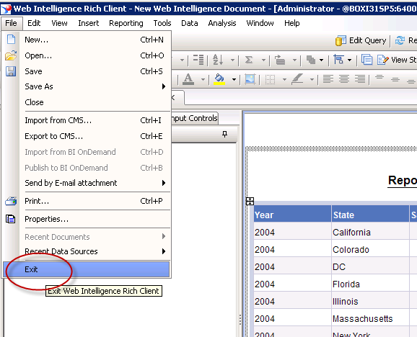

Optionally, Save the document locally.
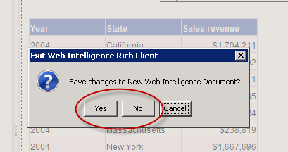

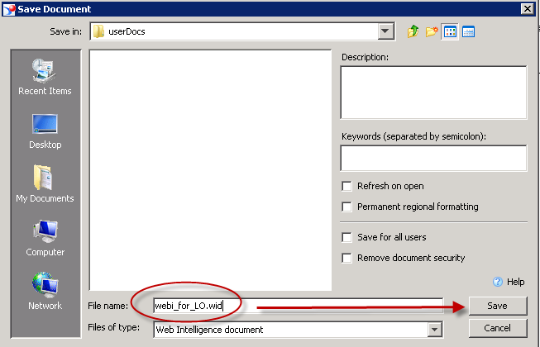

Creating the Connection in Microsoft Excel

- Open Microsoft Excel.
- Click on the Live Office Tab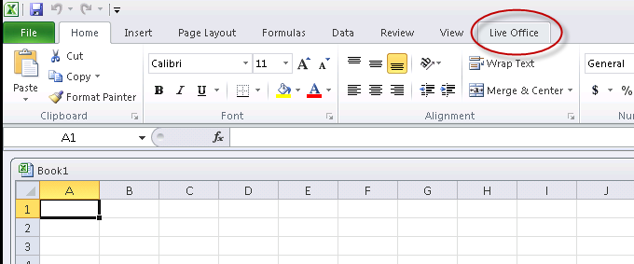

- Select Web Intelligence.
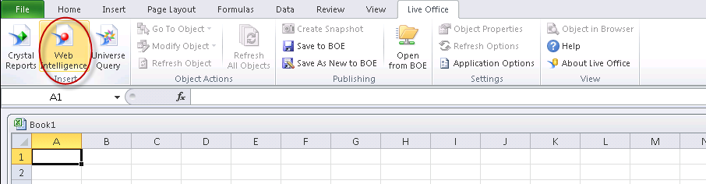

- Log into the BI Platform
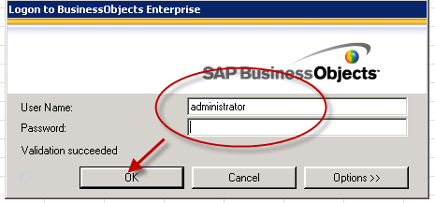

- Select the Web Intelligence Document and click “Next”.
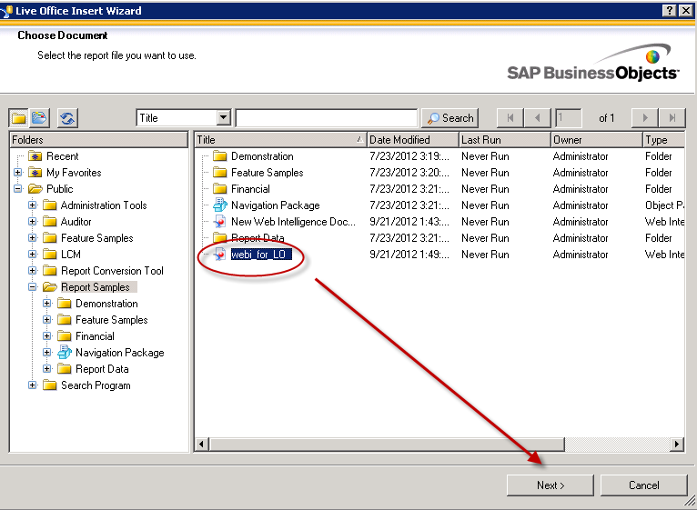
- Click on the report block to be used in the Dashboard and click “Next”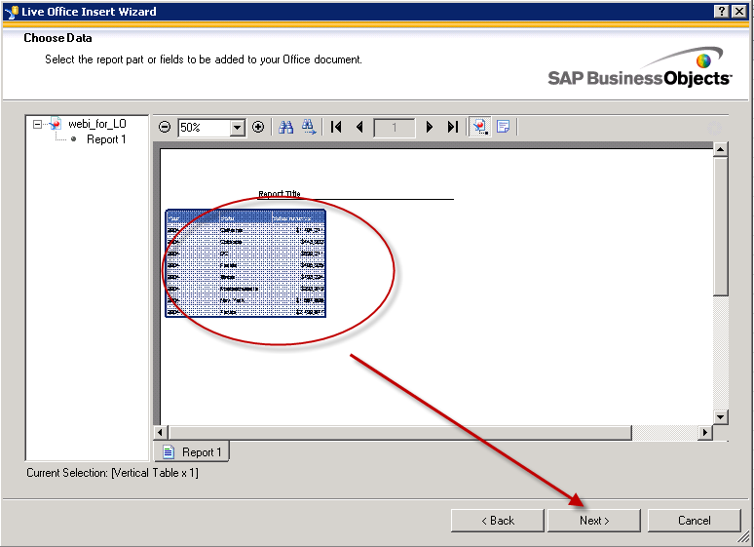
- Enter a name for the report block, or use default.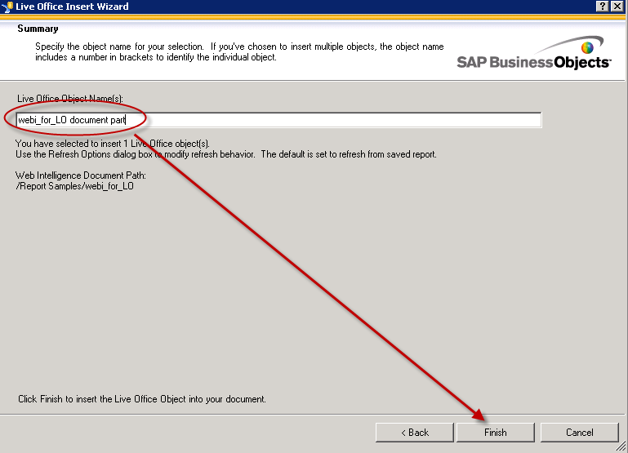

Note: The data block will be inserted into the spreadsheet into beginning at the cell selected in Excel. If no cell is selected, the default is cell A1.
- Click on the “Refresh All Objects” button.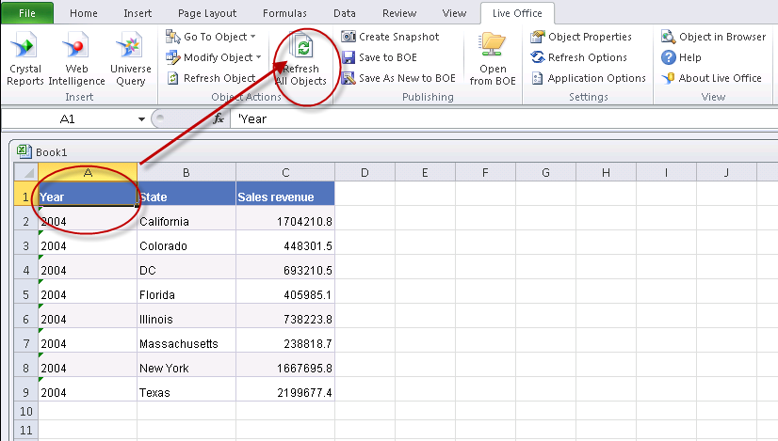

- Select Parameter Value and click “OK”.
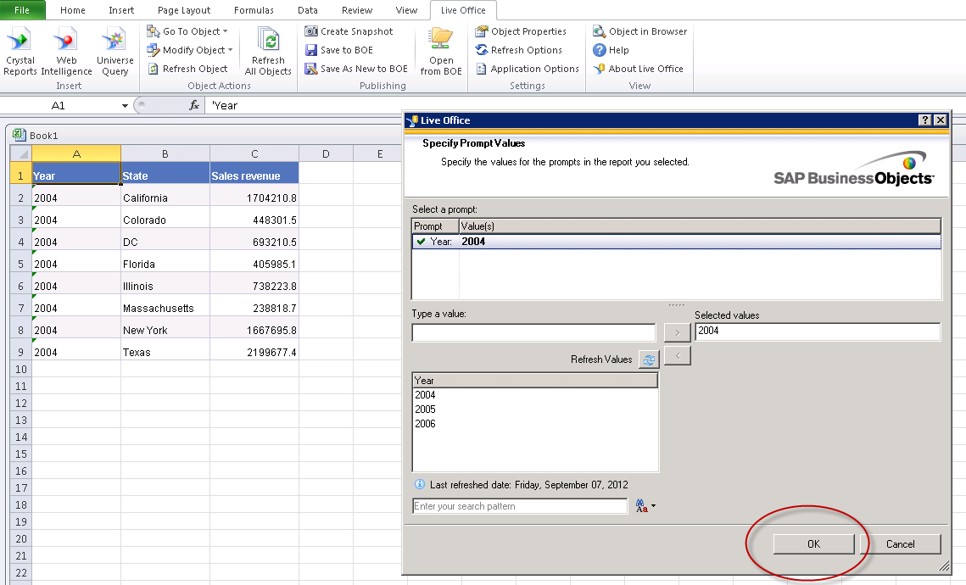
- Click on “Object Properties”
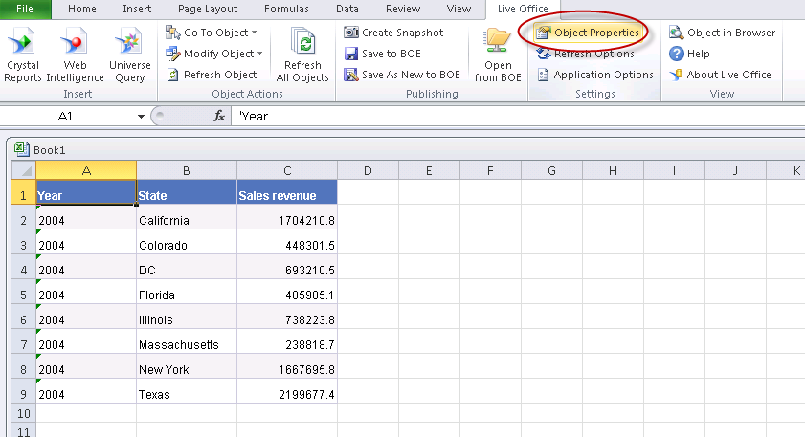
- Click on the “Prompts” tab.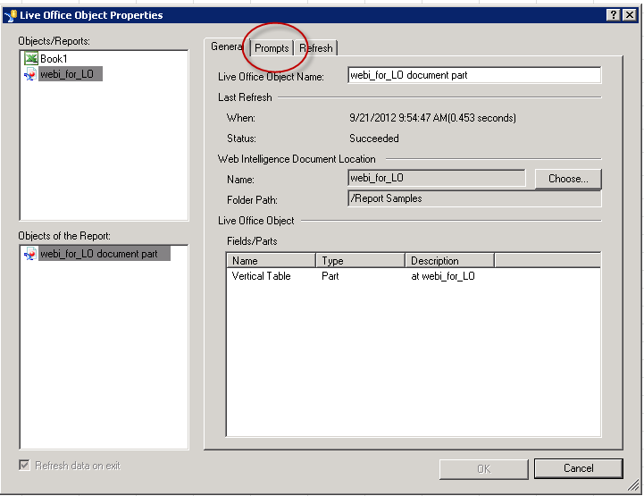

- Click on the “Prompt Values” button.
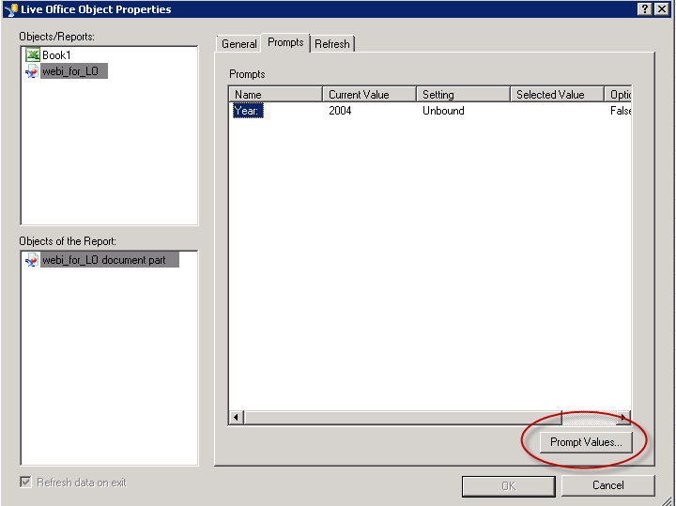
- Map the Prompt Value to a cell in Excel.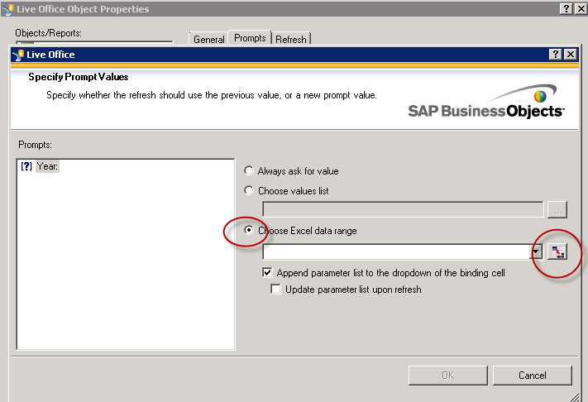

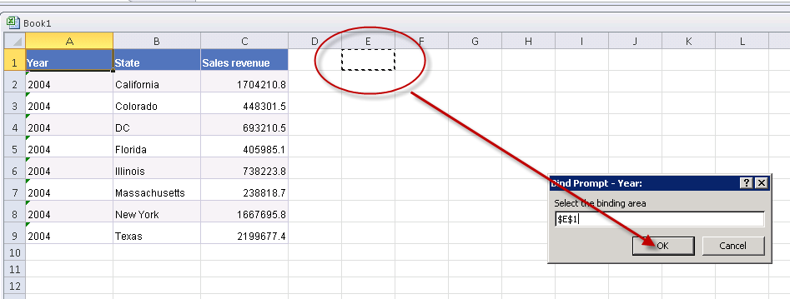
- Click “OK” once mapped.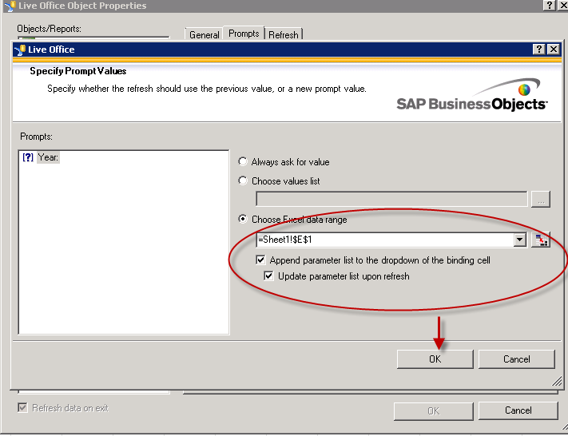
- Check that the binding is displayed and click “OK”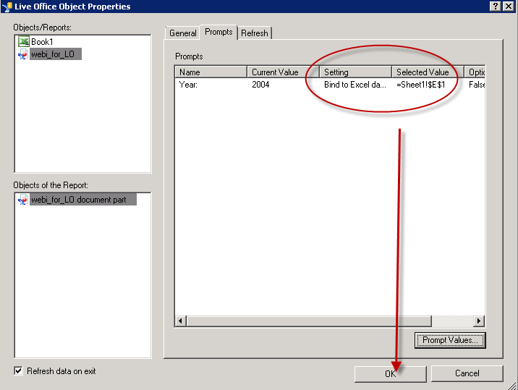

- Save the Excel file.
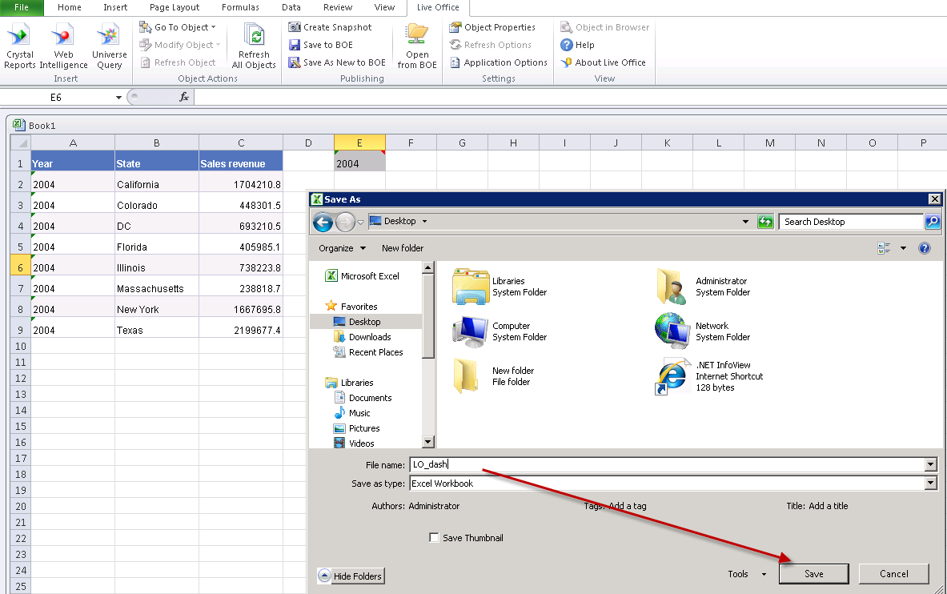
- Exit Excel.
- Open the Task manager and endure Excel.exe is NOT running.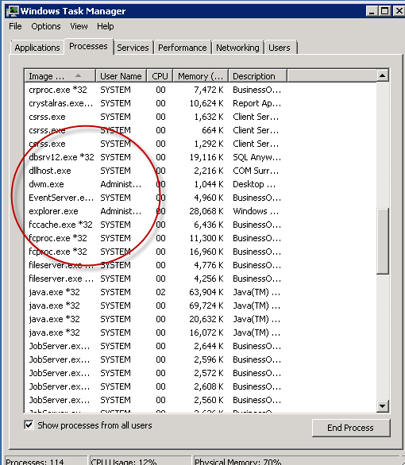

Using the Live Office Connection in the dashboard

- Start the Dashboard Design tool.
- On a new dashboard, click on the Data tab and select “Import”.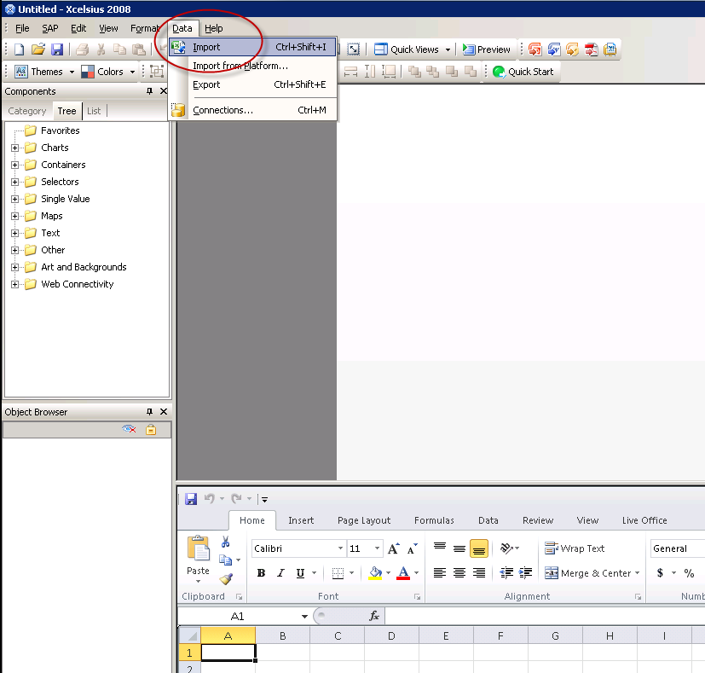

- Click “Yes” on the import dialog box.
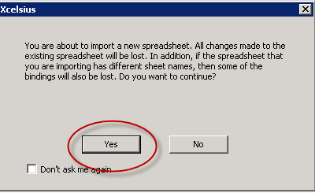

- Navigate to and open the previously saved Excel file.
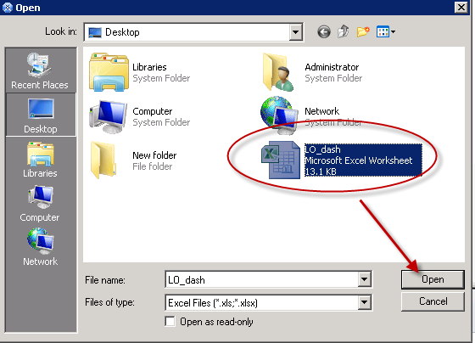

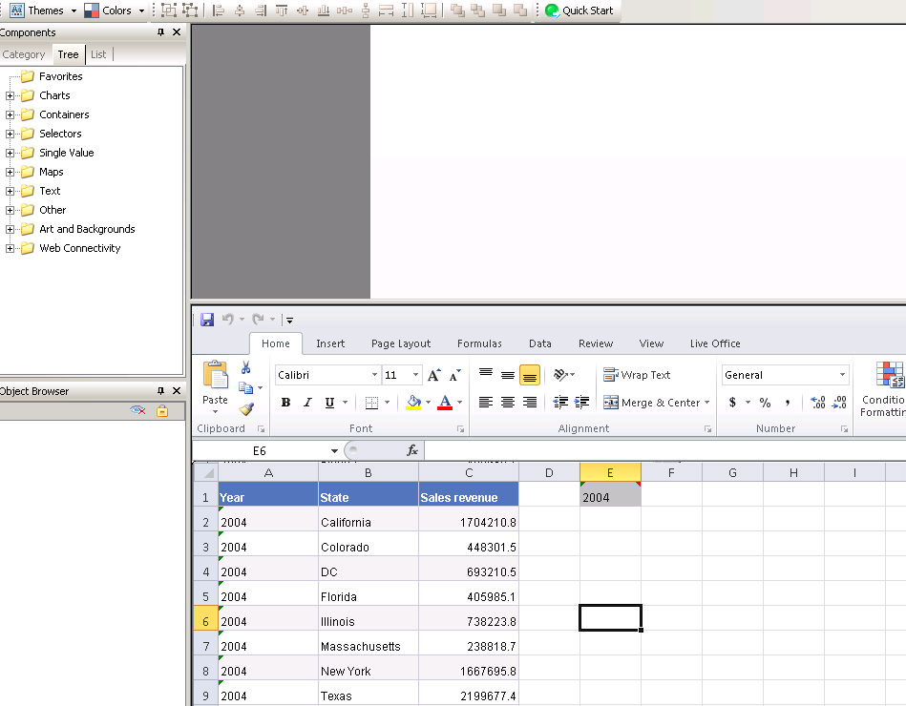
- Click on the “Data” tab and select “Connections”.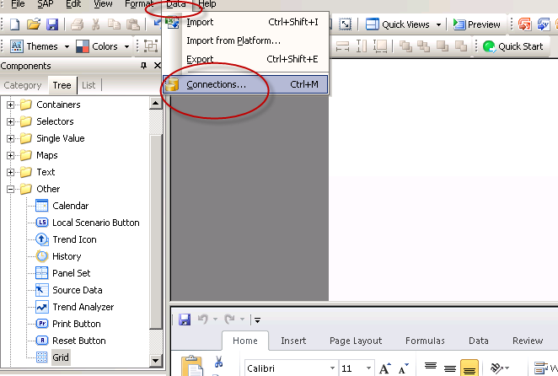

- Click on the Add dropdown and select “Live Office Connections”
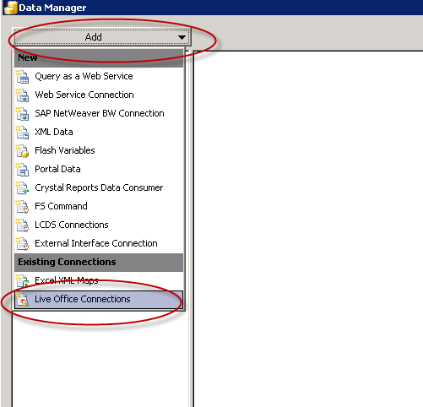
- Click on the connection listed on the left and edit the Session Url. Change <webserver> to the BI Platform machine. The URL can also point to a cell in the embedded spreadsheet.
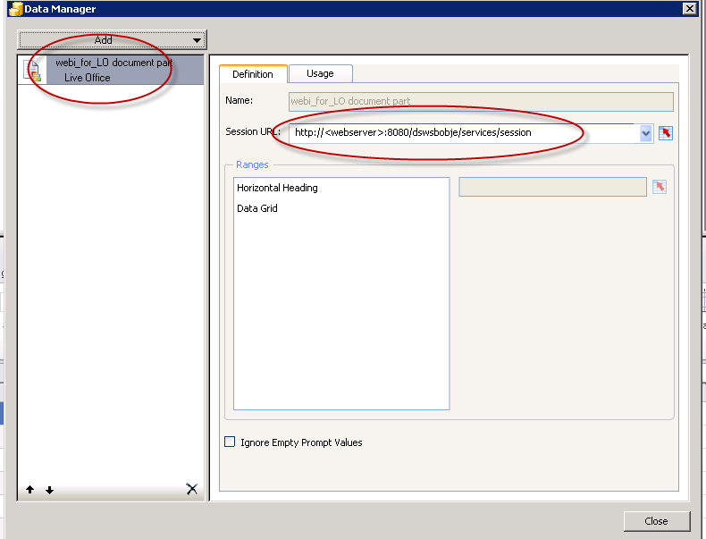

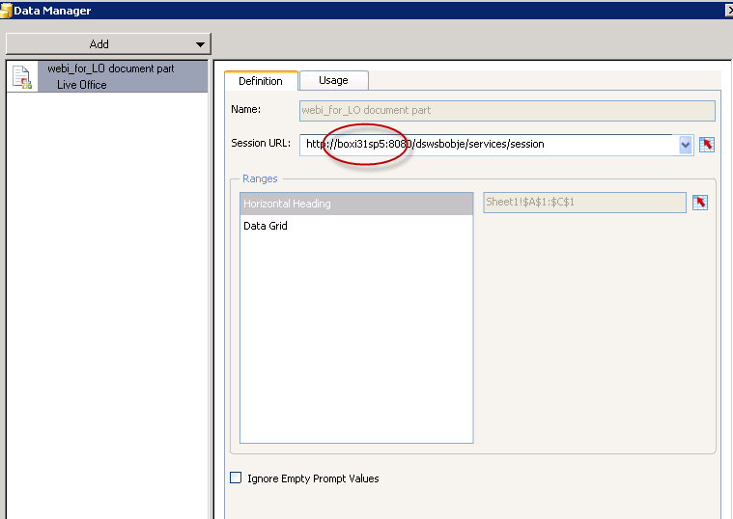

- Click on the “Usage” tab and set as required and click “OK”. 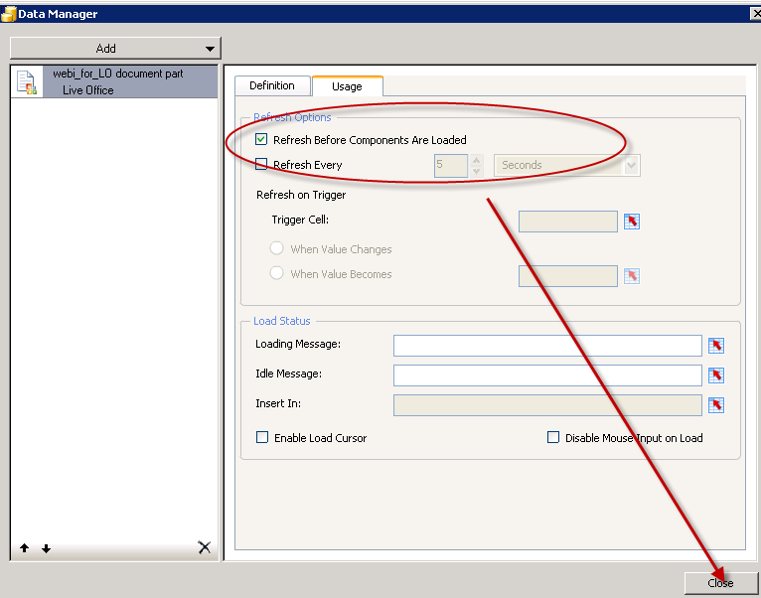

- Add components.

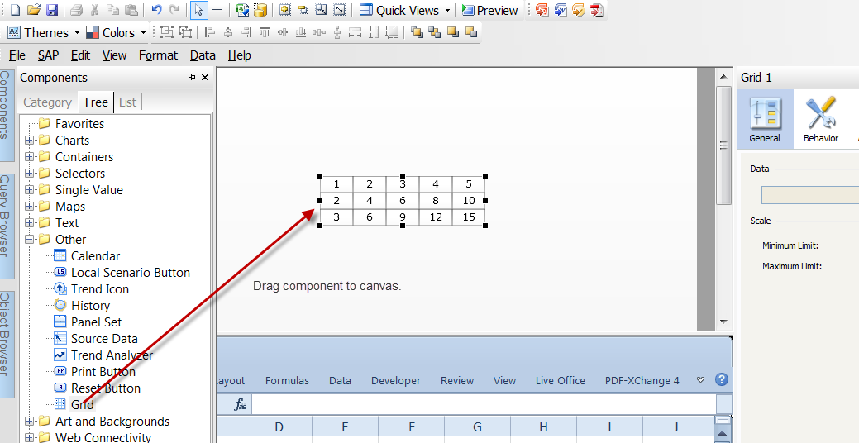
- Map component to data.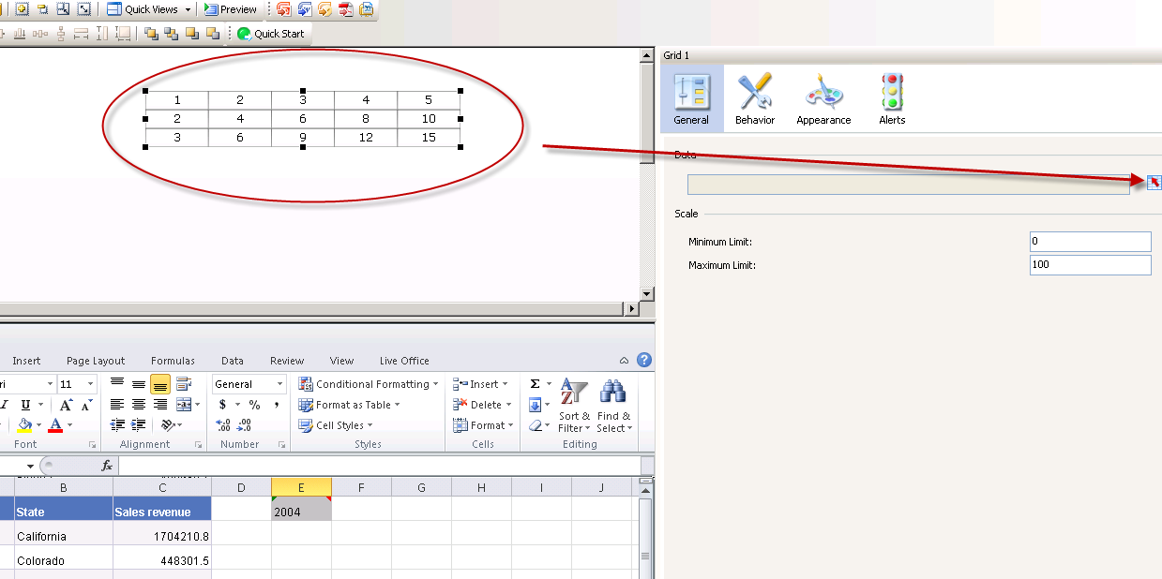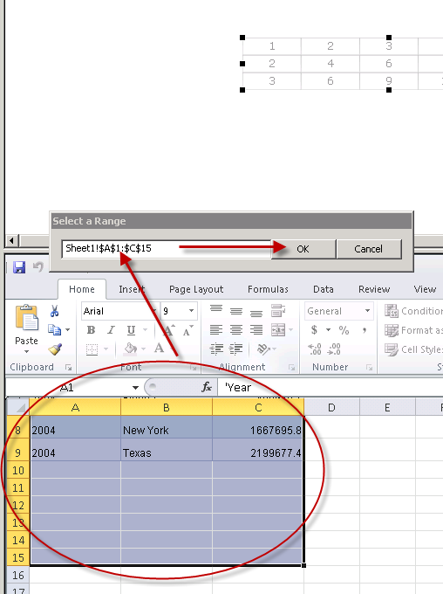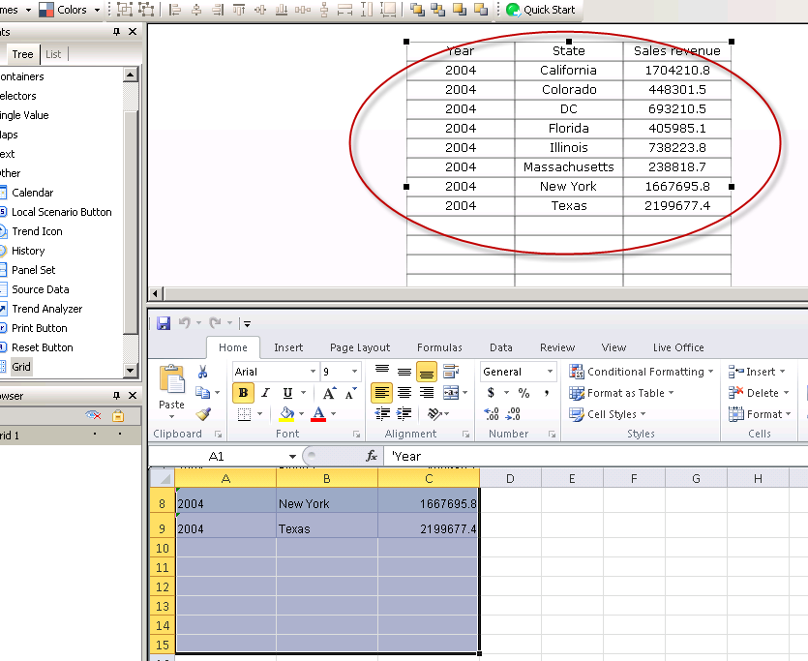

Optional:
In this example, a combo box is added and mapped to the controlling parameter cell.
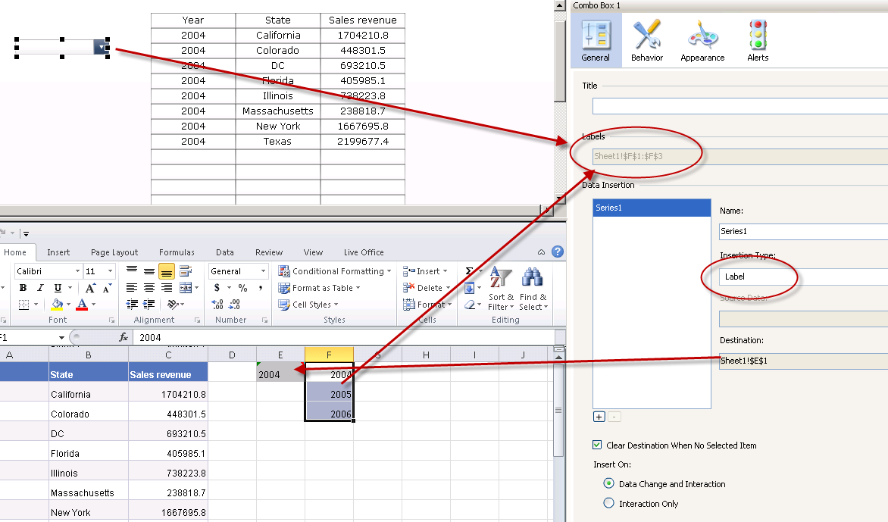

Include a “Connection Refresh” component. Users will select a prompt value and click the Refresh button to re-query the data.

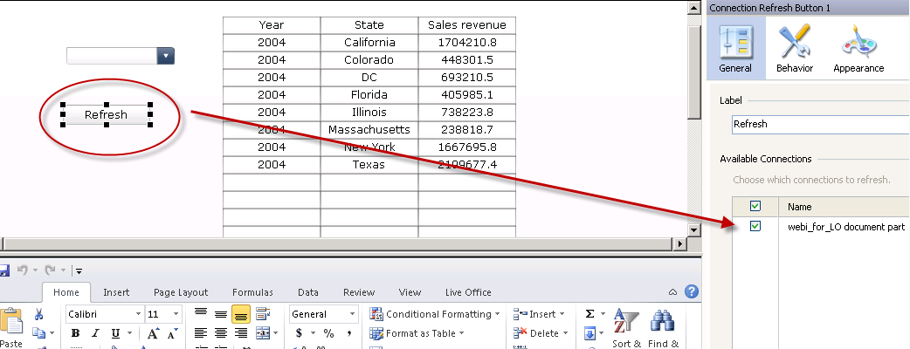

- Preview the dashboard and test.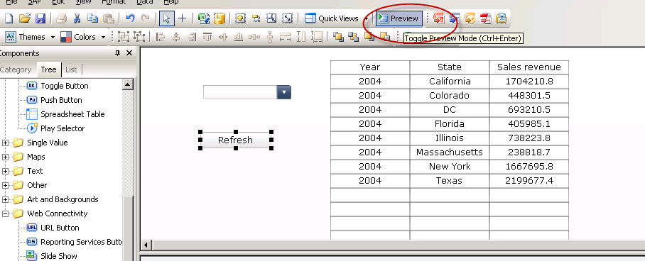
- Log into the BI Platform.
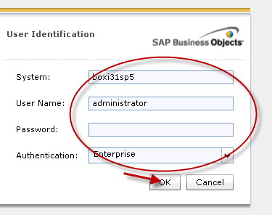

- Select Parameter from Combo Box and click “Refresh”. 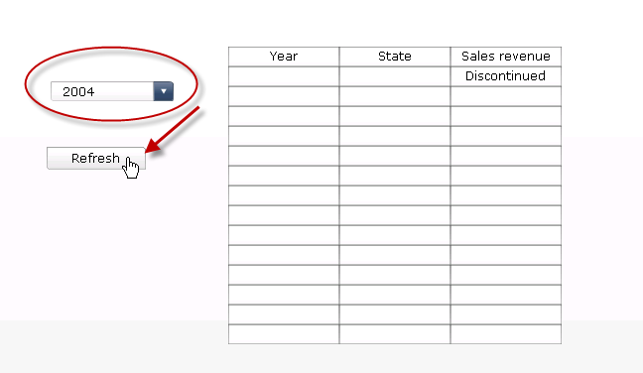
- View Data.
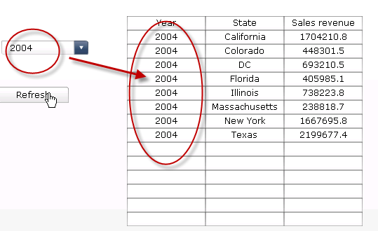

- Change parameter and view again.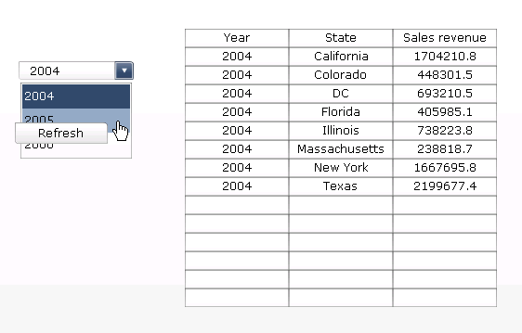

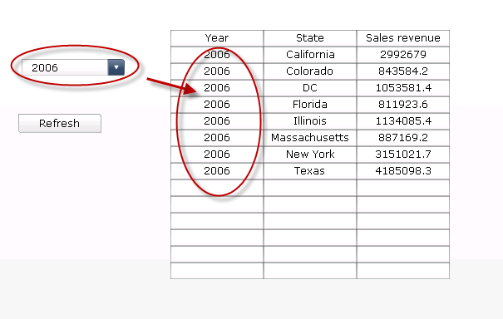
Related Content:
Related Documents:
SAP BusinessObjects Web Intelligence XI 3.1
SAP BusinessObjects Web Intelligence 4.0

