- Once you go to File >> Export >> SAP BusinessObjects Platform , it will pop up Log On window:

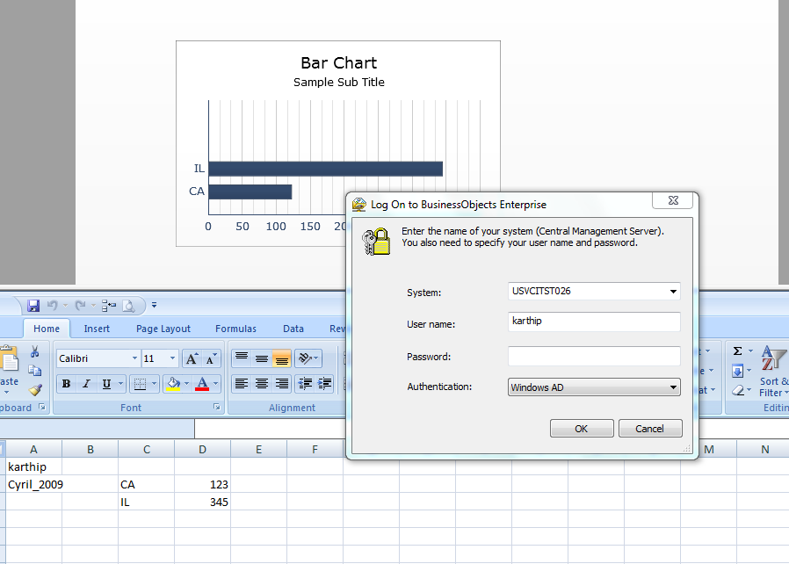
- Once you put in credential it will open Save As window:
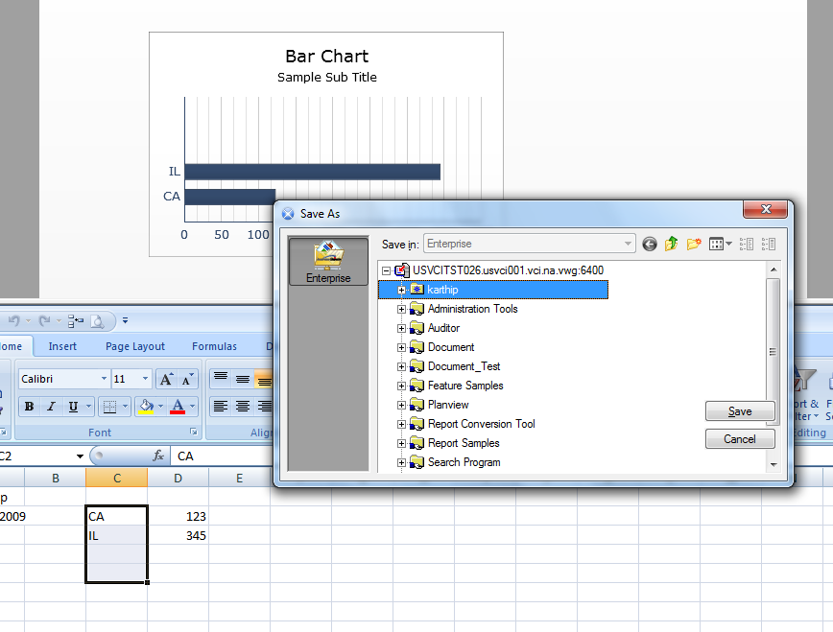
- Once you navigate to select the folder, it shows multiple ‘Save’ buttons.
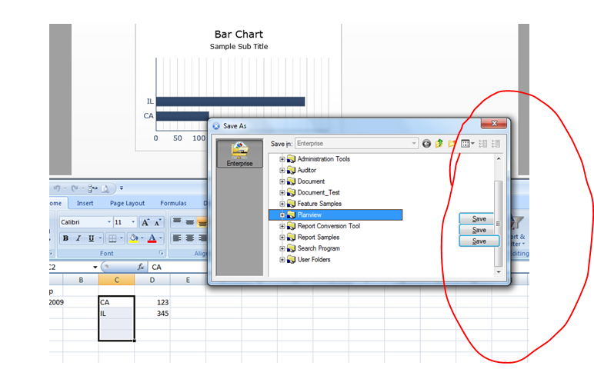
Multiple ‘Save’ buttons

