Quick Guide - SAP Jam and SF LMS
Setting up your demo system to demo the learning work patterns with SAP Jam and SF LMS

OVERVIEW OF STEPS --- PAGE 1-3

Prepare the SAP Jam demo system

Integrate LMS with SAP Jam

Setup demo data in LMS

Finalize the SAP Jam groups

PAGE 4FF --- MORE INFORMATION AND HOW-TO SCREENSHOTS

Step-by-Step

- Getting started
  - Go into SAP Jam demo admin section > Demo > Demo Data. You will see all available demo scenarios, including the new integrated ones: “Situational Leadership” and “Leadership Development Academy” (will be greyed out until integration is setup)
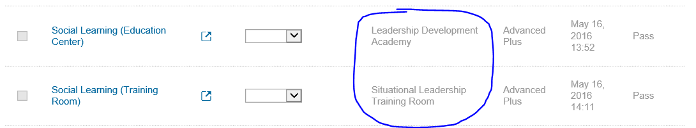
  - Important: Make sure that the SAP Jam admin has a corresponding account in SuccessFactors Learning and can also access to the learning catalog (demo user “admin” should have access to all. IMPORTANT: “sfadmin” will be made an admin in the next update, for now, please use “admin”)
  - It is highly recommended that import the „Actor pack“ to BizX before proceed to next steps, discribed in this guide
- Integrate SF LMS and SAP Jam (see full version in the SAP Jam Admin Guide)
  - Gather SuccessFactors Learning OAuth token information
    - SF Learning Admin > System Admin > Configuration > System Configuration
    - Search in the LMS_ADMIN configuration file for "jamIntegrationEnabled", ensure that it is set to "true", and click Apply Changes.
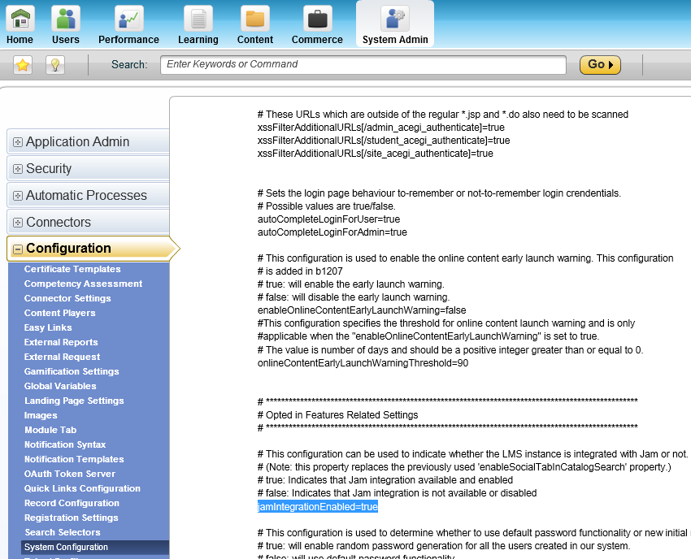
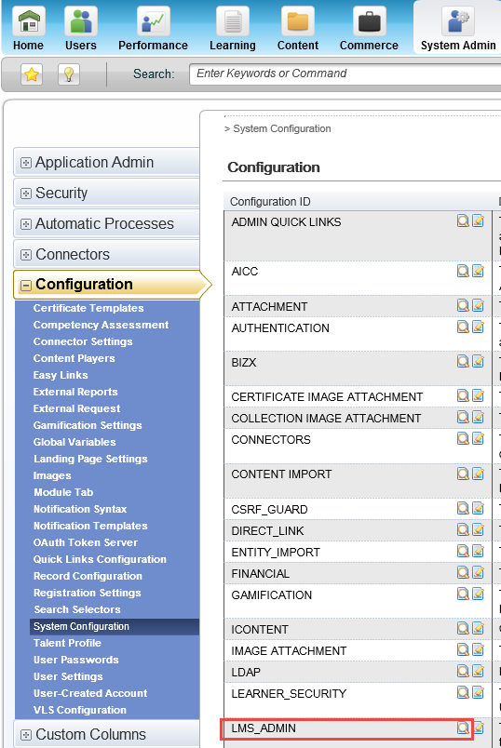

    - Gather the OAuth information: SF Learning Admin > System Admin > Configuration > OAuth Token Server. Generate a new client secret button. Copy and save : Client ID and Newly Generated Client Secret. Also copy the URL from domain name of your SuccessFactors Learning. 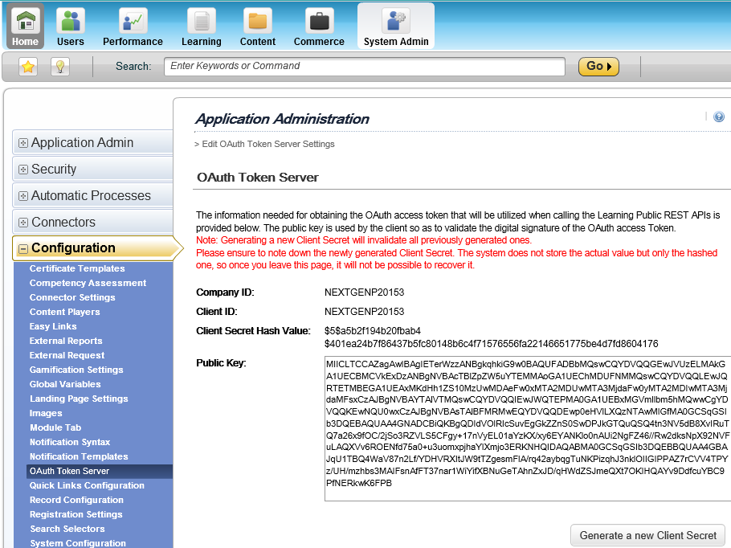

  - Register SuccessFactors Learning as an External Application in SAP Jam
    - SAP Jam Admin > Integrations > External Applications > Add Application: SF Learning
    - Add:
      - OAuth 2.0 Client Id
      - Newly Generated Client Secret field
    - Domain name of your SuccessFactors Learning (learning admin URl or e.g. in Chrome, right click "View frame info" and copy the base URL for the page) 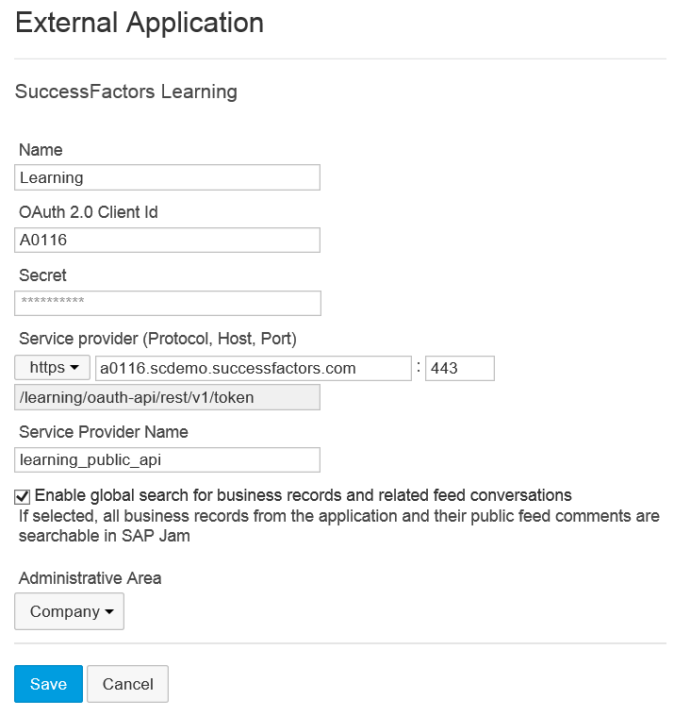

  - Make sure the admin user you are using has access to LMS Core Catalogue
    - IMPORTANT: your LMS admin account might NOT be a User account (search under Users, your admin account does not appear). In this case, raise IT Ticket ask your LMS admin account to have access to LMS Core Catalogue.
    - BizX => Admin centre => Learning => Learning Administration
    - In LMS admin => Users => Assignment Profile, search for “EMP” and select
    - Click on “Manage Rule” 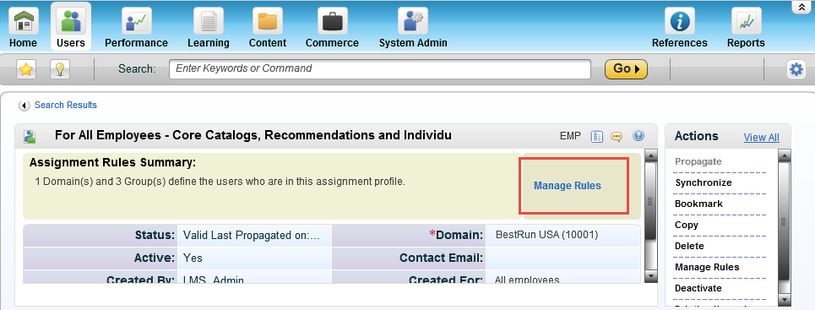
    - Add admin user “sfadmin”, “admin” to the rule, Save
      - Include, “twalker” and “ghill” if you already have imported actor pack
    - Click on “Propagate” to apply the changes

  - Register the SuccessFactors Learning business record in SAP Jam
    - IMPORTANT: the user you are using to register business record in SAP Jam should be a corresponding user on SFSF SuccessFactors Learning and should have access to LMS’s Core Learning Catalogue. Refer to above Step C.
    - SAP Jam Admin > External Applications > SF Learning > Action > Manage record type > Add record type > Import Default types.
    - Note: if you get the error message “import external resources” – failed – then there is most likely a cut and paste mistake, e.g. Extra spaces anywhere etc. can cause it to fail. To fix it, re-generate the client secret and delete and re-created the External Application.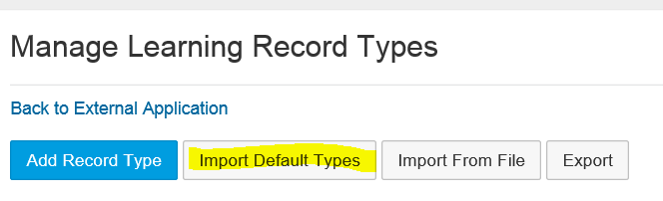

  - Setup demo data in LMS
Add schedule offerings to learning item (e.g., Situational Leadership)
    - SF Learning Admin > Learning > Items > Search in item title for “situational”
    - Go to Actions > Schedule > add date and time > save. Add additional dates and times. All will be shown in SAP Jam
    - Edit the item description as needed, (e.g., shorten the description to something like “Situational leadership model is a powerful, yet flexible tool that enables leaders to diagnose the variables of any given situation and adapt their management styles to the behavioral needs of the individual or group they are trying to influence. The model provides a framework which leaders can use to assess an individual’s performance readiness level to perform a specific task or function.”)
    - If the item does not show for a specific user, make sure that the user has access to the catalog where the item is listed or add the item to the right catalog. Example: Add the “Situational Leadership” item to the “HR” catalog (to which Tessa has access). Catalog tab for the course > click on the plus icon to add additional catalogs to the item if you should need
  - Add “Tessa Walker” to BizX and LMS (required to see the two new demo groups)
    - Adding Tessa Walker to BizX/Foundation
      - If you have uploaded the “SAP Jam demo actor pack.csv” you can skip this step.
      - If you have not uploaded it yet and/or are unfamiliar with adding new users to BizX, see the SAP Jam Demo Systems FAQ. You have two ways:
        - Option 1: Upload the SAP Jam demo actor pack.csv, which is the complete set of user accounts that support the official SAP Jam demo scenarios. You can find the link to the file and instructions in the SAP Jam Demo Systems FAQ
        - Option 2: Manually add specific users. Admin Tools > Add New Employee (or directly in the BizX file). In particular, take care in selecting the correct Login ID (=Person ID, e.g., twalker) and Email.

    - Adding user to LMS: LMS Admin > User > add new.
      - Important: make sure you add the UserID (not username/login!). To do that, export the BizX excel with user information that contains both UserID and User name and find the UserID. Tipically, twalker’s UserID = 82094.
      - Change her domain to your demo system’s main Domian: this can be “Corporate (CORP)”, “Industry(IND)”, “BestRun USA(10001)”, etc.

  - Manage the Assignment profile to give her access to a learning plan
    - Add Tessa(twalker) and Geoff (ghill) manually (or if you are familiar with LMS ensure that the “CORP” domain is included Assignment Profile “COREDEMO” and/or “EMP”)
      - Go to the Assignment Profile rules: User > Assignment Profile > EMP > Manage Rules
      - Add Tessa: Add new group > name it e.g. Tessa > Add rule: Attribute “userID” / Operator “matches” / [userID], e.g. twalker)
      - Save and if necessary synchronize/propagate
      - In Learning Administration > Users, add the Curricula LEAD-001 (Leadership Candidate Training Track) to the user.
    - To check: Login as Tessa, navigate to Learning. You should see her learning plan and if you search for “situational leadership”, the class should show.
    - Also, 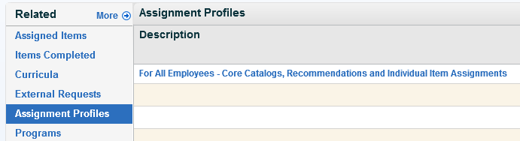

- Finalize the SAP Jam groups
You are now ready to perform the demo. Go into demo admin section and select the demo scenarios “Situational Leadership” and “Leadership Development Academy”, by checking the checkboxes and click refresh. Select the highlighted icon to access the demo scripts.

Note: Make sure you can search „Situational Leadership“ course in Business Record Type: Items. And user twalker(82094) exists on LMS with Core Catalogue profile assgined.
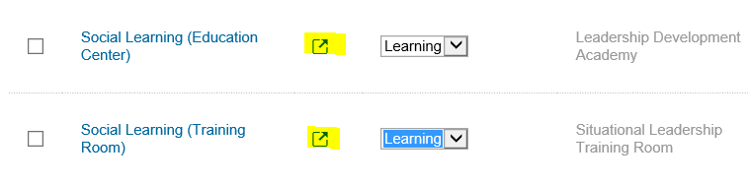
√
√
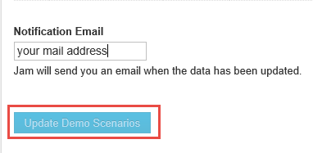

- Additional useful tips
  - See below links to the key documents that contain all information to setup the integration and your demo system
  - One common issue is that the automatic process of inviting users into SAP Jam after enrolling into a training is not working. This can be easily fixed by restarting the process in LMS: >Learning Admin > System Admin > Automatic Processes > Jam Groups
  - A SAP Jam group can be created from a learning item and with 1505 also from a curriculum or scheduled offering
  - When creating a Jam group based on a Business Record, the learners are not automatically assigned to the Jam group, the link has to be created in LMS

More INformation
- The setup instructions are in the official SAP Jam Admin Guide: http://help.sap.com/download/documentation/sapjam/administrator/index.html#7bb26b5afea340f290571696b55514ea.html
- The feature descriptions are in the User Guide:
http://help.sap.com/businessobject/product_guides/Jam14/en/sap_jam_user_guide.pdf
(section 12.1.7)
- For questions on demoing SAP Jam are addressed in the SAP Jam Demo Systems FAQ
https://jam4.sapjam.com/groups/6aISwLJBdnaryocM2nqtqg/documents/OKfX8SR11TZOIDBLxXsS9R/slide_viewer?_lightbox=true

How-to Screenshots
Adding a learning item to a catalogue:  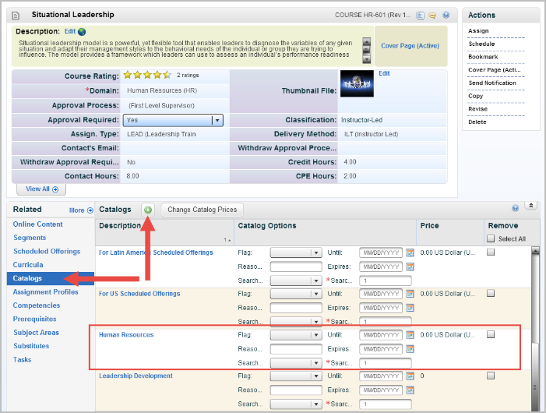 | Adding a new user:  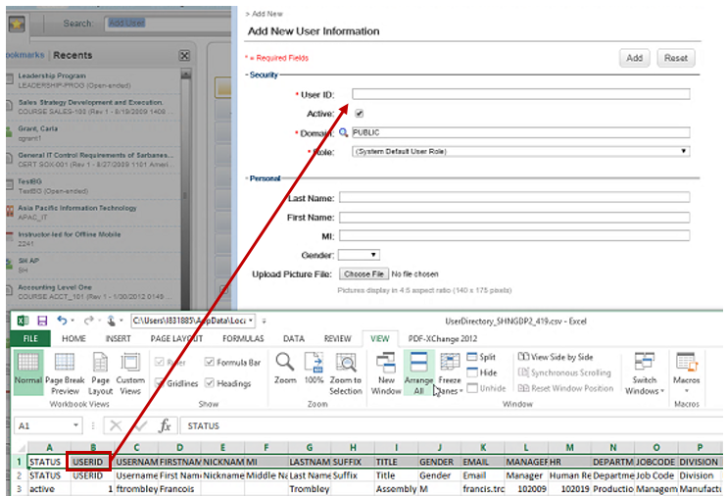
Ensure that new user is part of the Domain “Corporate CORP”

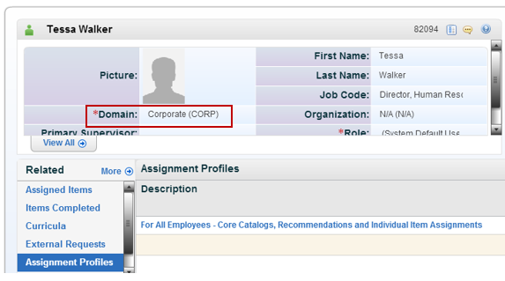

Managing the Assignment Profile

