SYMPTOMS:
Time off Calendars stuck while launching.
ENVIRONMENT:
Employee Central: Time Off
REPRODUCING THE ISSUE:
Please go through the following steps to troubleshoot this issue.
Jobs which are currently stuck are as under:
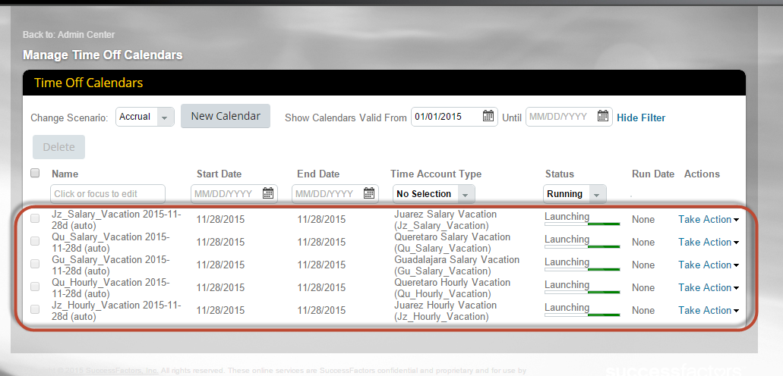
CAUSE:
Probable Root Cause :
- High service response time or unavailability of the server.
- Lag in the server
- Intermittent network connectivity, causing excessive errors.
However, server issues have been specifically temporary. The reason behind this, is a server available to take up requests, consist of numerous clusters having multiple managed servers which is designed to work in a round robin fashion.
RESOLUTION:
Go to import and export and export Time account Change Calendar.
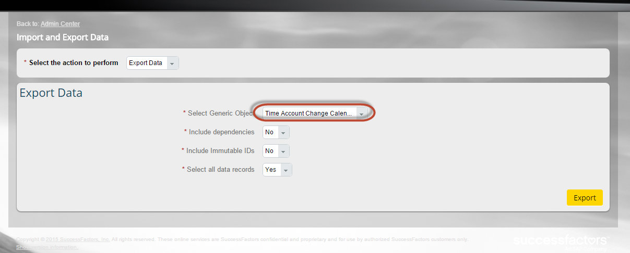
Go to Monitor job and Download the response file.
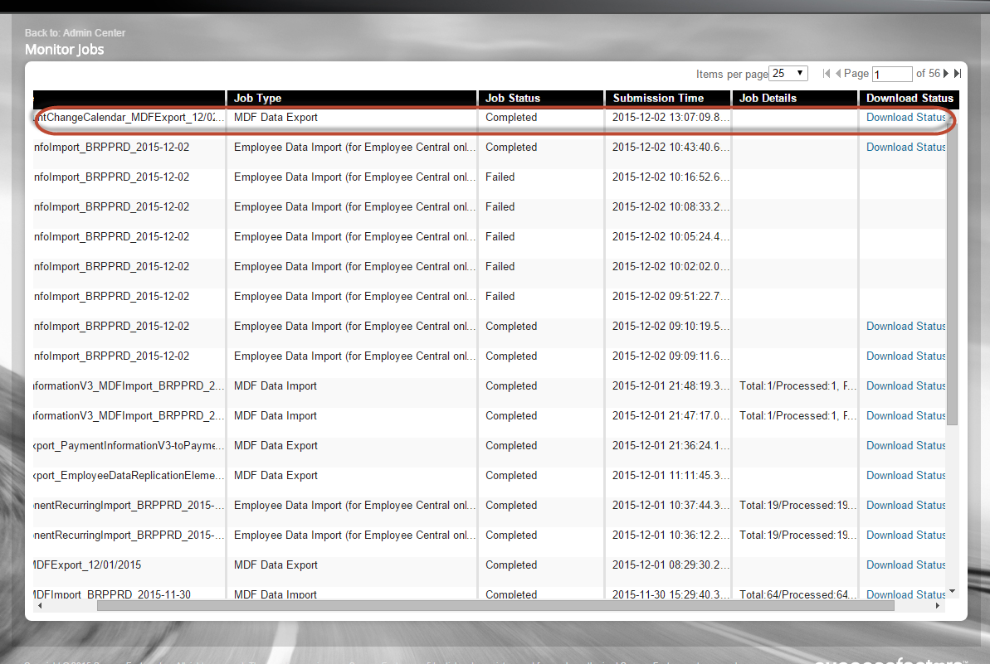
Filter the csv file with status “Running”. Copy these externalCode.
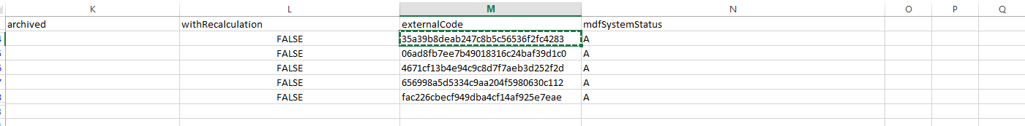
Go to Manage Time Off Structures and select Time Account Change Calendar and paste the externalCode one by one.
For every external code, go on changing the status from “Running” to “Finished” and hit save.
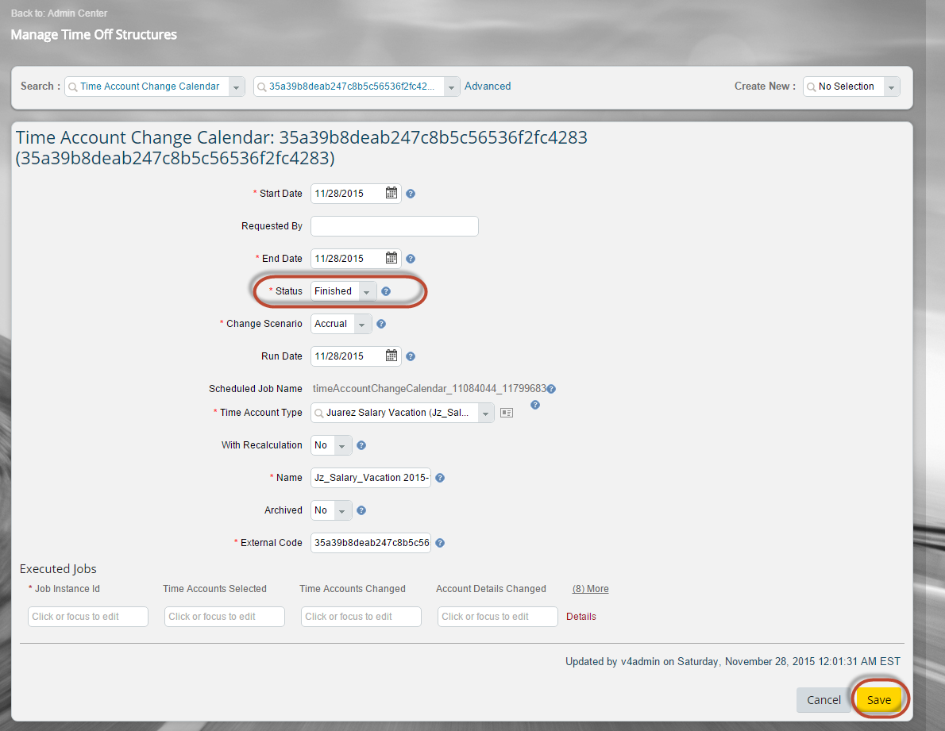
You can launch the calendar by creating a new. The newly created calendar will not get stuck. If there are more than few (say 4 to 10) jobs which get stuck, then import the calendar data through the import and export data by just setting the status of the calendar as “Finished”.
