Symptoms:
Missing Generic object menu for Import and Export Data
Environment Details:
UI of the instance which needs configuration.
Reproducing the issue:
For reproducing the issue please follow the below navigation steps:
Admin tool Employee Files Import Export data Select action to perform ( import / export/ download template)Select generic object ex: Position (template won’t be available)
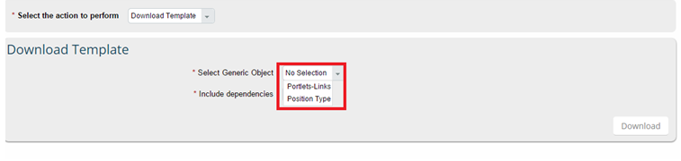
Cause:
Permissions not enabled in RBP
Resolution:
Step 1: navigate to Admin tool set user permissions manage permission roles select the role of the user
Step 2: Click on the role go to permissions miscellaneous permission select the generic object and enable the import/Export option.
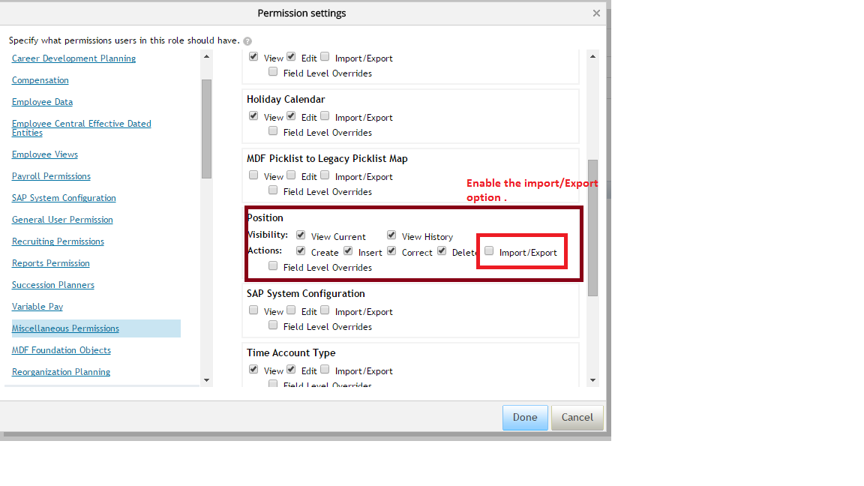
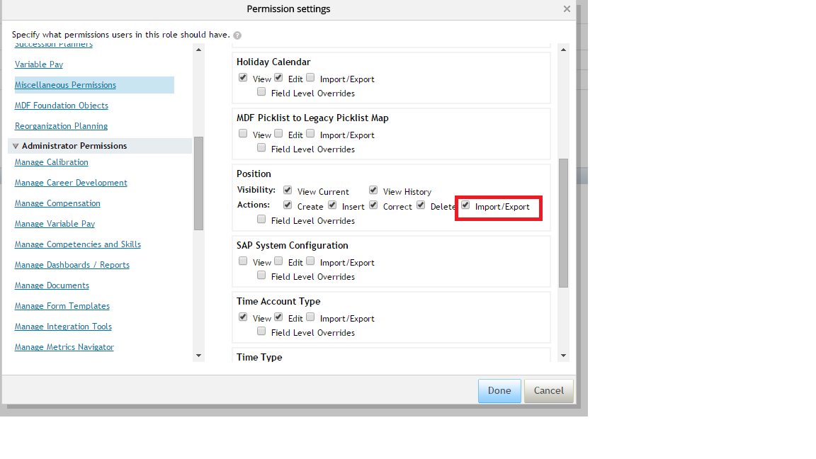
Step 3: Click on done and save the changes.
Step 4: once changes save please logout and login the system.

Admin tool Employee Files Import Export data Select action to perform ( import / export/ download template)Select generic object .
Position template is available
