Create Manager reports

SuccessFactors: Analytics – Advanced Reporting
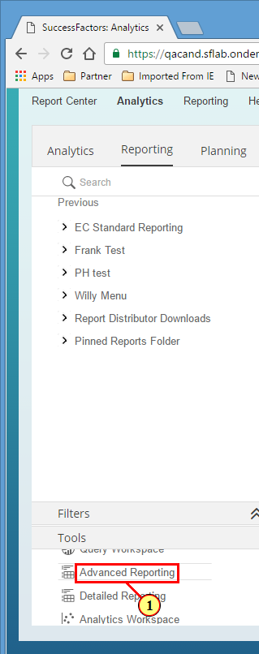
(1) Click .

SuccessFactors: Analytics – Advanced Reporting
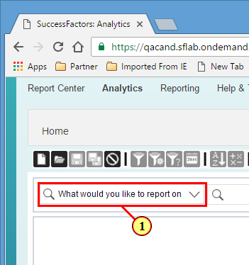
(1) Click .

SuccessFactors: Analytics – Advanced Reporting
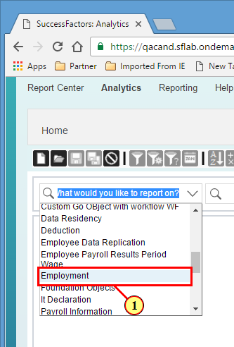
(1) Click .

SuccessFactors: Analytics – Advanced Reporting
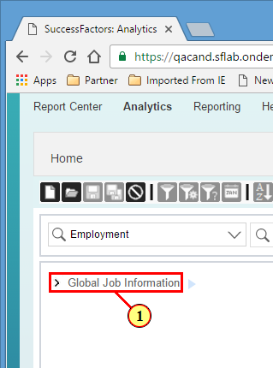
(1) Click .
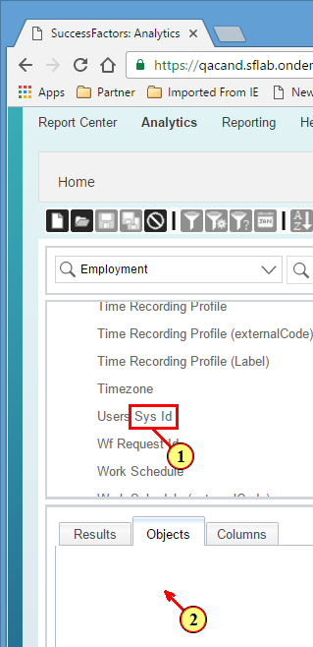
(1) Drag .
(2) Drop on .

SuccessFactors: Analytics – Advanced Reporting
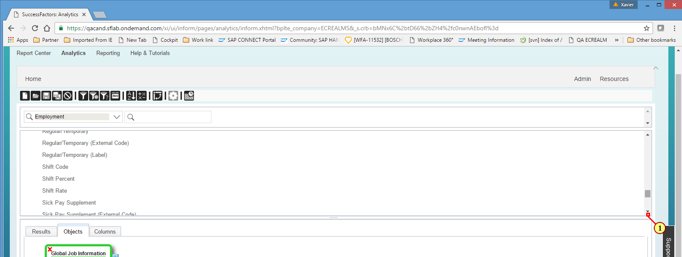
(1) Scroll Mouse wheel up to bring the screen to desired location

SuccessFactors: Analytics – Advanced Reporting
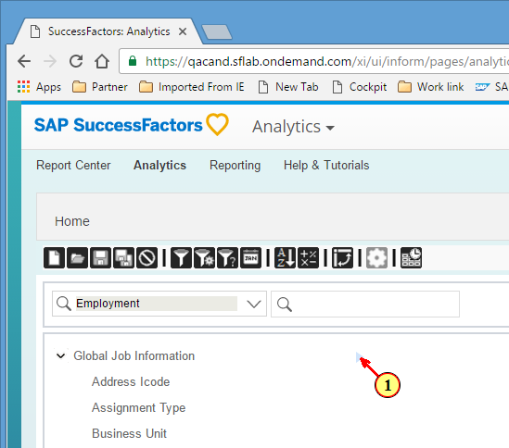
(1) Click here .

SuccessFactors: Analytics – Advanced Reporting
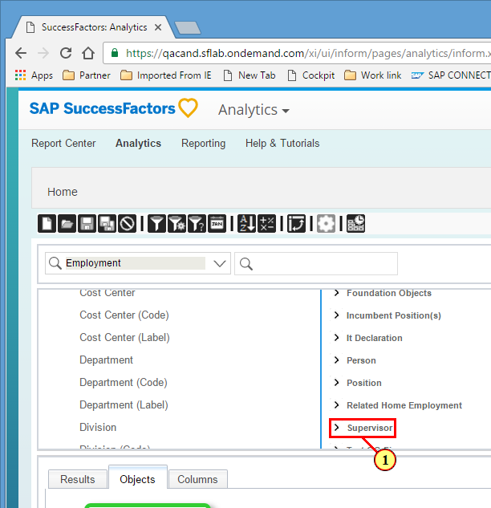
(1) Click .

SuccessFactors: Analytics – Advanced Reporting
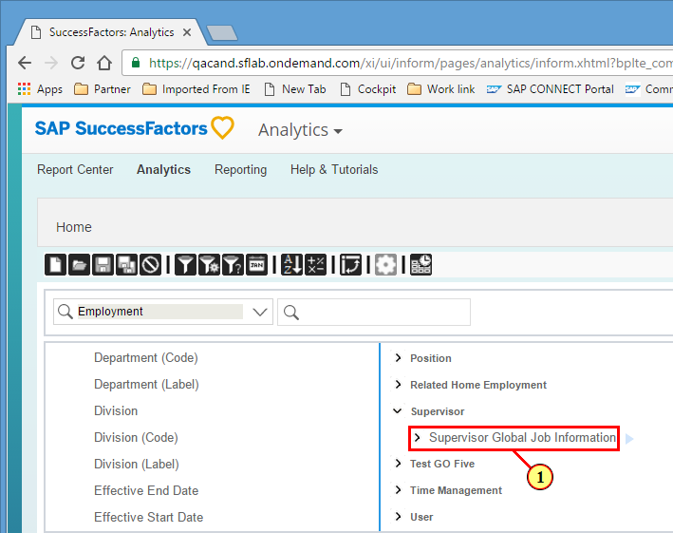
(1) Click .

SuccessFactors: Analytics – Advanced Reporting
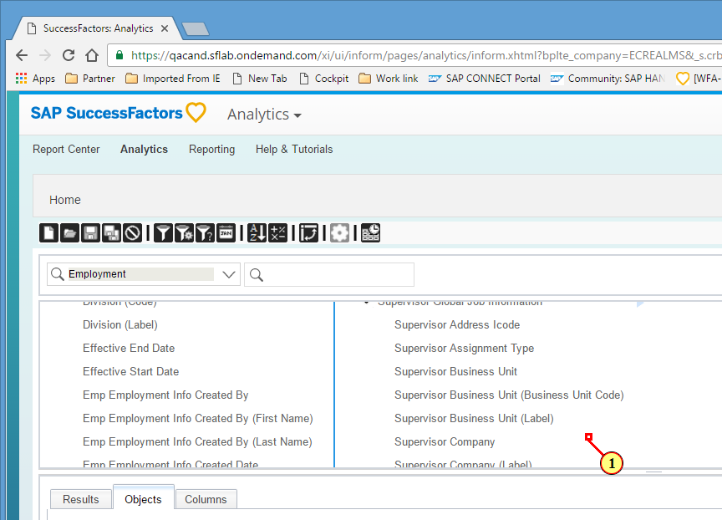
(1) Scroll Mouse wheel down to bring the screen to desired location

SuccessFactors: Analytics – Advanced Reporting
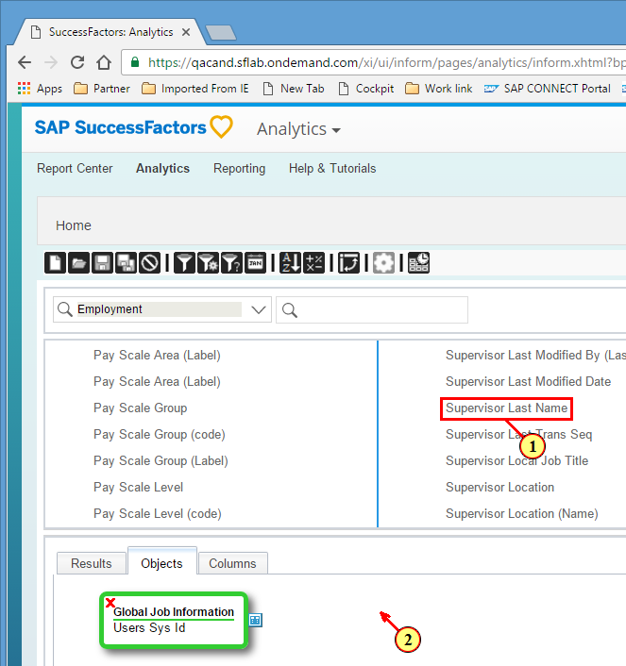
(1) Drag .
(2) Drop on .

SuccessFactors: Analytics – Advanced Reporting
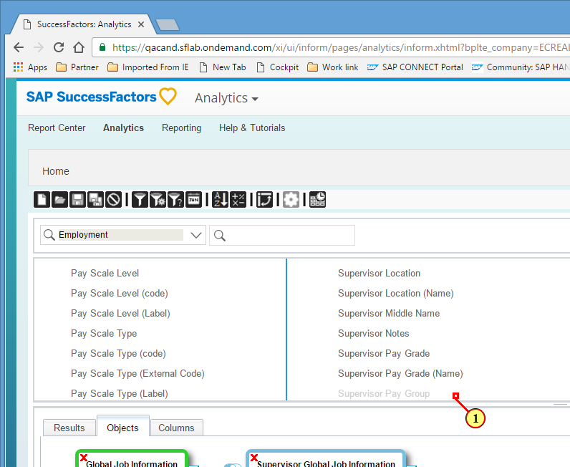
(1) Scroll Mouse wheel down to bring the screen to desired location

SuccessFactors: Analytics – Advanced Reporting
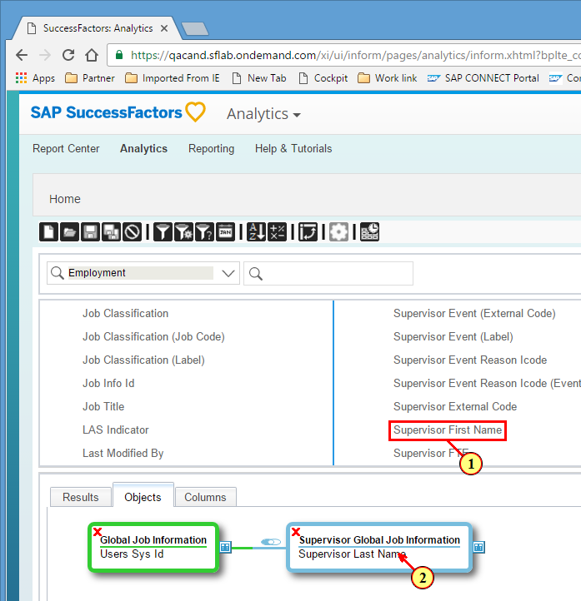
(1) Drag .
(2) Drop on .

SuccessFactors: Analytics – Advanced Reporting
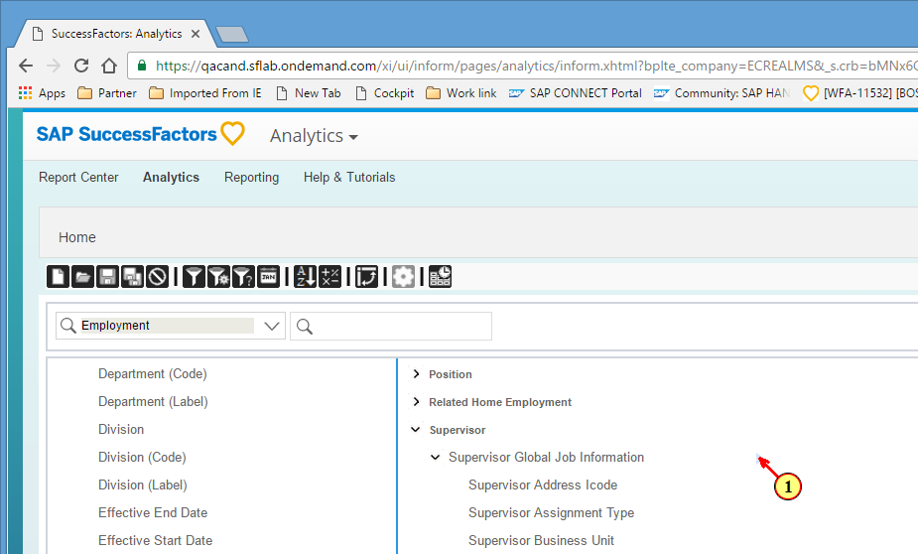
(1) Click here .

SuccessFactors: Analytics – Advanced Reporting
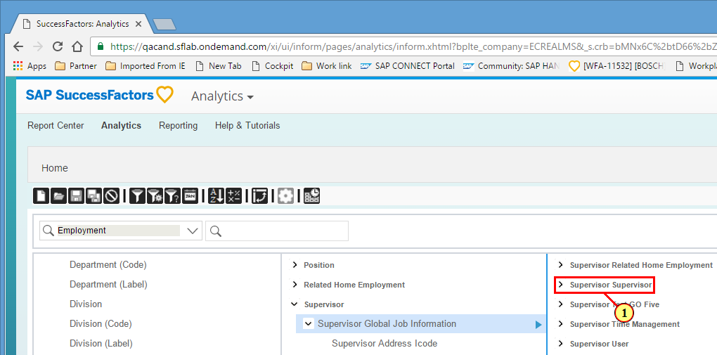
(1) Click .

SuccessFactors: Analytics – Advanced Reporting
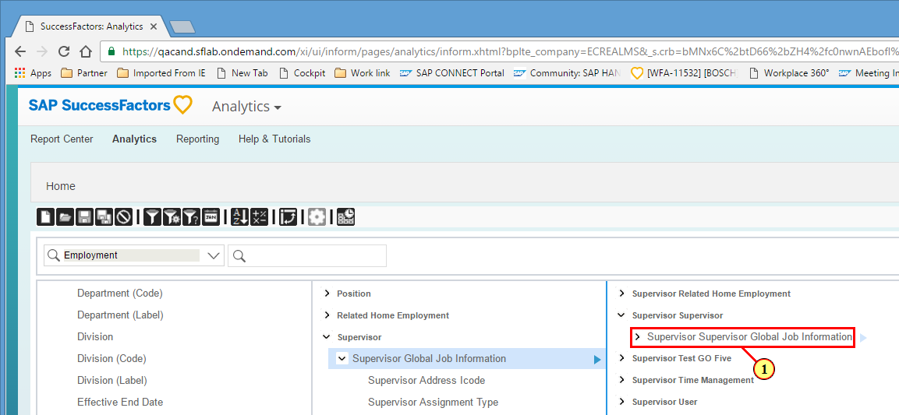
(1) Click .

SuccessFactors: Analytics – Advanced Reporting
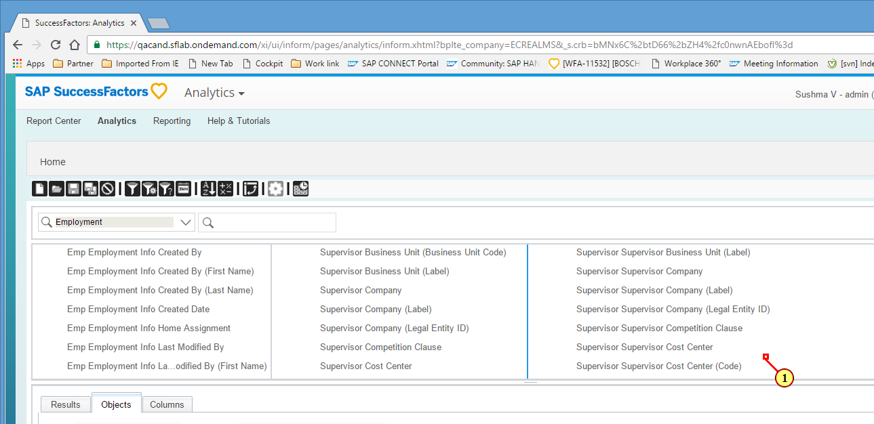
(1) Scroll Mouse wheel down to bring the screen to desired location

SuccessFactors: Analytics – Advanced Reporting
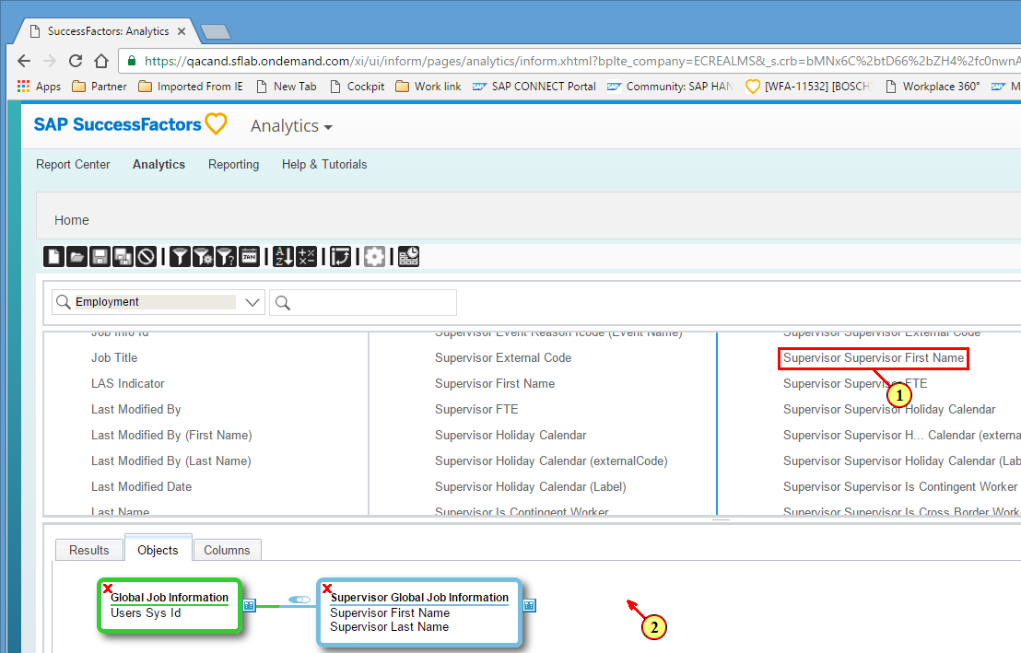
(1) Drag .
(2) Drop on .

SuccessFactors: Analytics – Advanced Reporting
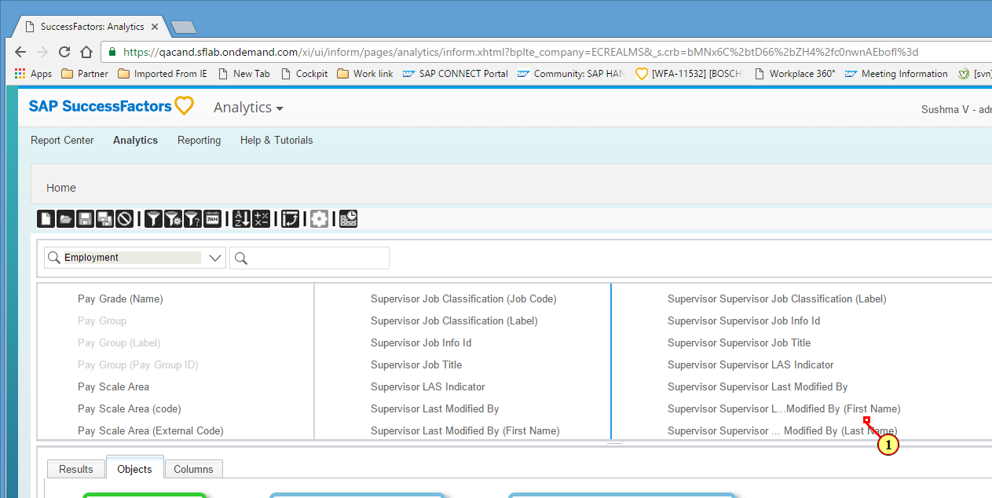
(1) Scroll Mouse wheel up to bring the screen to desired location

SuccessFactors: Analytics – Advanced Reporting
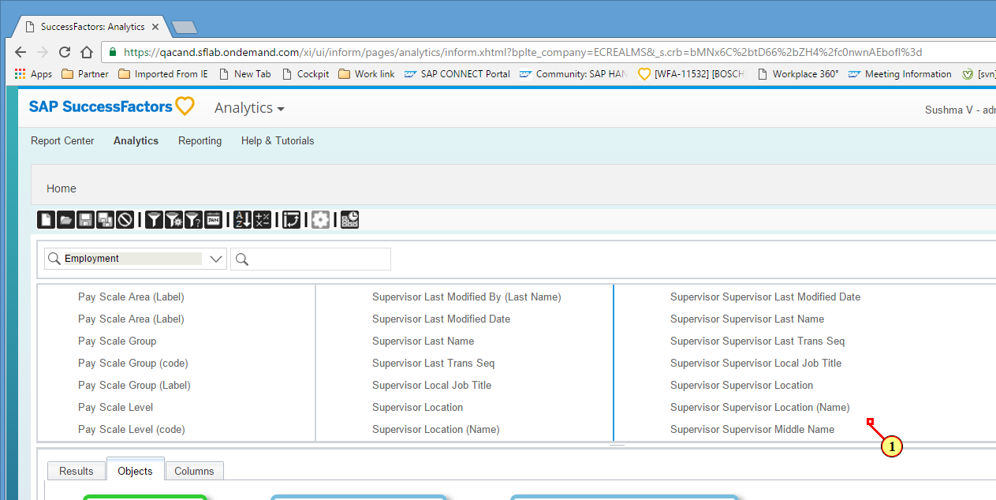
(1) Scroll Mouse wheel down to bring the screen to desired location

SuccessFactors: Analytics – Advanced Reporting
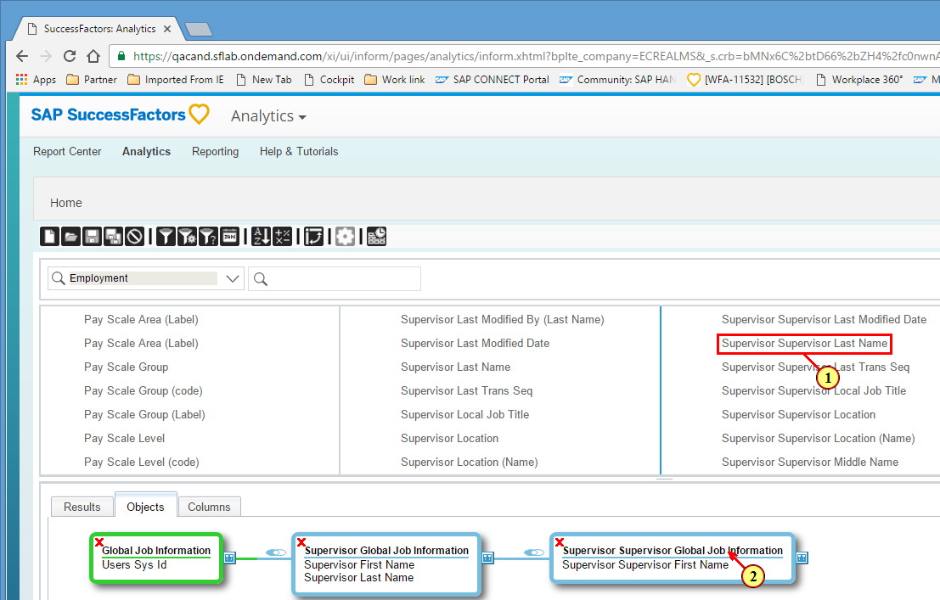
(1) Drag .
(2) Drop on .

SuccessFactors: Analytics – Advanced Reporting
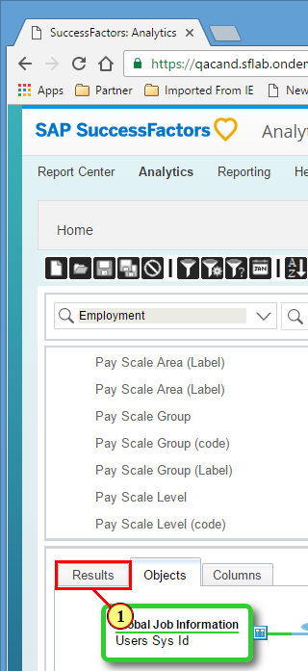
(1) Click .

SuccessFactors: Analytics – Advanced Reporting
You can now save your query and/or bring additional other fields from other tables to finish your query.
