Steps for currency conversion
Symptom:
- Currency conversion is not working

Resolution:
- Go to Admin Tools -> click on ‘Back to old Admin Tools’
- Click on Manage Currency Conversion Rate Tables
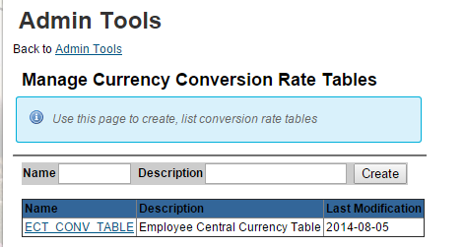

- Click on ECT CONV TABLE
- Click on ‘Export’ to export the excel
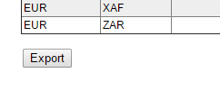
- Enter ‘USD’ in first column and ‘JPY’ in second column and enter the current equivalent unit
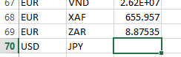
- Save the file without changing the file name
- Import it and verify it in test environment.

