WFA – To Edit a Custom Member/Set that has broken.

Symptom:
A report breaks after a refresh. After validating the report, you will see the Error message:
“Customer Set xxxxxxx has validation errors”

Why does this occur?
Custom Members and Sets break when there has been a change in the nodes in the original Dimension.

For example the original Age Dimension includes
<20
21-25
25-30

Then with a refresh, it is decided that the organisation no longer requires the <20 node, and they now group this with the 21-25 node to create a node called <25.
However, the Custom Member/Set still contains the node <20 and 21-25, as per the original dimension. The custom member/set will need to be amended to work again. They are not dynamic and will not pick up the changes made to the original dimension.

To fix this issue:
Go to Analytics>Analytics>Query Workspace
Edit
Edit Custom Measures/Dimensions
Then select the broken Measure/Set from the Analytics Tab on the left of screen
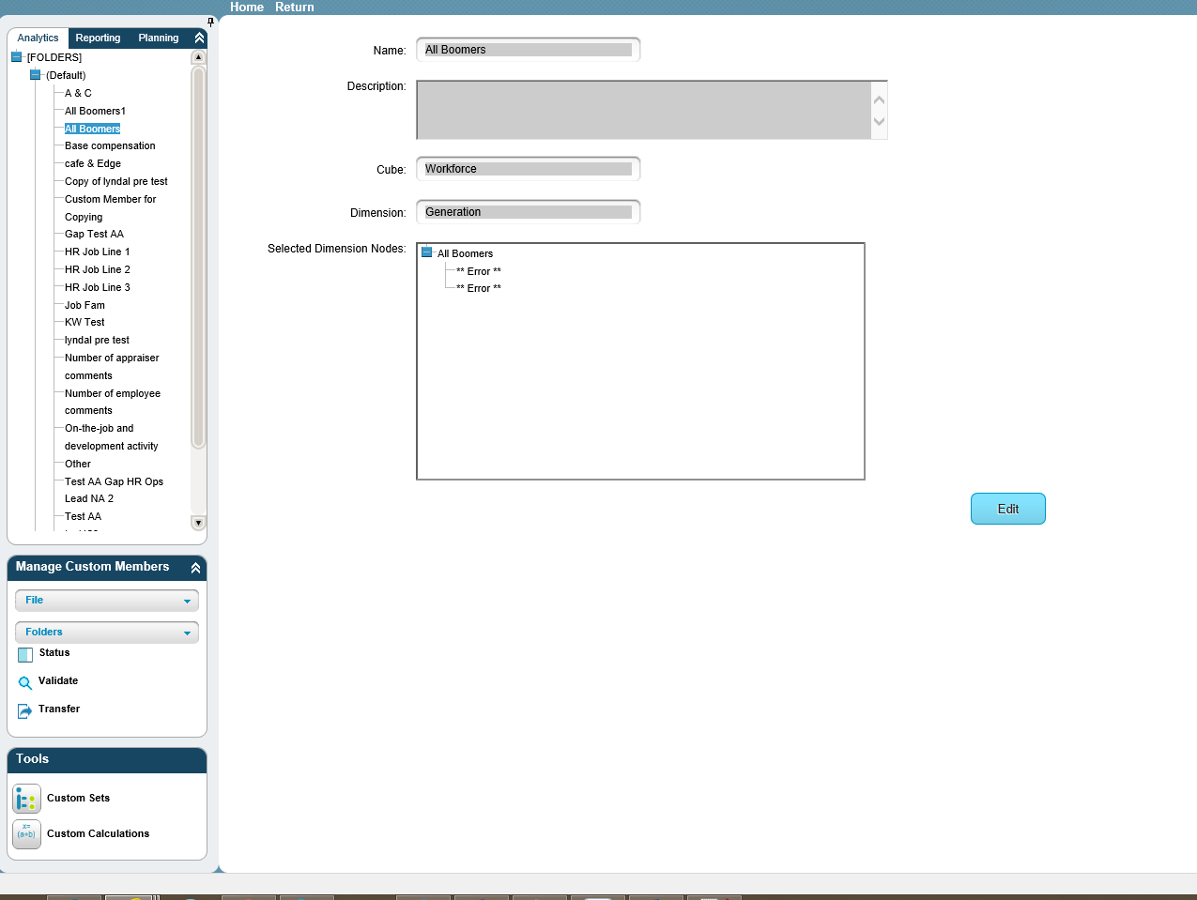
Click on the Edit button
Click on the “Paths” tab
Click on the “Remove All” link
Then drag on the nodes that are required.
Click OK
Then click on “Return” at the top of screen
This is now fixed.

