Employee’s Profile / Position

1. Go to Manage Job Profile Acknowledgement Settings and set the triggers.
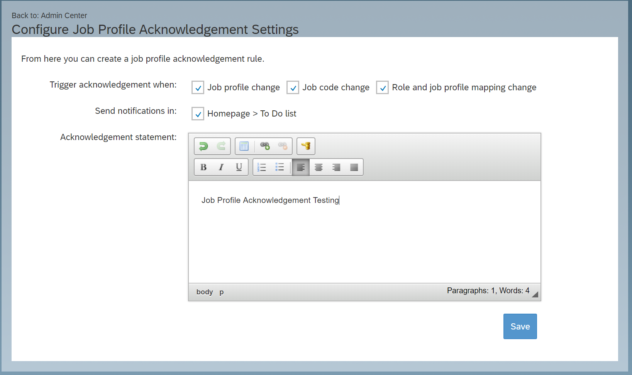

2. Make changes in the Position Based Job Profile

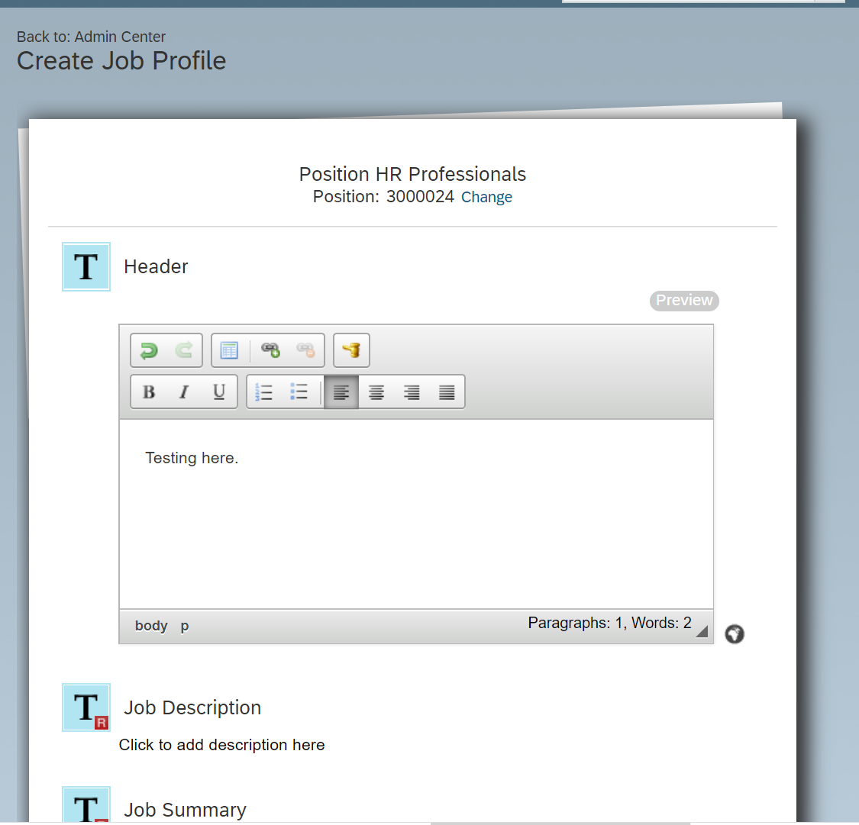

3. To Do has no Pending Approval for Job Profile Acknowledgement Settings.

