Issue: Adhoc Report provide numbers instead of the labels from Employee Profile (performance / Potential Portlet)

This is the Employee Profile > 9Box Placement is Emerging Potential
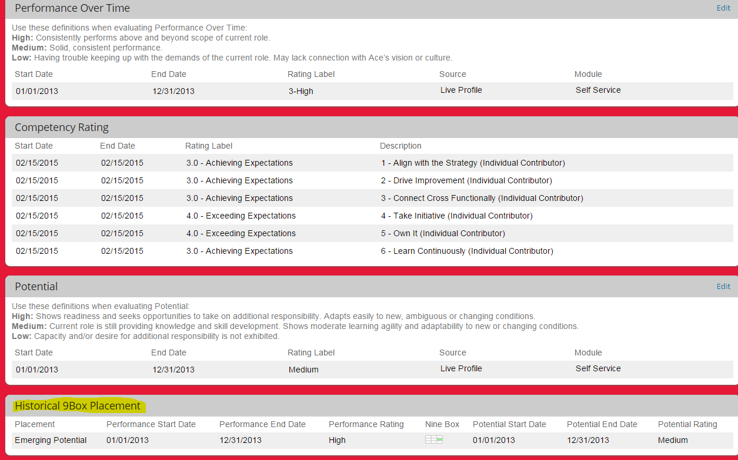

If you use the Employee Profile Report you will only get Values indeed the 9Box Report will only use the information related to 9Box placement (1-9)

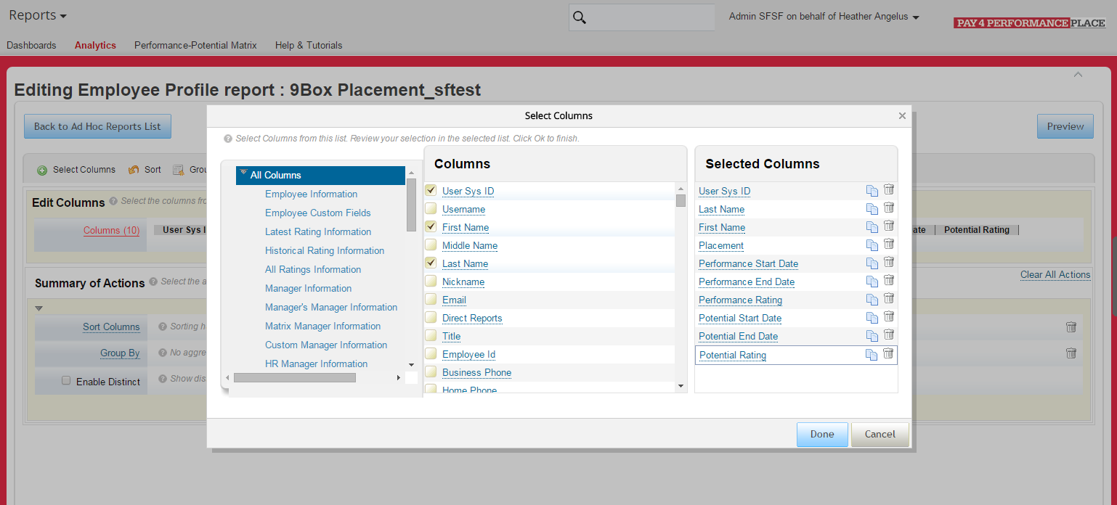
For the 9Box Placement you will receive a number from 1 to 9

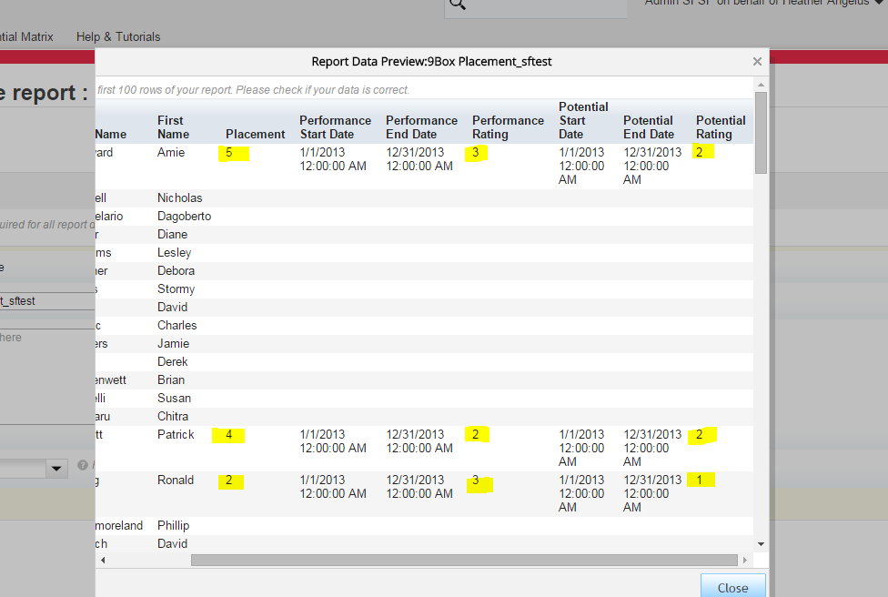

This is Expected behaviour
If customer wants to see the Labels use the Succession by Position Report

