Recording Diagnostic Information via Webmeetings, Screenshots and HttpWatch

- Screenshots
  - How to collect server information
  - How to collect browser information
- HttpWatch
- Webmeetings/GotoMeeting
- Model example of capturing screenshots

Capturing Step-by-Step Replication in Screenshots

The most helpful practice that helps Support resolve issues quickly is the use of clear step-by-step screenshots of the issue. When the steps leading up to an issue, and including the issue are fully captured in screenshots, Support can not only quickly replicate the issue, but also has a record of the issue that will be shared with SuccessFactors Engineers to review. For screenshots to be most helpful do not simply capture the error itself, and crop the image, as that provides no context on how the error occurred and will not typically help support replicate the issue, which is the first step towards successful resolution.

Please take note of the step-by-step screenshots we have in this document explaining the use of HttpWatch and Recording Webmeetings. These are good examples of how you might use screenshots to document and comment on your issue in a word document.

Open a Microsoft Word. Copy & paste into this word doc screenshots of the issue (full screen – not cropped) then attach your document to the case.
It is helpful for screenshots to contain:
- Server Info & timestamp of test (see screenshots below)
  - In v10 this can be found in the footer of most pages
  - In v11 go to the home page and click on the help icon (small gray question mark icon just below menu bar top right) and then > About SuccessFactors. You can also find it on other pages by viewing the html source code.
- Also include the browser versions being tested. (Comparative tests using multiple browsers and versions is strongly recommended for most issues)
- A brief explanation for each screenshot that clarifies what aspects of the shot we should take note of.
- Shows the usernames involved and who I might need to proxy in as
- Steps leading up to the issue so we quickly understand how to replicate
- Comment on what might be missing if that is the issue
- When showing comparisons, explain what differences you are highlighting
- We ask that you don’t crop the screenshots, just leave full screen as there are many other elements on the page that we may want to take note of that help us in troubleshooting.

How to Collect Server Information and Timestamp
- Ultra: When the customer login to Home Page of SuccessFactors application, they can obtain the server info by navigating to Help Icon. (Home PageHelp Icon About SuccessFactors). Please refer to Figure 1.
[put answers above]
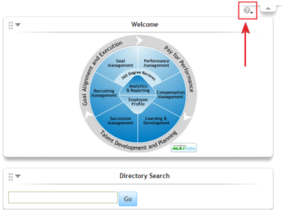
Figure 1: Help Icon for Ultra
After clicking on the “About SuccessFactors” icon, customer can see a popup window. The server and timestamp information are shown in the Figure 2. Please take a screenshot and send the information to SuccessFactors.
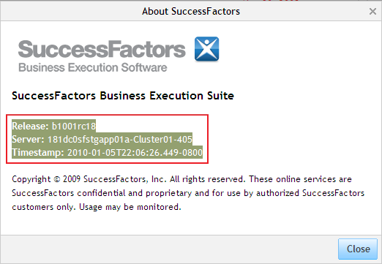
Figure 2: About SuccessFactors Screen.
V10 Clients: You can find this information at the bottom of most pages as shown below. Please copy & paste the SuccessFactors application server information in the page footer at the bottom of the SuccessFactors screen.

How to Collect Browser Information
We recommend for most issues that you run multiple tests using various browsers to get comparative test results. Check Browser Version: Help > About (capture screenshot)
What version and flavor of the browser is used?
(e.g. IE 6.0 SP1 or Firefox/2.0.0.4):

Recording Web Meetings – When to Use and What Not to Do
- Along with the best practices above that speed up troubleshooting, take care to avoid the following which can hinder and slow down progress
- DON’T rely on just a webmeeting recording! Always provide supporting screenshots.
- Recordings can be helpful in the case of showing slowness or some real-time processing issue, but are NOT required for simple issues that can be sufficiently demonstrated with screenshots.
- DON’T just take a recording, because “it’s easier” for you to do than creating screenshots.
  - It may be easier for you to record, but since recorded movies become very large, they are often difficult to use. Recordings may be so big you cannot even attach to a case or JIRA.
  - Recordings are hard to follow and tend to include other activity that is unrelated to the issue and therefore misleading and confusing to the watcher.
  - Watchers can’t hear the phone discussion that often accompanied the web recording and without that it’s often very difficult to understand events.
- If you do need to attach a recording, be sure to include detailed notes that clarify it’s purpose and include timestamps of the events to watch for. It’s not always intuitive what specifically you want the watcher to take note of, so you must provide very detailed notes along with your recording when including these.

The Instruction of HttpWatch
- Overview
HttpWatch integrates with Internet Explorer and Mozilla Firefox to provide unrivalled levels of HTTP monitoring. It is very useful to collect performance diagnostic information by using HttpWatch.
- where to download
HttpWatch Basic Version can be downloaded from:
http://download.httpwatch.com/httpwatch.exe
- how to install
  - Run the httpwatch.exe file, and click Next to proceed.
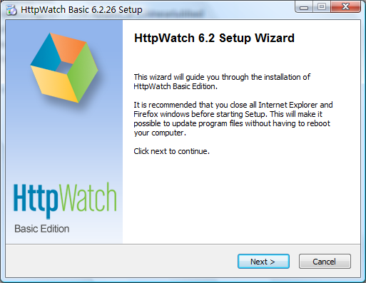
  - Review the license agreement, and choose I Agree.
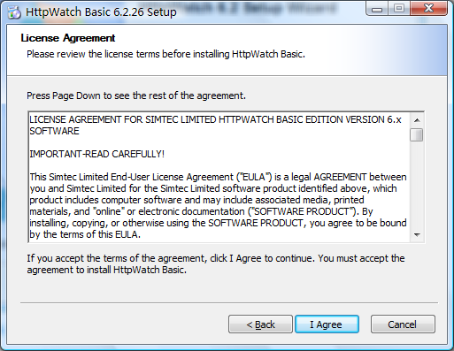
  - HttpWatch plug-in to Firefox can be optional.
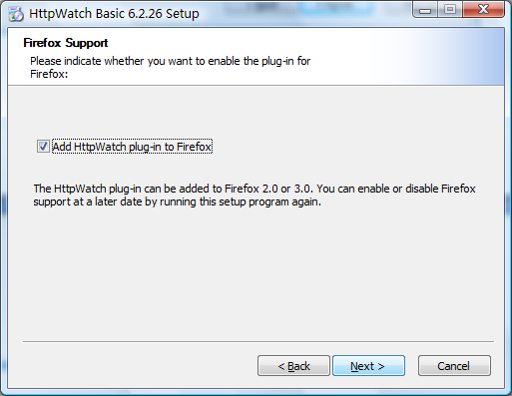
  - Choose install location, and click install to start the installation.
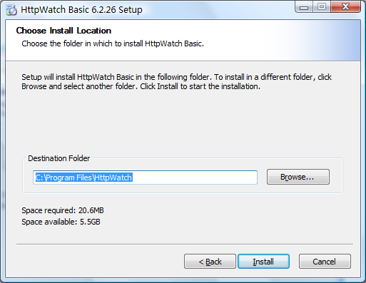
  - Finish the installation.
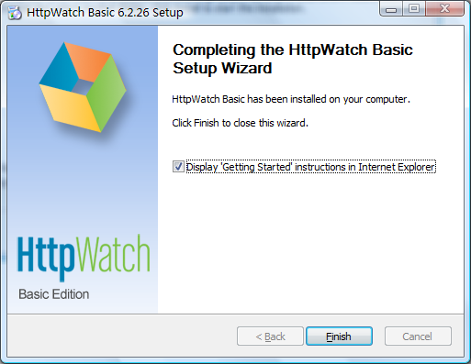
- How to enable HttpWatch in IE
After the installation, HttpWatch plug-in is installed in Internet Explorer, and optionally in Firefox. The HttpWatch plug-in can be displayed in the lower part of the Internet Explorer (IE) window by using one the three methods shown below:
1. Click on the HttpWatch toolbar button which is normally on a hidden part of the IE command bar. You need to click on the toolbar chevrons (>>) before clicking on the HttpWatch button:
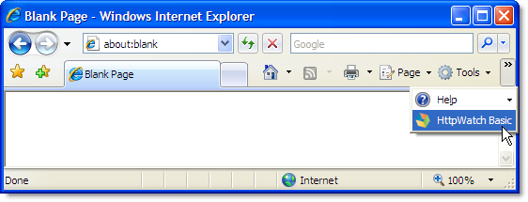
If the HttpWatch button is not in the IE command bar you can use the Tools->Toolbars->Customize... menu item to make it visible (see the Customizing the location of the HttpWatch Toolbar button section below).
2. Select it from the Tools->Toolbars->Explorer Bar menu:
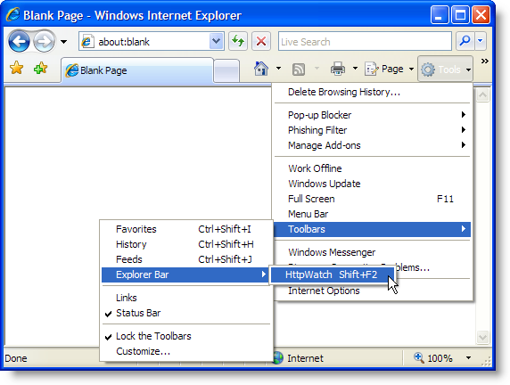

3. Use the shortcut key, Shift+F2, within Internet Explorer.
If none of these options open the HttpWatch window, please restart Windows.
- When to click on Record(just before the slow actions)
  - Navigate to the page that contains the link to the slow action, e.g.
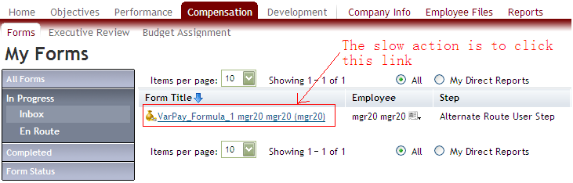
  - Open HttpWatch, and press the Record button.
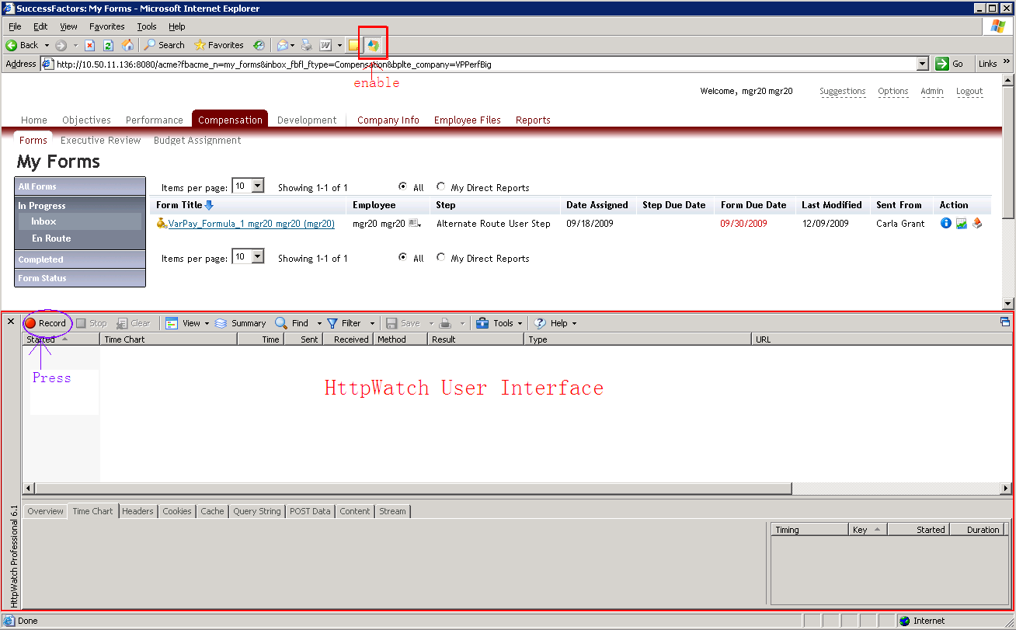

  - Click on the link and trigger the slow action.
- When to stop
  - Make sure: ①No more downloading resources in the Request Grid of HttpWatch. ②IE shows “done” status. ③The progress/loading bar in the bottom right of the status bar which shows the loading of the page disappears.
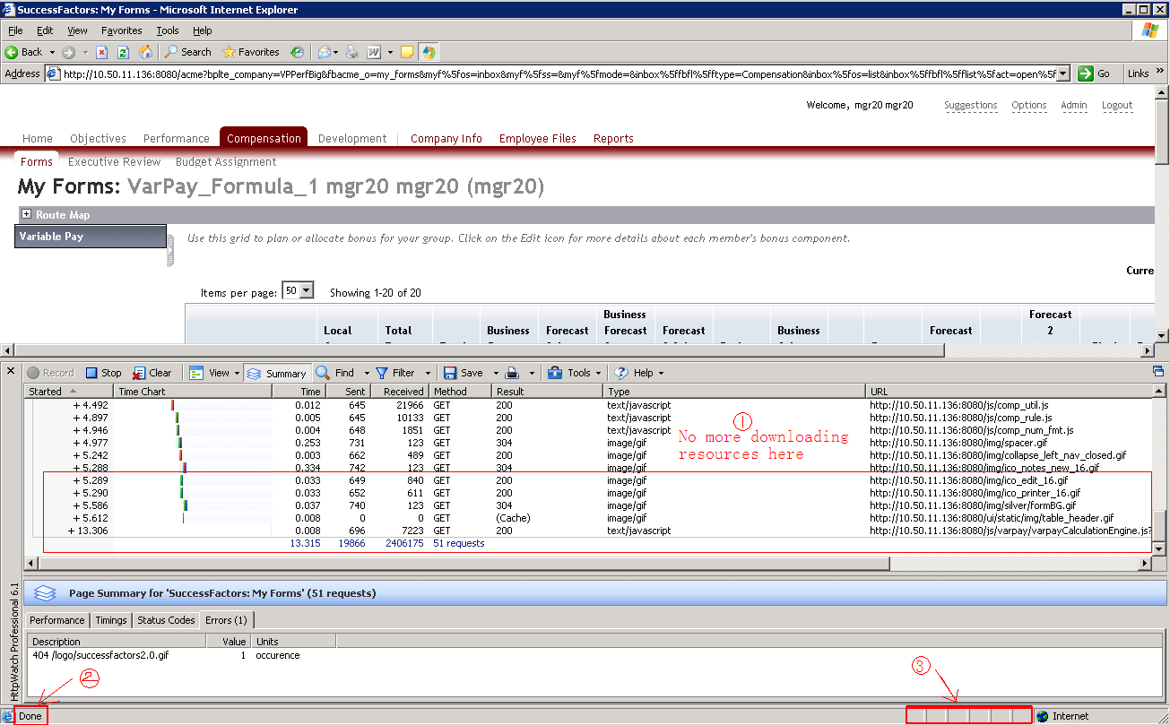

  - Press the Stop button.
- How to save
  - Press the Save button.
  - Choose File name & Save location, and click Save with default save type (*.hwl).
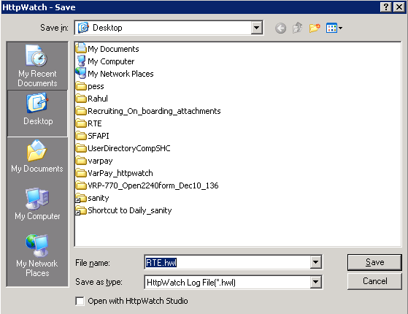

Recording GoToMeeting session.

To start recording follow the steps below.
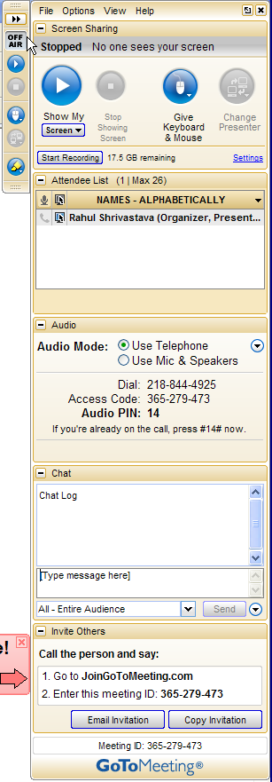
In order to do a voice recording, please dial into the number provided in the “Audio Mode” setting.
Step 2 - Click on the “Show my screen to attendees”.
Step 3 - Click Start Recording. When finished, click the same button to stop recording. In order to locate the recorded file, open directory that you provided in step 1 (see Figure 16).
Step 1 - Click on setting which will open Figure 16. Pick right setting options and click ok.
Figure 15: GoToMeeting screen sharing
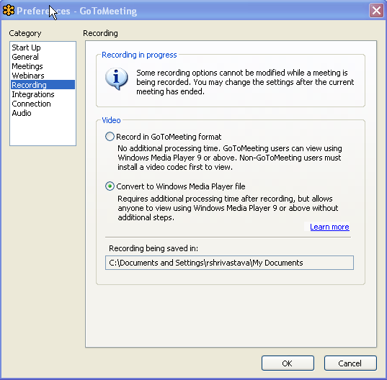
Make changes to video format and directory setting if needed.
Figure 16: Recording option

Model Example of Capturing Screenshots When Replicating Issues

RN Case #: 091223-000081
Customer Name: Lisa Pogue, Edison Mission Energy

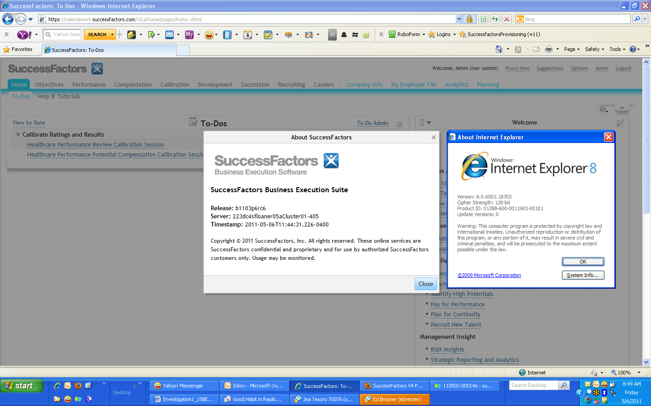

Release: b0911ip4erc3
Server: 23dc4sfapp03aCluster01-405
Timestamp: 2009-12-23T16:16:12.541-0500

- Checked their existing User Data File to check for employee eligibility

- Saw employee Amy Gattoni, she is ineligible for both Base and LTI

- Checked Executive Review, on the Base tab, Amy’s name appears under the “Name” column

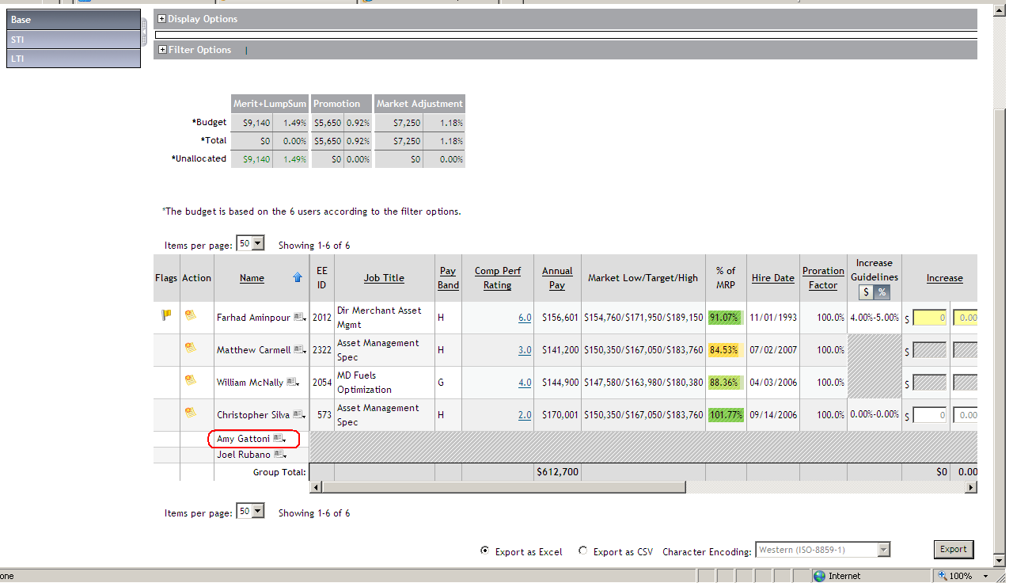

- On the LTA tab, Amy’s name appears under the “Action” column

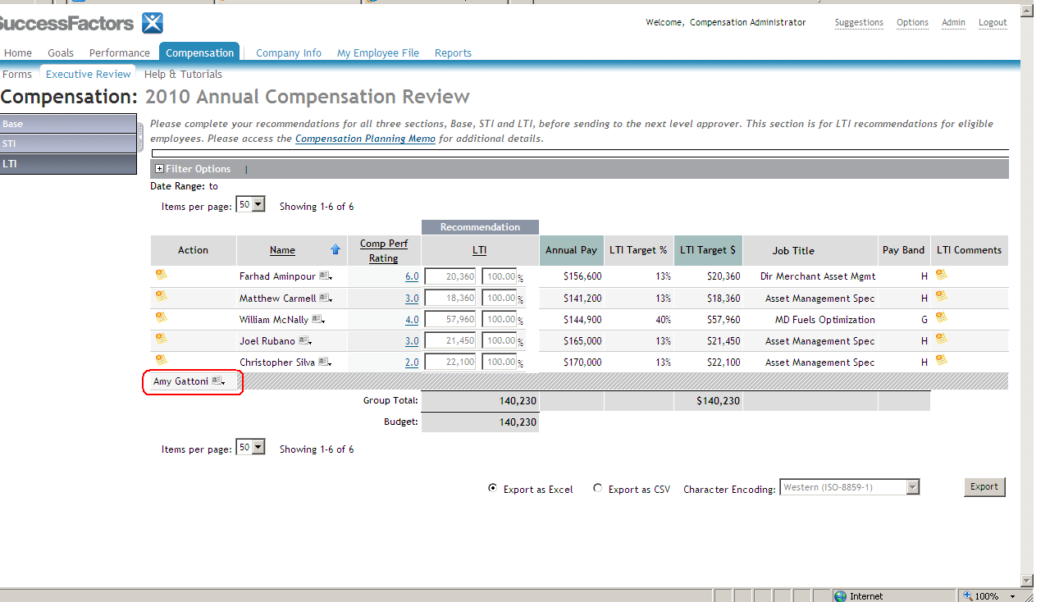

- Uploaded the Annual Compensation Review on my ACE Instance: TIER2CSA016

- Downloaded my user data file and modified cgrant’s team
mhoff – Salary Enabled = False
– Stock Enabled = False
– Bonus Enabled = False
- Genearated a test 2010 Annual Compensation Review for cgrant’s team: TEST_ANNUAL_COMP_REVIEW – ID: 5501

- Checked the form through the Compensation Tab. The names of the ineligible employees for Base, LTI and STI appear under the Name column.

Base

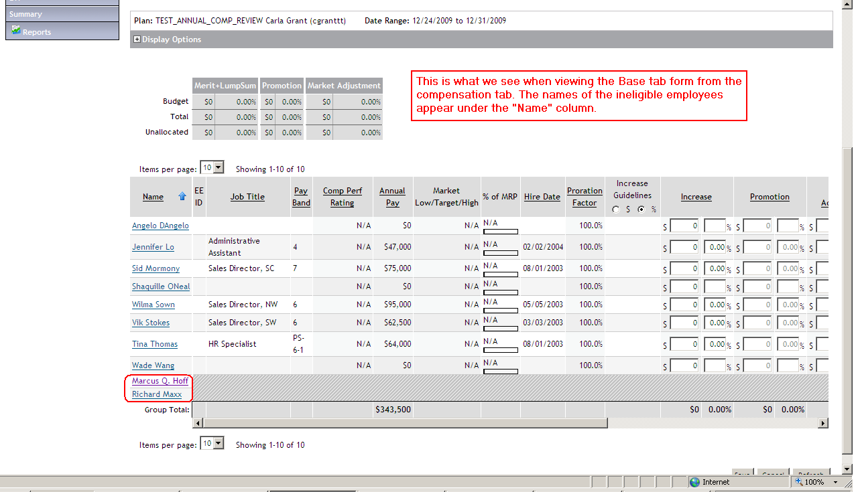

STI

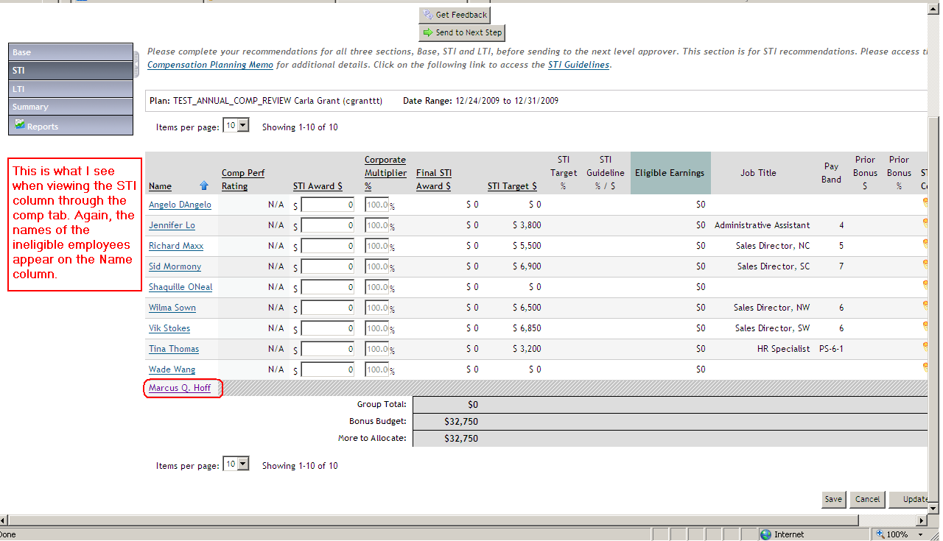

LTI

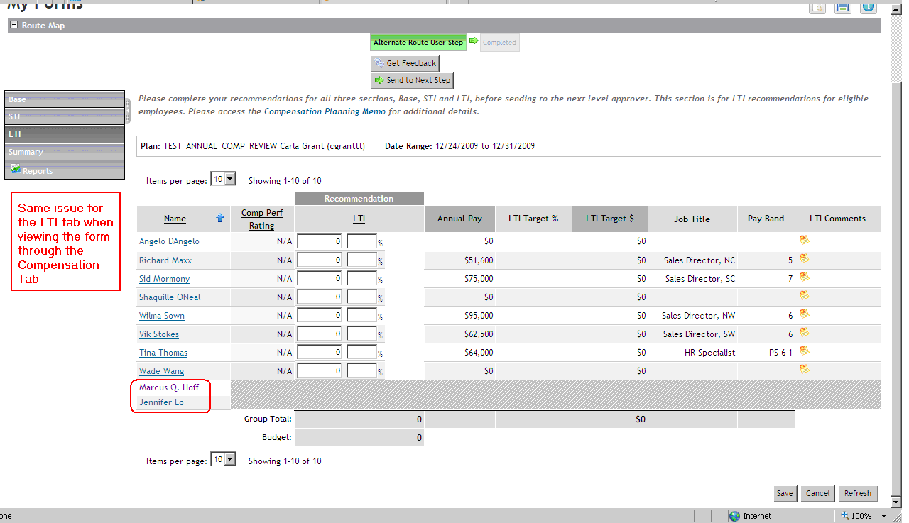

- Checked the form through Executive Review.

Base
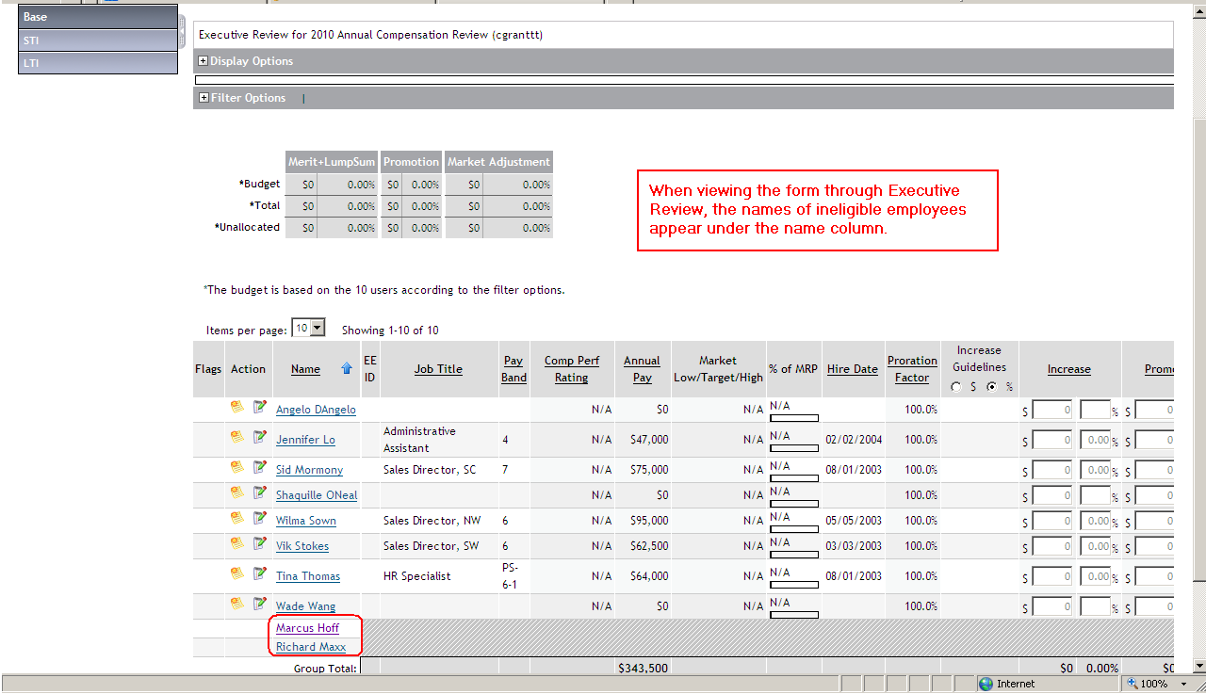
STI
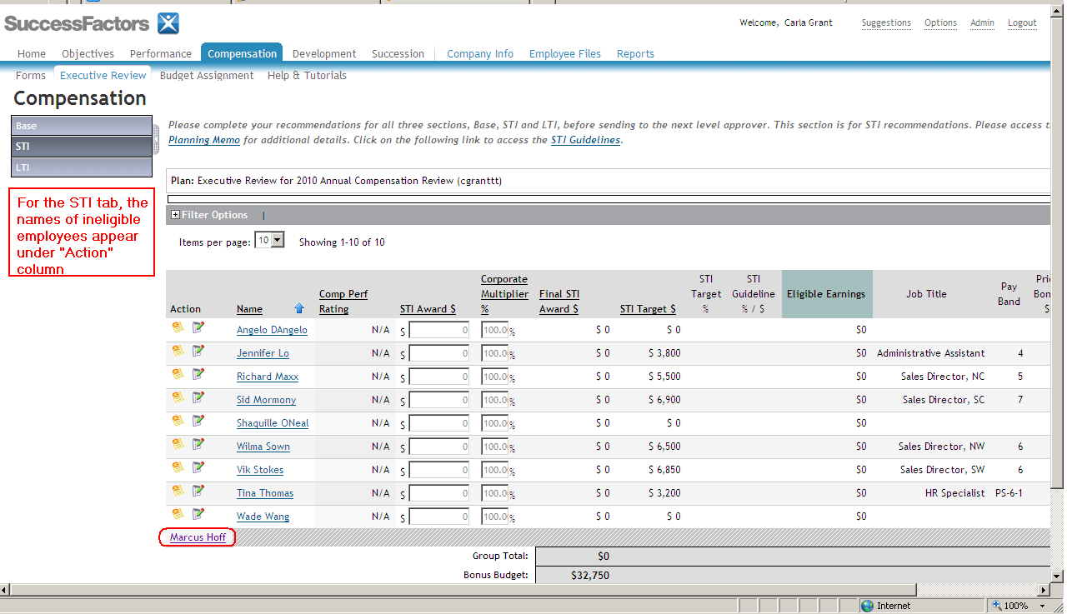
LTI

