In Admin Tools / Manage Organisation, Pay and Job Structures we can set up a Workflow with Collaborative Workflow.
Contributor and CC Role have been added.

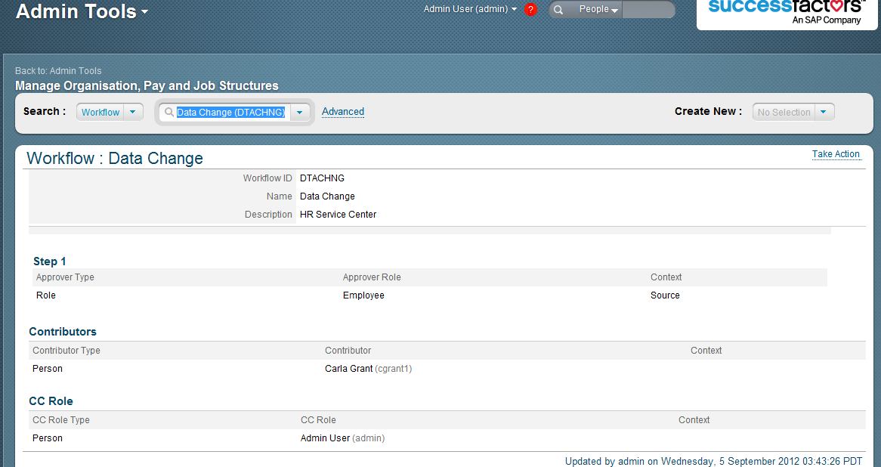

A data change is made which triggers the approval chain.
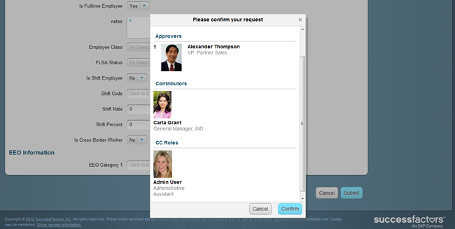

The Collaborative Workflow Contributor Carla Grant is notified
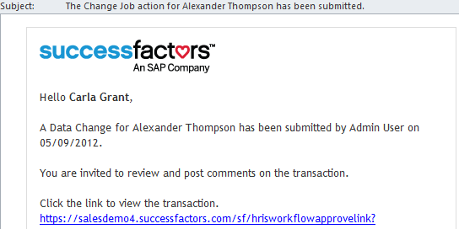

and Carla Grant has the item in notifications

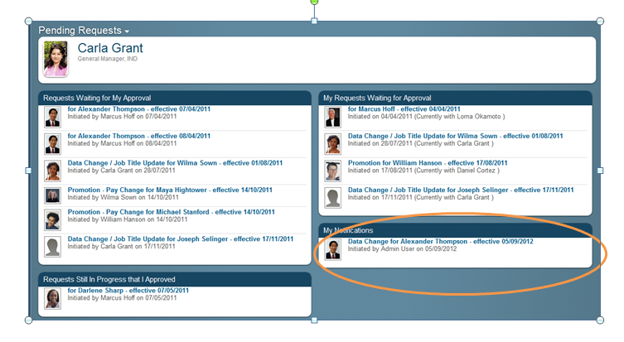

And comments can be added by Carla but she cannot approve

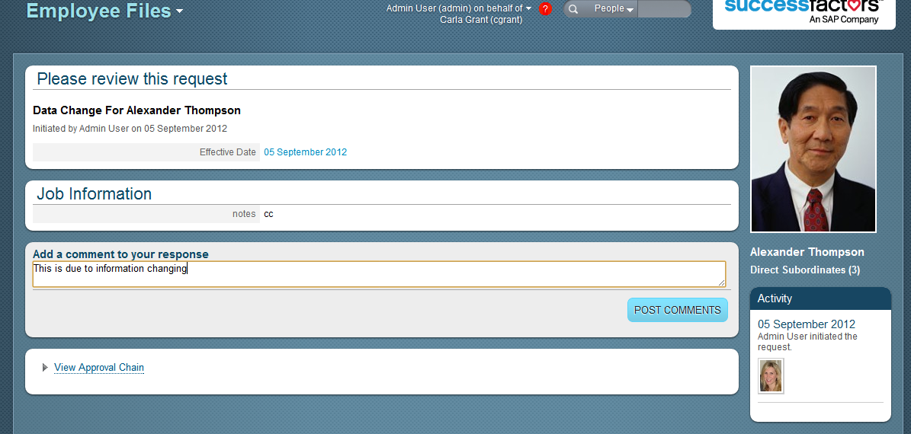
Alexander, the approver, approves the item. Note he can see Carla’s comments on the right hand side
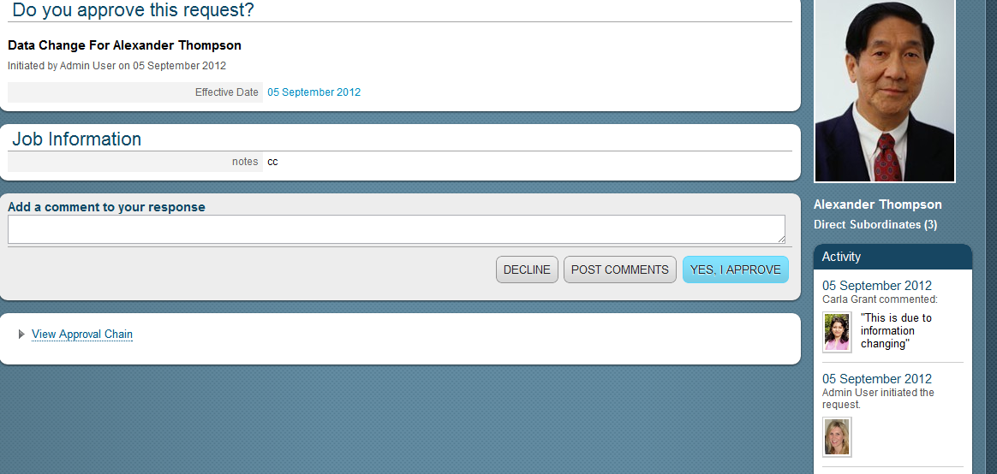

And the Collaborative Workflow CC (Admin user) gets notified and can view the item too

