Fiddler tutorial

This tutorial shows the process of capturing network traffic using the Fiddler tool.

1 - Requirements

Fiddler runs only on Windows
You need to have .NET Framework installed, if not, you can download it on Microsoft website http://www.microsoft.com/en-ie/download/details.aspx?id=17851

2 - Download Fiddler

From http://fiddler2.com/get-fiddler
(The one supported by your .NET version)

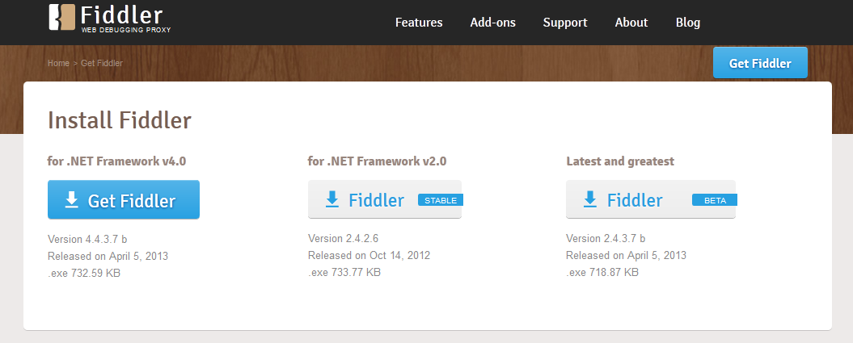

3 - Start Fiddler

-From Start menu -> Fiddler2
Or
-From Internet Explorer -> Chevron (>>)->Fiddler

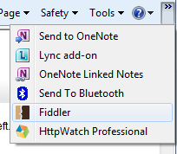

4 - Configure Fiddler

We need to enable HTTPS traffic:
-In Tools -> Fiddler Options
-Check 'Capture HTTPS CONNECTs' and 'Decrypt HTTPS traffic'

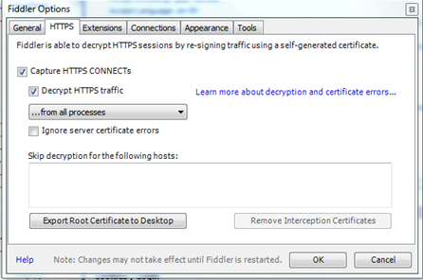

Clear original traces by pressing ‘Remove all’.

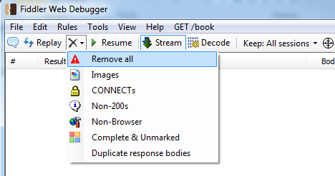

Target the right process

If you using LMS in Internet Explorer, Fiddler has to capture traces from the IE process, to do it:
-in the tool bar press 'Any Process' , it will show 'pick target' and cursor will become a cross.

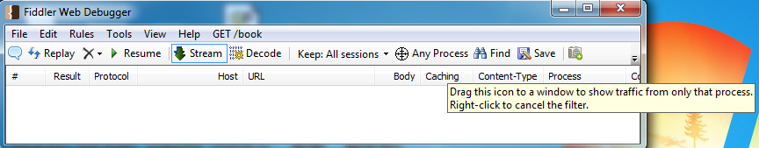

- Drag the cursor to your LMS session in IE (colour will change), 'pick target' will get the name of the process (for ex: iexplorer: 4424 )

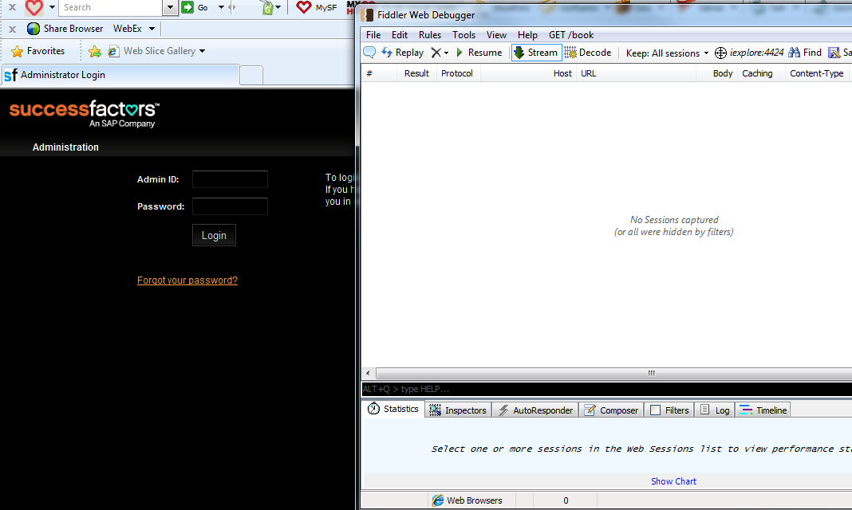

4 - Capture traces

Make sure capture Traffic is enable (F12 or File menu->Capture Traffic), you will see ‘Capturing’ in bottom left of Fiddler window.

-Reproduce your issue (ex : login to LMS)
-You should see traces populating the Fiddler pane:

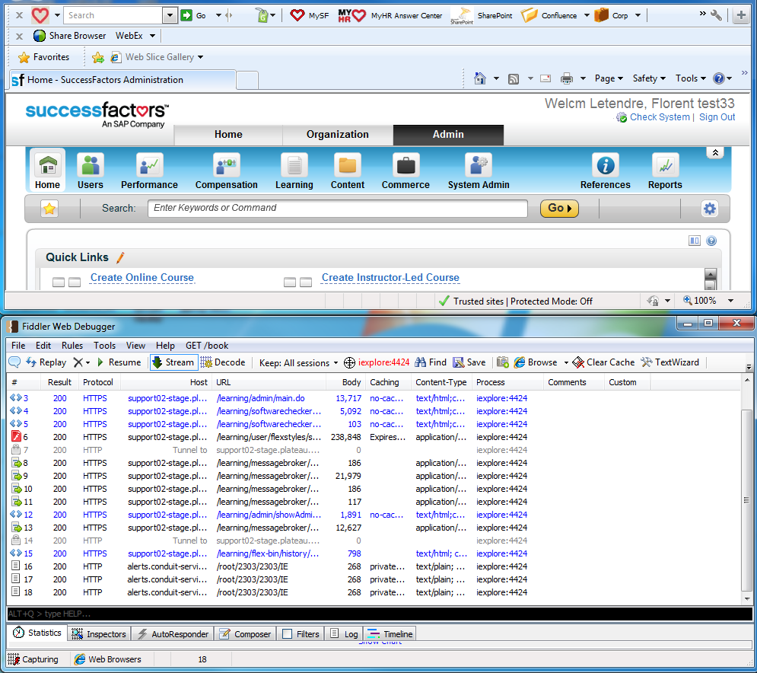

Stop traces (by pressing F12), 'Capturing' will disappear.

5 - Save
Save traces by pressing 'Save ' button, it will save them in a .saz file.

6 - Send
To send the traces to SuccessFactors support, simply attach the .saz file to your CRM case.
Thanks for your cooperation!

