Set Up and Approve Consultants for Provisioning Access
Contents
1 Overview 1
2 Setup Admin for Role Based Permissions 1
3 Create New Group 2
4 Create New Role 4
5 Approve Consultants 7

Overview
This document goes through the set up and approval process used to enable consultants for BIZX Provisioning Access. Set up requires an administrator to have basic permissions to approve consultants. By default each tenant provided to customers include one administrator with username sfadmin with no permissions.
The document creates one group to which the sfadmin user will belong and one role which includes the appropriate permissions.
The end state:
- New Role called “Approver Role” with permissions to approve consultants
- New Group called “Approver Group” which includes the default role and while includes the admin user
Additional information can found on the SAP Support KBA: 2519639 - Manage Provisioning Access Tool - BizX Platform (sap.com)

Setup Admin for Role Based Permissions
- Login using sfadmin account provided from handover email
- Use Search box top right to search “RBP”
- Select Manage Role Based Permission Access
- Check whether a) sfadmin is in the list, b) Role-Based Permission Admin is enabled
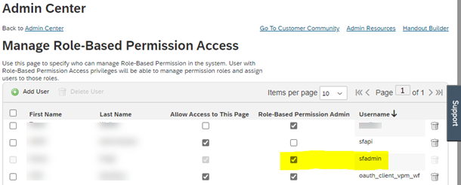
- If user sfadmin is not listed, click Add User and Grant Permission
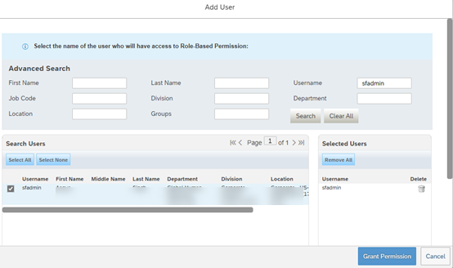

Create New Group
- Search for “Permission Group” and Select Manage Permission Groups
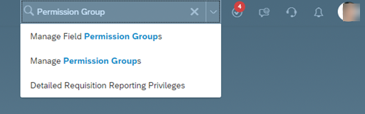
- Create New Group “Approver Group”
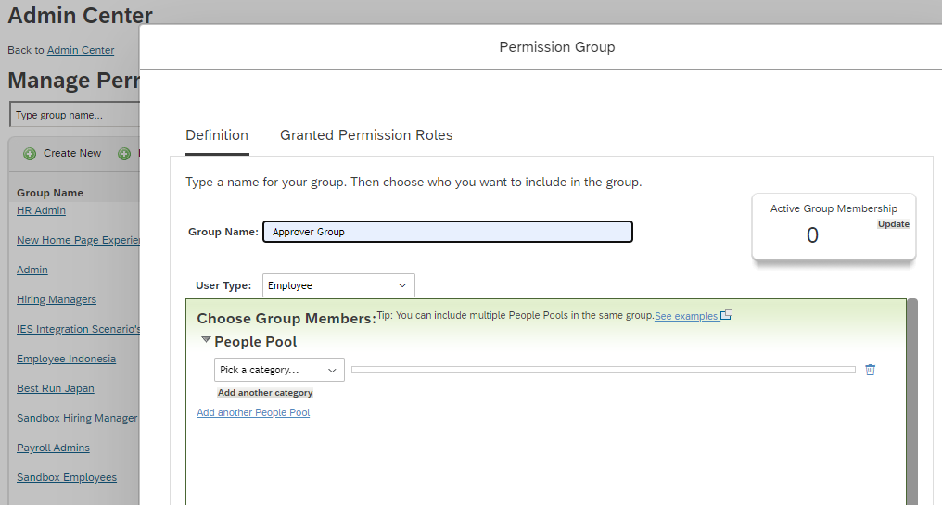
- Select Category Username from the People Pool and search for user sfadmin
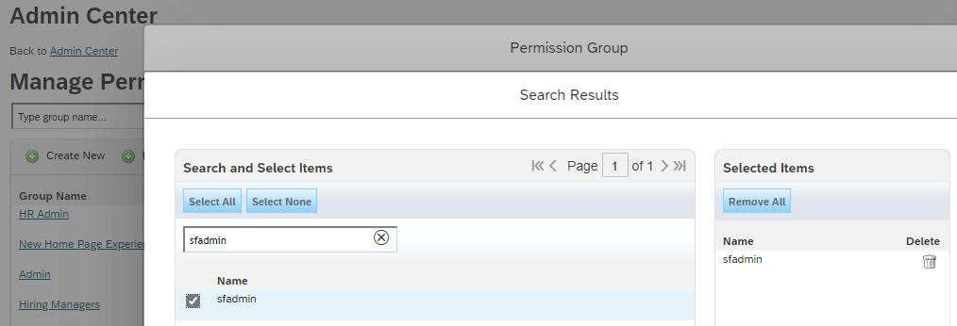
- Click Done on to finish the group creation
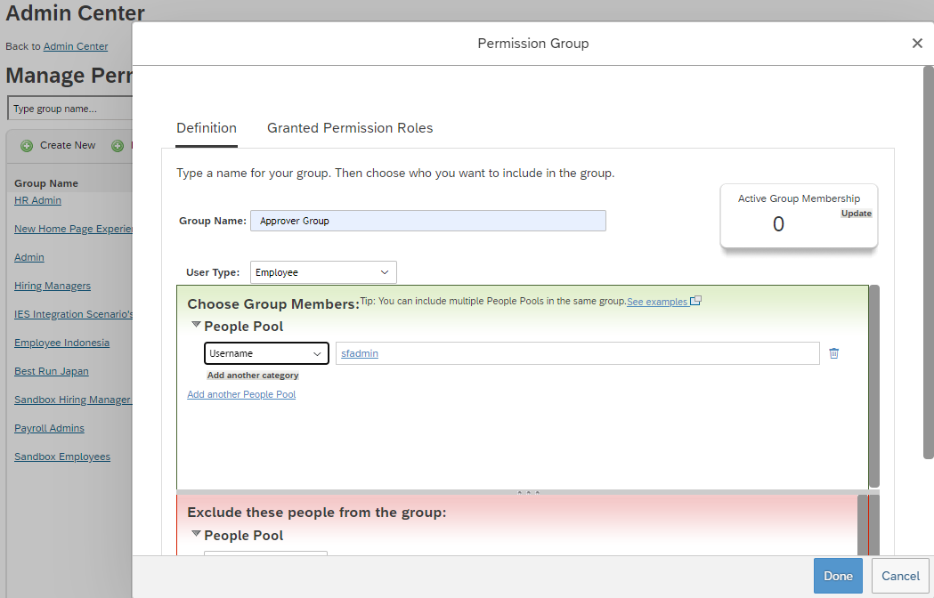

Create New Role
- Search for “Permission Role”
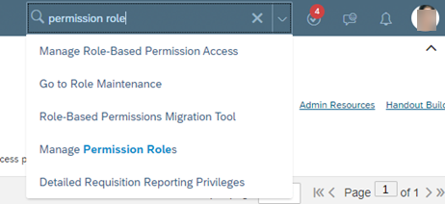

- Create New Role

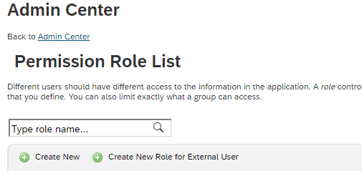
- Create Role “Approver Role” name for the Role Name and Select Permissions View Provisioning Access and Control Provisioning Access from the category Manage System Properties (You will need to scroll down the list of permission settings).
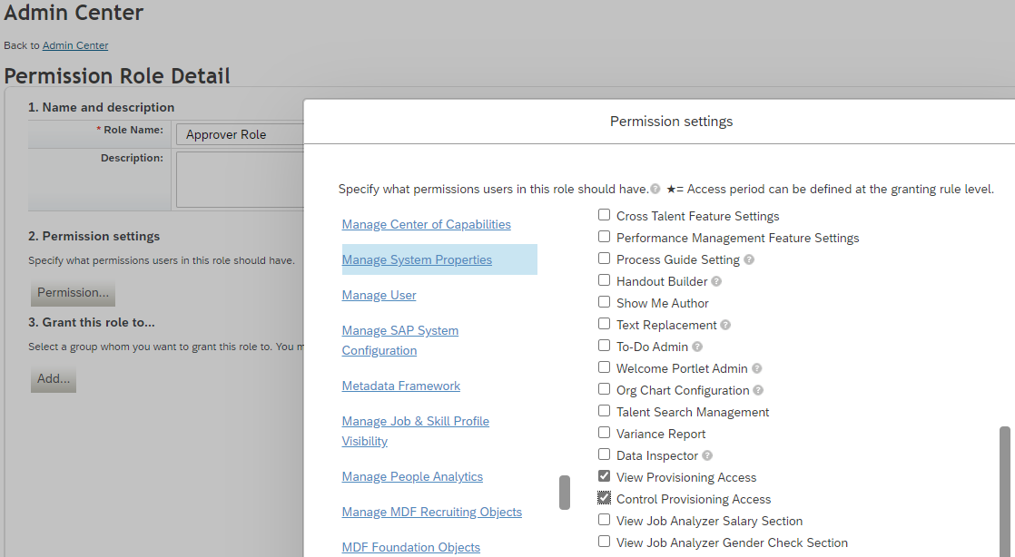
- Add the new role to the group
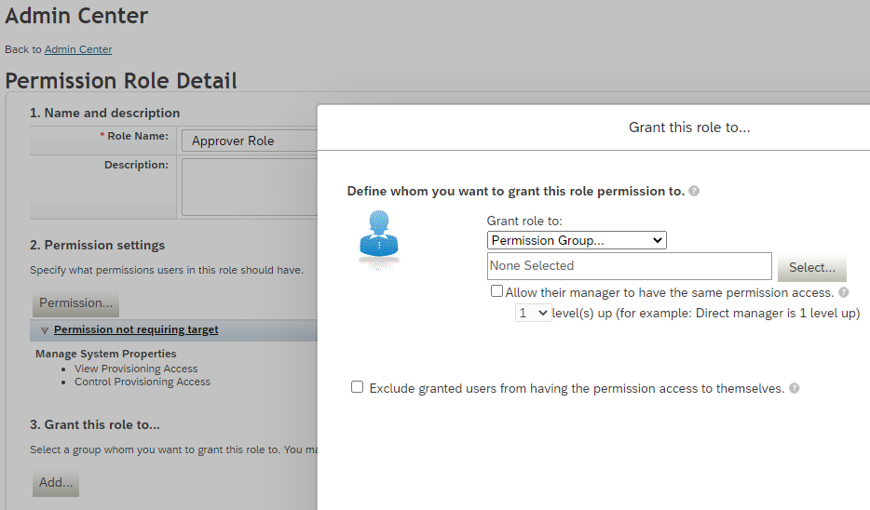
- Select “Approver Group”
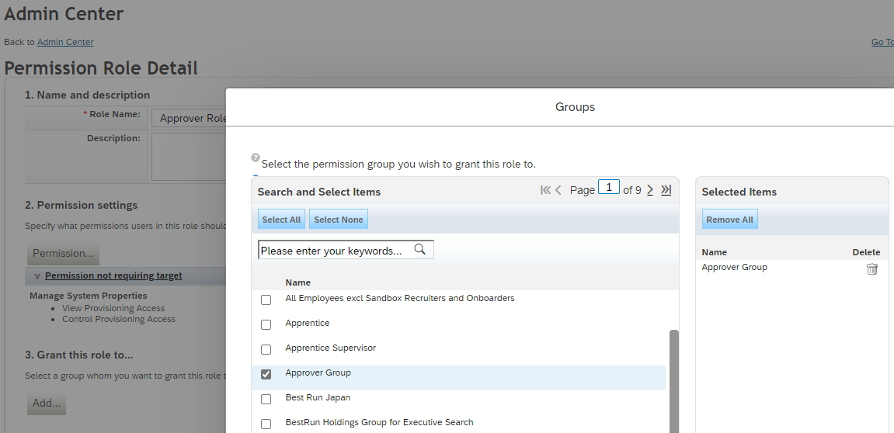
- Click Save Changes
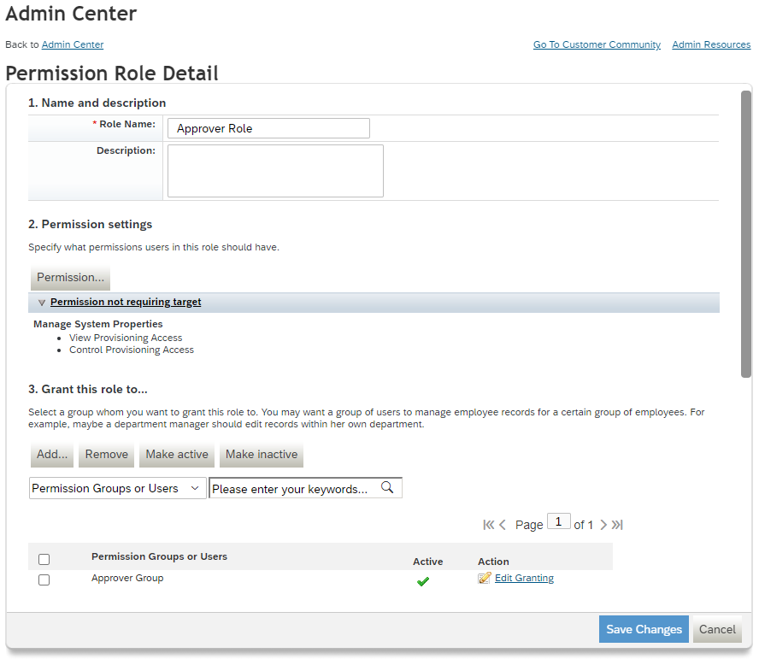
- Log out then Log back in

Approve Consultants
- Search “provisioning” and select Manage Provisioning Access
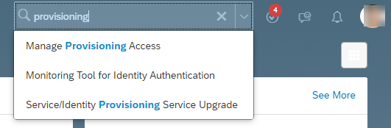
- Click the “+” button and enter the consultant email
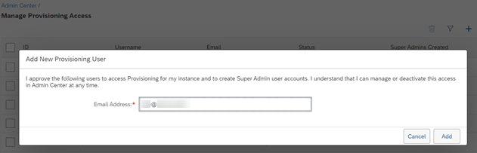
- Click add to send the approval email to the consultant.

