Choosing the Analytics App Server – Solution for Private Data Protection

Purpose
This guide is provided to assist you in ensuring that your WFA Analytics session is assigned to a particular web app server.
Our aim is to ensure that Private Data Protection is executed on the preferred DC8 App01 server.

Overview
The overall aim is to directly control which app server you are assigned to. Normally, this is dynamically assigned and often changes on each new browser session.
Our Load Balancer uses a browser cookie to persist the assigned webapp server node.
We can set that cookie to achieve the desired effect.
This will be a one-off effort. Once done, it is expected to stick for an indefinite period of time.

Requirements
Our solution requires using the Mozilla Firefox browser. It may be possible that similar functionality exists in other browsers but this has not been investigated.

Steps

Part One – installing the Cookies Manager+ add-on.

- Show the Add-Ons menu
In Firefox, to open the Add-Ons menu :- Click the hamburger menu then the Add Ons jigsaw piece.
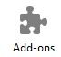
- Extensions
Click on the Extensions tab on the left hand panel
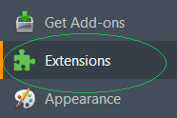

- Type “cookies manager” in top right corner to search. You may need to click All Add-ons if it defaults to My Add-ons.
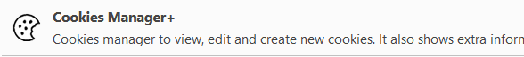
- Click “Install” on the right-hand side
- Restart the browser when requested. Click the “Restart now” link.
- You can close the Add-ons Manager tab if you wish
- Click the hamburger again. This time, find the “+ Customize” link in the grey area at the very bottom of the menu.
- When the customize panel opens, look for the Cookies Manager+ icon.
- Click-and-Drag it into the menu button area to the left of the hamburger.
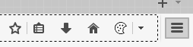
- Click the “Exit Customize” button at the bottom.
You have now installed the Cookies Manager+ add-on to your browser.

Part Two – Setting the Cookie

- Go to the Analytics Load Balance page in Firefox
https://analytics8.successfactors.com/Production/lb.html
- Click the Cookies Manager icon
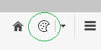
- In the popup, type “bigip” in the search box.
You are looking for the entry with Domain = analytics8.successfactors.com
and Name = BIGipServer
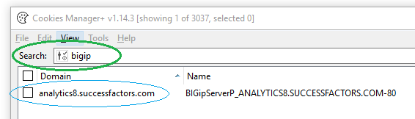
- Click on it, then click “Edit” at the bottom of the pop-up screen.
- In the “Edit cookie” dialog, change the “Content” panel to be simply
186386442.20480.0000
There is likely to be a long encrypted string entry there currently, Just delete that all out.
- Change the “Expires” choice from “at end of session” to “date”.
- Select a date far in the future. I’ve used 31st December in this example but you can go into next year or beyond.
- Result should look like this
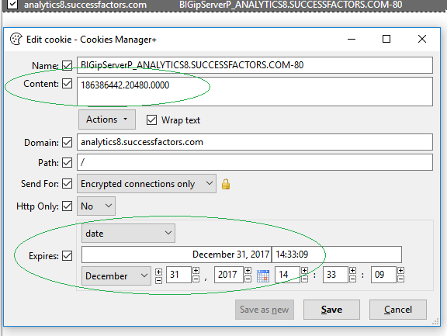
- Click the Save button.
- Click the Close button at bottom left of Cookies Manager+

From this point, you should always be on App01.
Navigate to https://analytics8.successfactors.com/Production/lb.html
and confirm the answer is “Load Balancer Test Page SuccessFactors App01”
This will enable Private Data Protection.

