Supplier Invoice Task unassigned with the below action log.
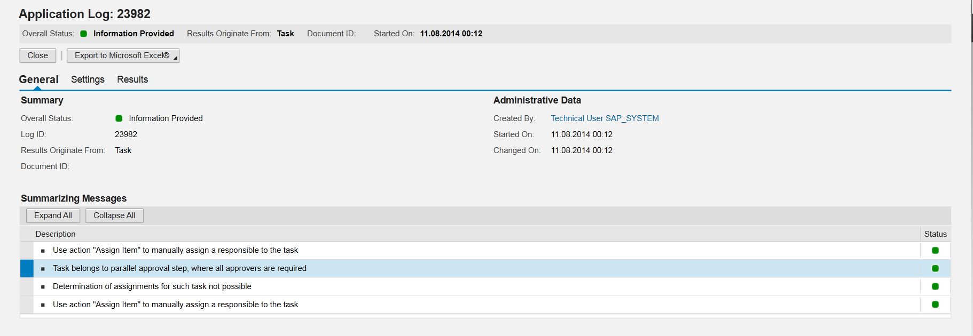
In one of the steps, All Approvals Required flag is set and leads to issue.
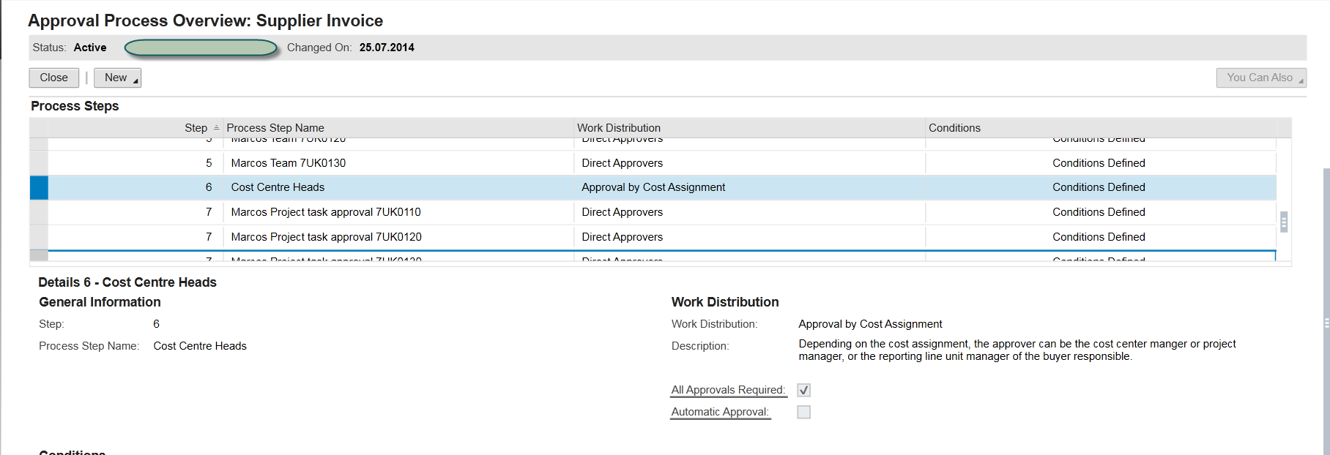
Additionally the responsible person does not have proper assignments.
