- Open the excel file and copy all the line items’ information in excel. (from the row with “line Items” to the last row with content.
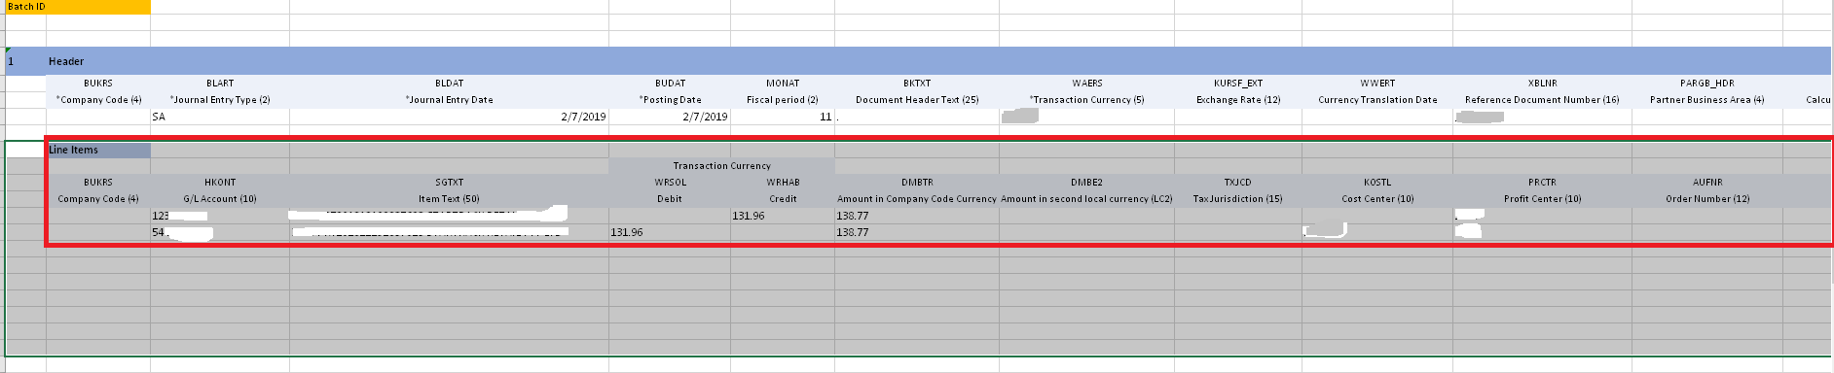
- Open a txt file and past the copied content into text format.
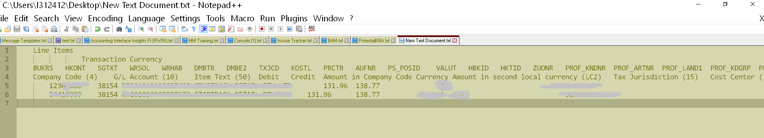
- Delete all the selected rows in excel
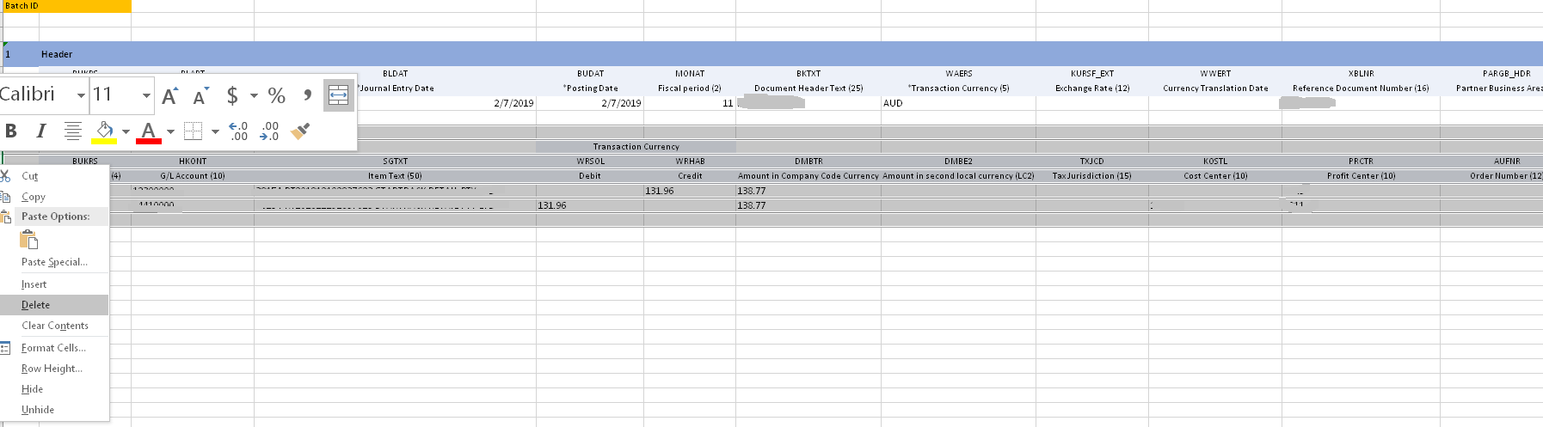
- After the deletion, there should be no line items in the excel
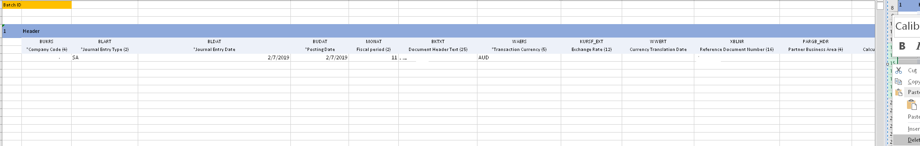
- Copy the content in the txt file (which is shown in step 2)
- Select enough cells in the excel file (to make sure all the copied content can be placed)

- Past the copied content into it. A popup may show up, choose “OK”.
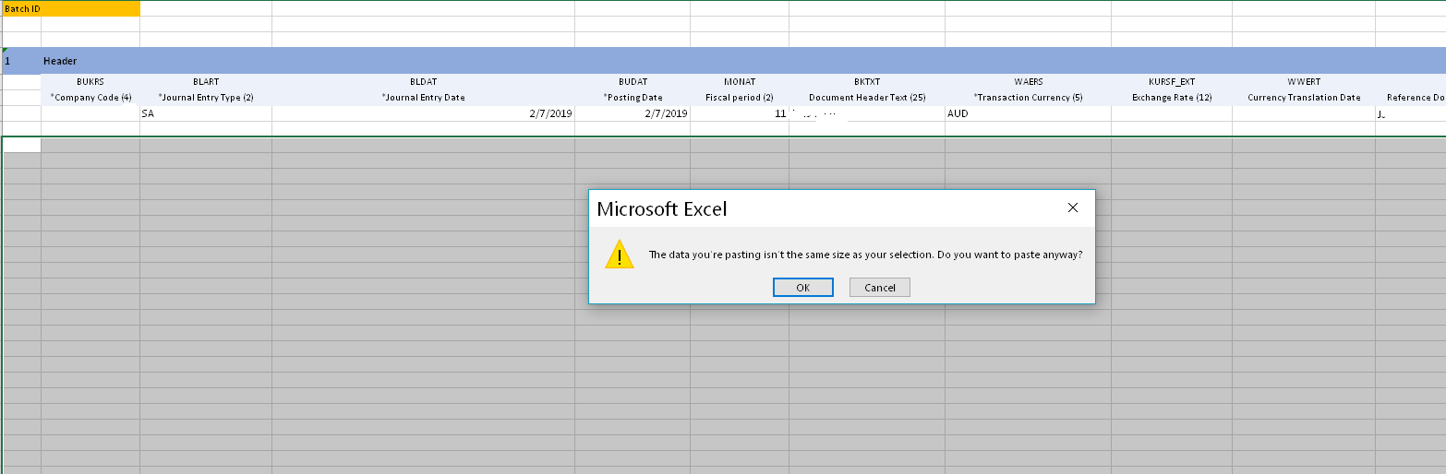
- The content is copied in format “Text”.
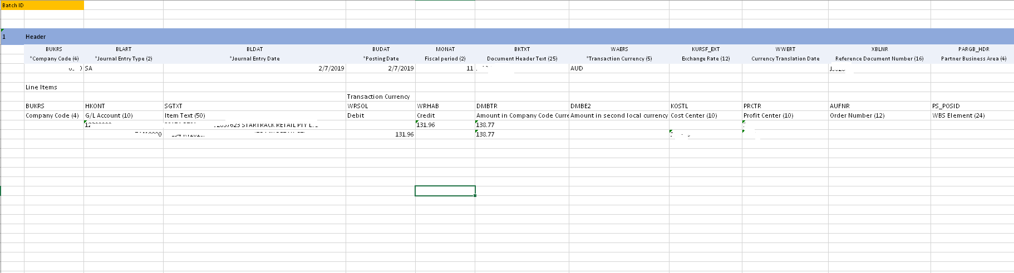
- Save it and upload it in the fiori app “Upload General Journal Entries”.

