Enhancement on Time in Company/Department/Location Pay Scale Level in Job Information Portlet

Example: refer the below Job Information Portlet in Employment Information Page

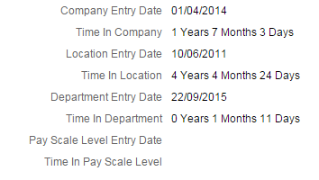

The fields that display the “Time In Calculation” are transient fields, not saved to the DB:
- Time in Company
- Time in Location
- Time in Department
- Time in Pay Scale Level

Implementation Steps:

- To make these fields visible on the UI, configure them in Succession Data Model in hris-element jobInfo:
Please refer the XML code below
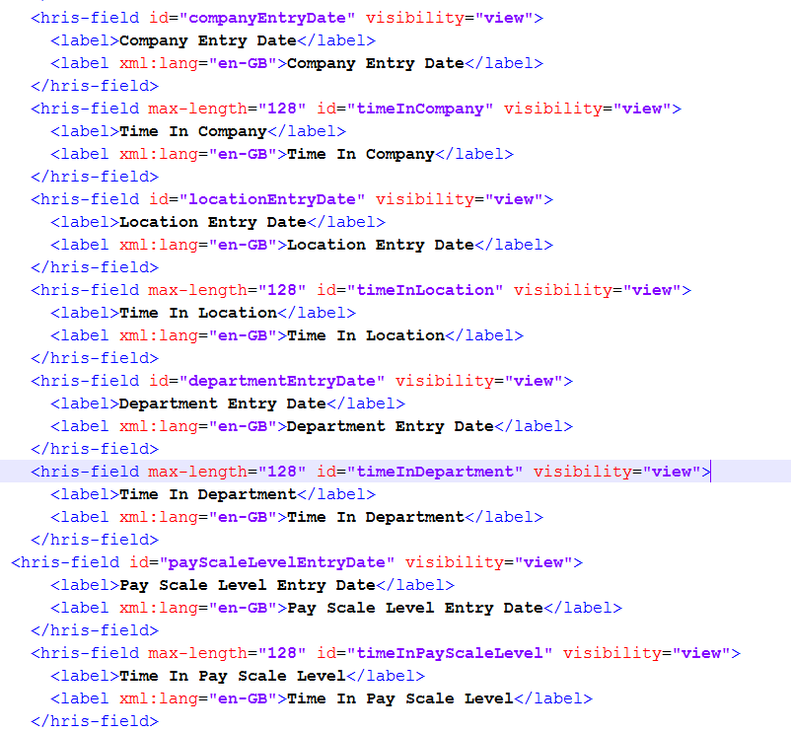

- Afterwards, set the permissions for these fields in Admin Centre as follows (only “View Current” and “View History”):

Admin Tools -> Manage Permission Roles -> Super Admin -> Permission… -> Employee Central Effective Dated Entities -> Job Information

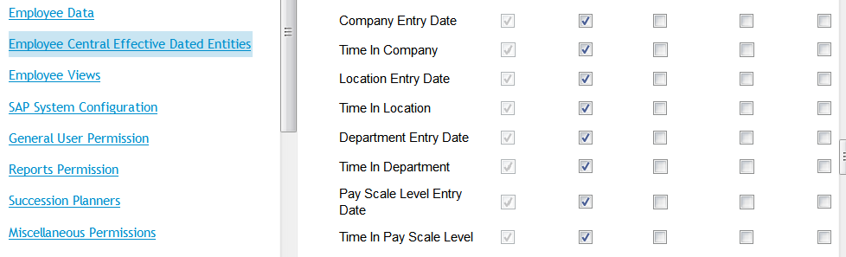

You must also configure your system to run “Pay Scale”.

- There is a new job available in Provisioning -> "Manage Scheduled Jobs" with the name: "Initialize additional entry date fields in job info".
Start this job and check in UI that the fields are set correctly.
Note: the fields are added to Succession Data Model and RBP is given for these fields.

If you run the job again, the old values should be overwritten. If you changed the entry dates manually in UI they should be reset to the original value.

IMPORTANT:
Please make performance tests in systems with many users and jobInfo records.

NOTE:

If there is no job available in provisioning "Manage Scheduled Jobs" with the name: "Initialize additional entry date fields in job info", create a new Job type: Initialize additional entry date fields in job info

Refer Example below

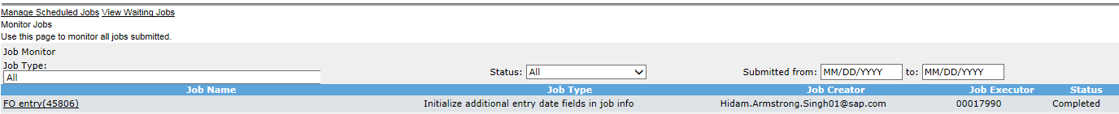
Provisioning -> "Manage Scheduled Jobs" -> Create New Job
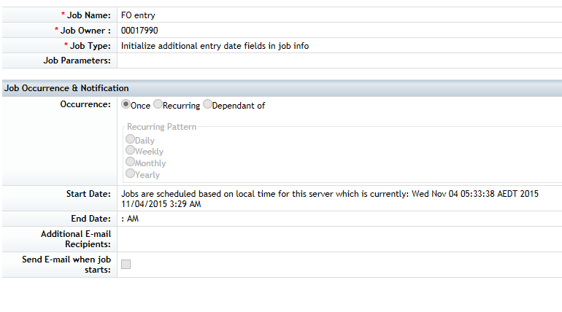
Once this Job is ran successfully, verify the result in UI.
Example: refer the below Job Information Portlet in Employment Information Page

