Projected Material Flow: On-Hand Stock – Allocated Stock = Available Stock = 0
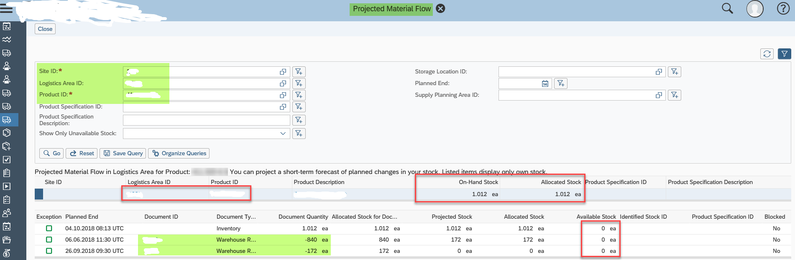

Cancel Allocation:
