- Create a new CR report or open an existed CR report.
- Add a new Formula Fields with 16 digits named NumberWith16DigitsUnder5 and set its value as “1111111111111114”.
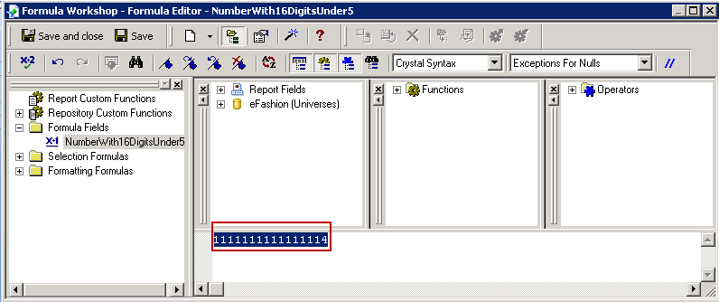
- Drag NumberWith16DigitsUnder5 into report.
-> It will be rounded down at last digit.
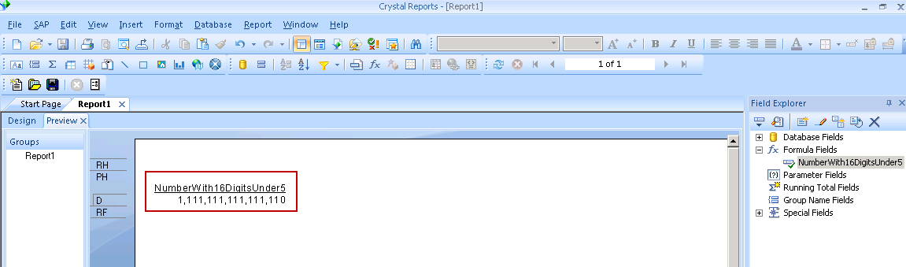
- Add a new Formula Fields with 16 digits named NumberWith16DigitsOver5 and set its value as “1111111111111115”.
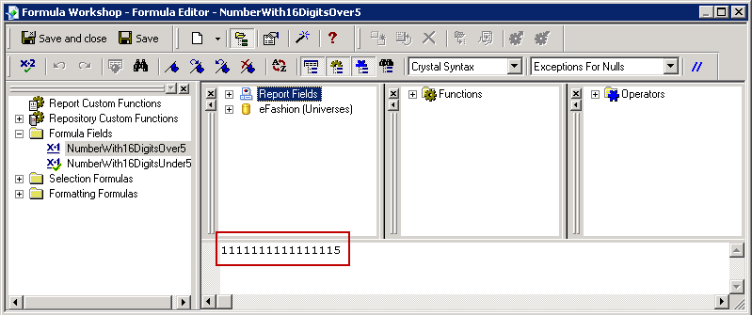
- Drag NumberWith16DigitsOver5 into report.
-> It will be rounded up at last digit.
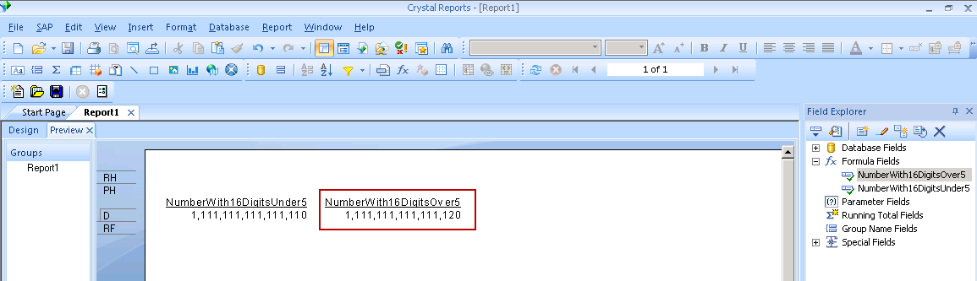
- Add a new Formula Fields with 18 digits named NumberWith18DigitsUnder5 and set its value as “111111111111111114”.
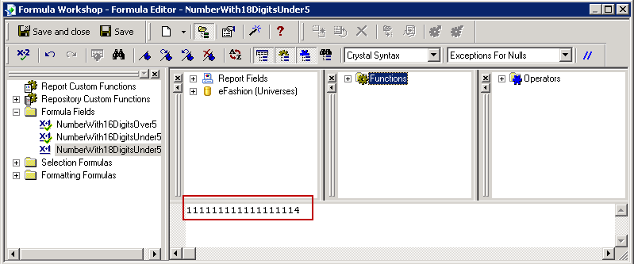
- Drag NumberWith18DigitsUnder5 into report.
-> It will be displayed as scientific notation format.
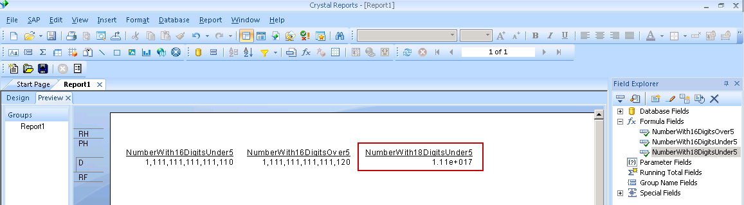
- Add a new Formula Fields with 18 digits named NumberWith18DigitsOver5 and set its value as “111111111111111115”.
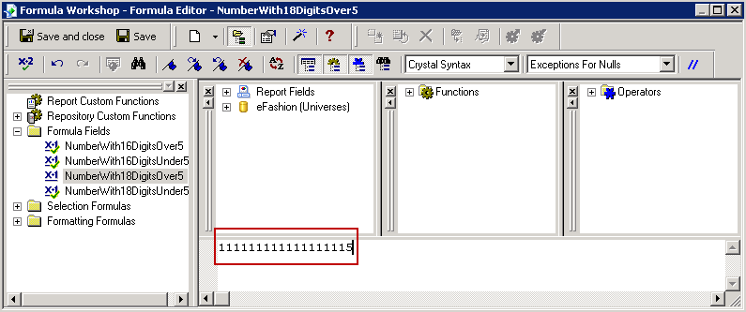
- Drag NumberWith18DigitsOver5 into report.
-> It will also be displayed as scientific notation format.
