SYMPTOMS
Failed to create any new job classification. Error while selecting country drop down.
ENVIRONMENT
Employee Central – MDF
REPRODUCING THE ISSUE
- Navigate to Manage Data under the Admin Center – Employee Files.
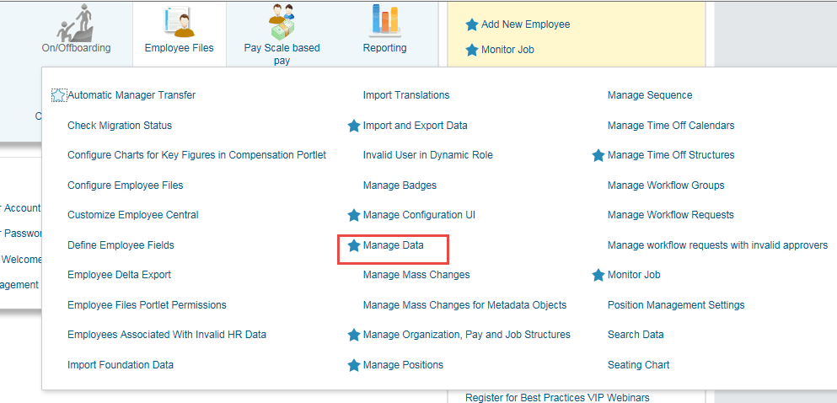
- Select Job Classification under create new drop down.

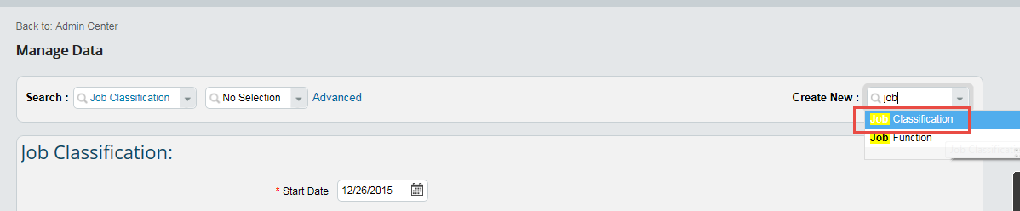

- Enter the necessary details such as Start Date, Job Code, etc and then select the associated country list. On selecting the list you will get the following error.
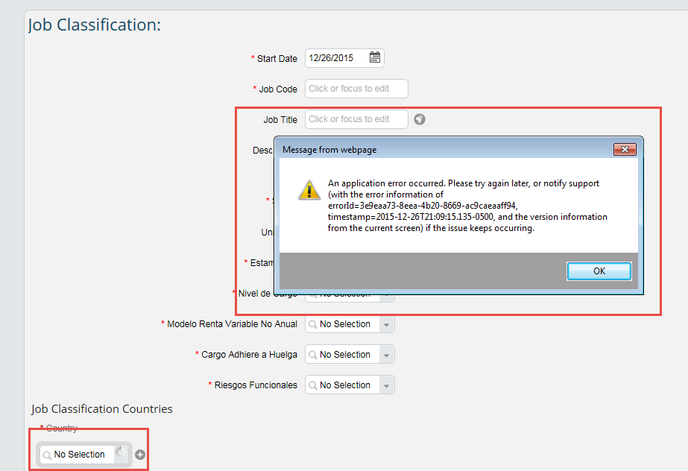
CAUSE
After the latest release, job classification has a parent-child association with Job Classification Country Object.
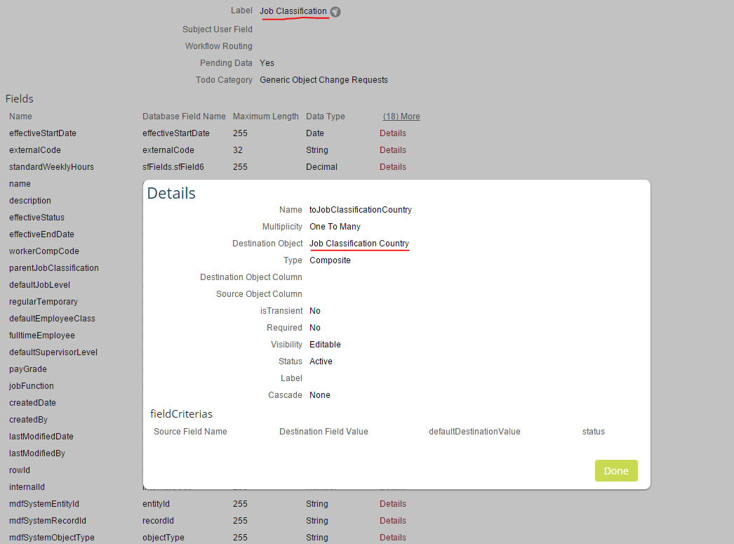
The Job Classification Country in turn is associated with the different country specific Job Classification objects such as JobClassificationUSA,Job ClassificationCanada, etc.
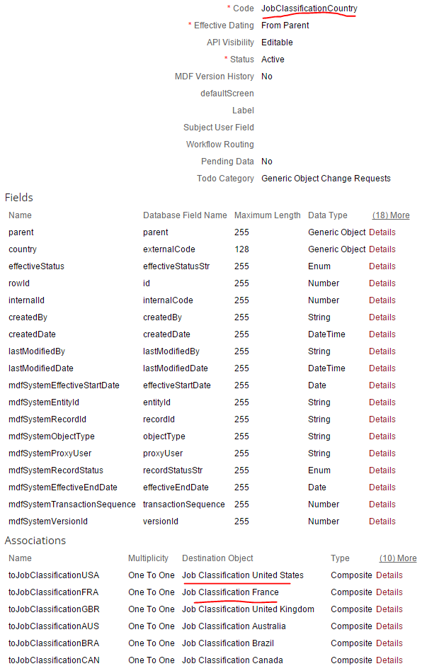

The reason is that the association under the Job Classification country is set as Not Visible. Hence when you select the country list drop down it throws error.
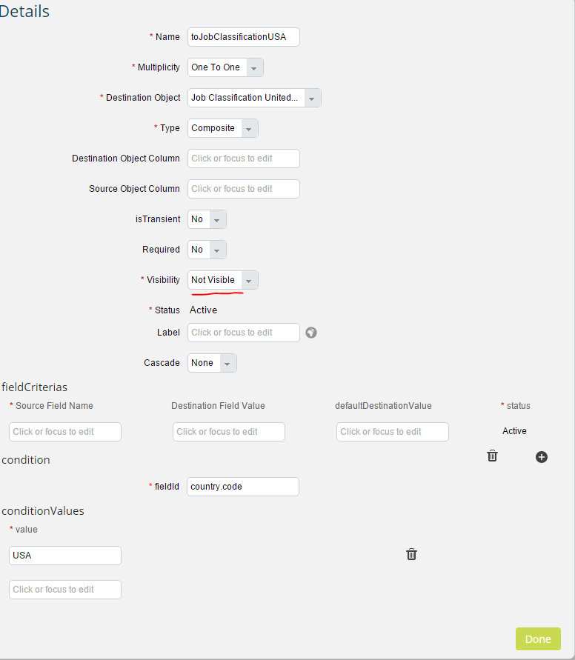
RESOLUTION
To have the country list populating in the drop down, make the associations – Job Classification USA, Job Classification Canada, etc. Under Job Classification Country object as Editable.
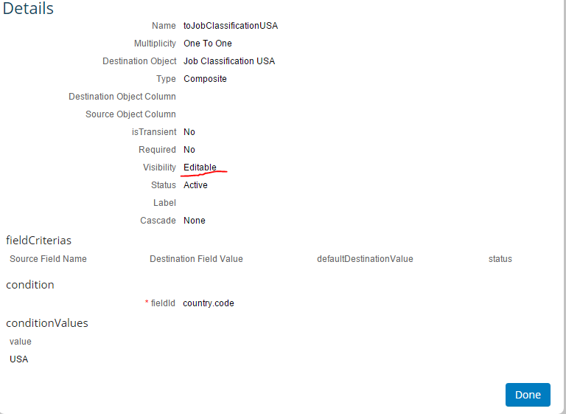
Once done, you would be able to select and add the country from the list in the drop down. As a result would be able to créate a new Job Classification.
