Requirement Analysis
Requirement to restrict the target population for the user who is importing the data for Compensation Info. To illustrate, customer had a admin user for USA which could import/see the data for all the users for Legal Entity belonging to USA. Since we have element/field level permission support for the UI, no such support existed for the import. So, before this change, this admin user could import the data for other entities even if the target group did not contain these users.
Customer needed a way in the system, where customer can define that a particular admin user could import the data for a specific type of element for specific set of users.

Configuration
To make this feature as backward compatible, we have provided the switch : "Enable RBP Access Validation for EC Elements during Imports (Do not enable during first time import)" under RBP page. This switch can be used to enable RBP access check validation during imports. So this feature becomes an opt-in feature.
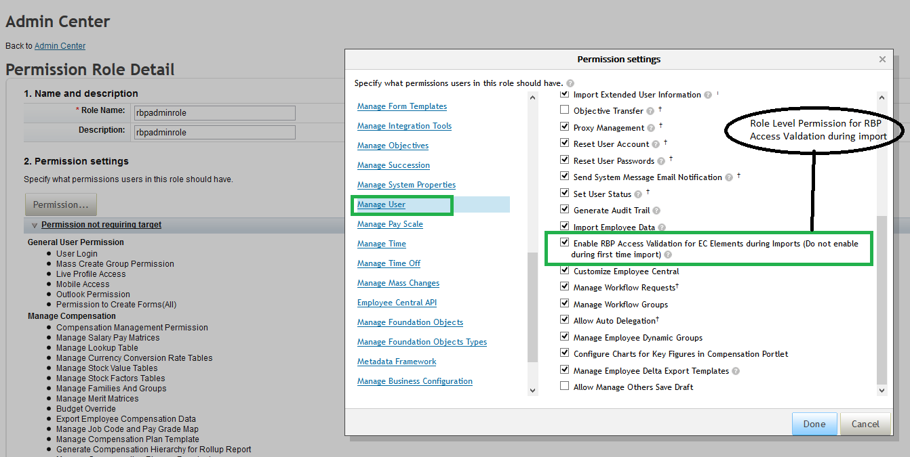

Once this switch is enabled, user still needs to provide the permissions for different element types, which are currently supported i.e. Compensation Info, Pay Component Recurring and Pay Component Non recurring, Job Info,mJob Relations Info. For this, we have introduced a new permission category: "Employee Central Import Entities" for which Target needs to be defined:
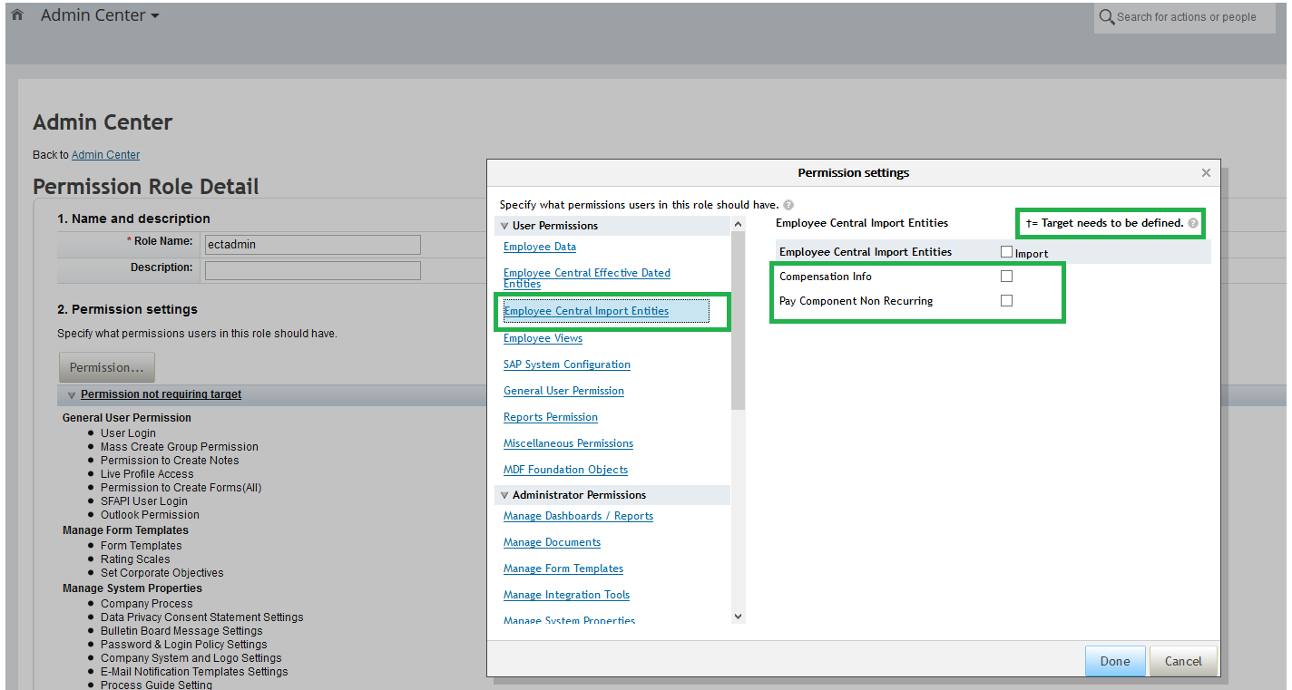

Again, for a particular "Permission Role". we need to define:
- "Grant Role To " : which specifies whom you want to grant this role permission to.
- "Target Population " : which specifies the target population whom the above granted users have permission to access.
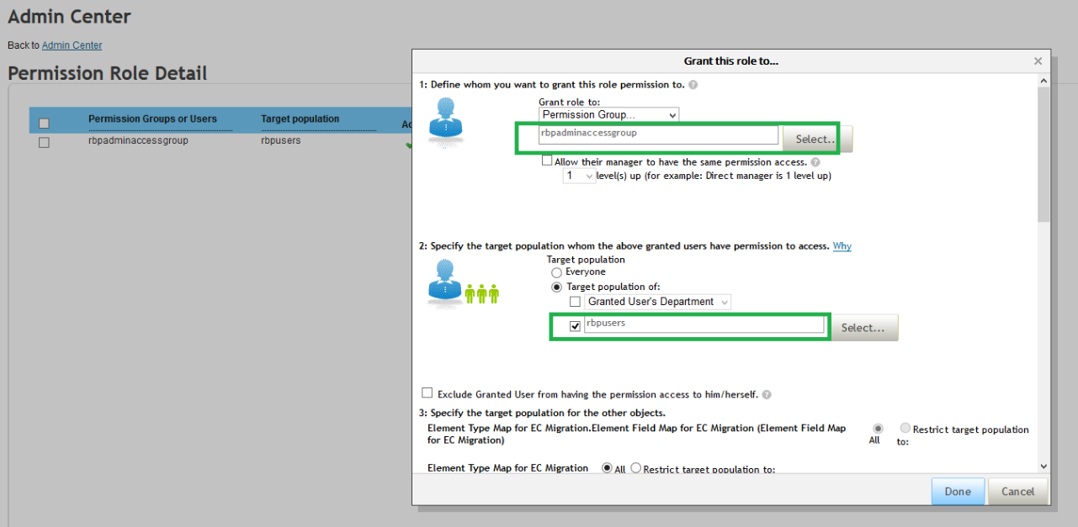

EC Import and Validations:
Once the above setup is done and let's consider the following scenario:
- Admin user importing the data : SUPERADMIN
- User's being imported : rbptestuser1 and userid15
- SUPERADMIN belongs to the Permission Role which has RBP access validation permission for rbptestuser1 and not for userid15
Now, if we import the following Compensation Info import file:

user-id,custom-string1,end-date,custom-string2,custom-string3,start-date,pay-type,notes,seq-number,pay-group,is-eligible-for-benefits,event-reason,salaryCurrencyCode
User ID,custom-string1,End Date,custom-string2,custom-string3,Event Date,Pay Type,Notes,Sequence Number,Pay Group,Is Eligible For Benefit,USA: event-reason | CAN: event-reason | IND: event-reason,salaryCurrencyCode
userid15,,,,,5/23/2014,,first-comp,1,,,DATACHG,USD
rbptestuser1,,,,,5/23/2014,,first-comp,1,,,DATACHG,USD

We get the following error:
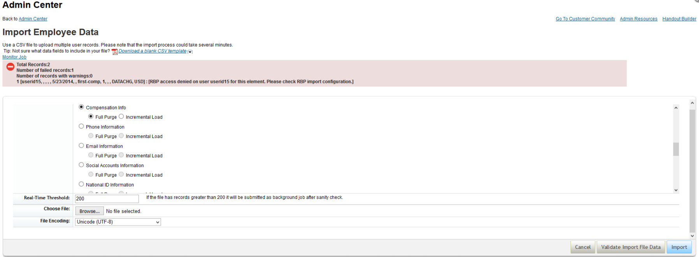

This way admin is permitted to import data for only the target population and target elements which he has access to in RBP .

What if this is enabled during hire imports?
As this involves target elements and target which would not exist yet, it results into errors.
Hence for hire imports or first time data imports, please disable this switch and proceed with the import.

