“IS ADDRESS SAME AS EMPLOYEE” field is set to no post address is copied

Environment :Employee Central: Personal Information
Scenario:
1) Go to dependents Portlet Editconfirm the date of detailspress details.
2) Set “IS ADDRESS SAME AS EMPLOYEE” as “YES” and fill in all the mandatory details.
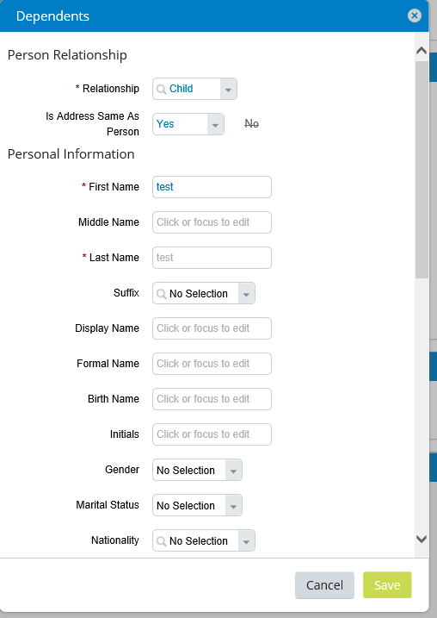
3) Address is copied same as employee
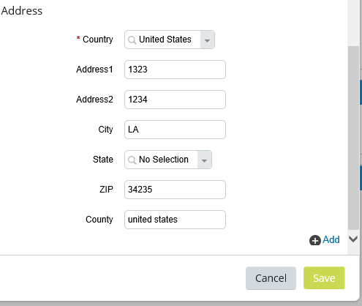

4) Save the details
5) Go to Details section again and you will observe that the field “IS ADDRESS SAME AS EMPLOYEE” is again set to “No”

Resolution:
This is the expected behavior of the system and “IS ADDRESS SAME AS EMPLOYEE” field is always reset to “no” once the address is copied to dependents from the employee. This field work as a trigger once the address I copied and details are saved this field again is set back to no.

