- Symptom:
Customer has reported that there are differences on the output when the exact same Adhoc report is run manually and automatically [schedule job]. Both don't have the same results between runs manually or automatically.
- Reproducing the issue:
  - Run the report Manual
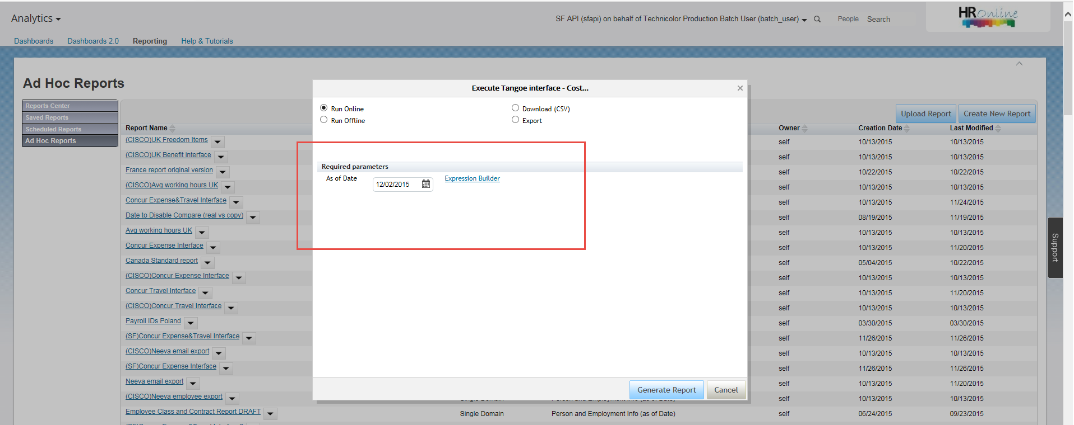
  - Run the same report automatically from Provisioning without selecting the Expression Builder ${today}:
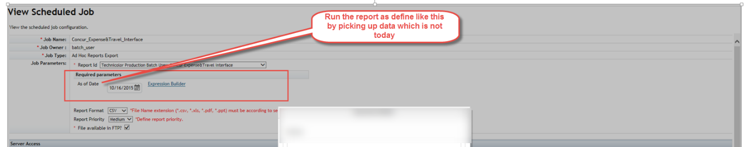

- Resolution: Add the expression ${today}

