reportPercent of Tgt/totalGoalResultsPayoutPercent = Final Pay-out/Total Target Amount
Final Payout/finalPayout = Sum of Assignment Final Pay-out amount
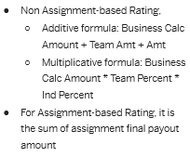
Total Target Amount/assignmentTargetAmountTotal = Sum of business sections, Ind section amount and assignments.
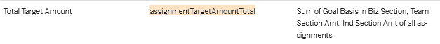

The calculation above could be calculated as follows.
First you need to create a custom field within each section. In this case are you do not use business you would ned to create the following columns under TEAM and INDIVIDUAL sections.

NOTE: All fields from section upwards to assignment need to be of MONEY type.

INDIVIDUAL Section column – Make sure you have “calculate total” & “Reportable selected”.
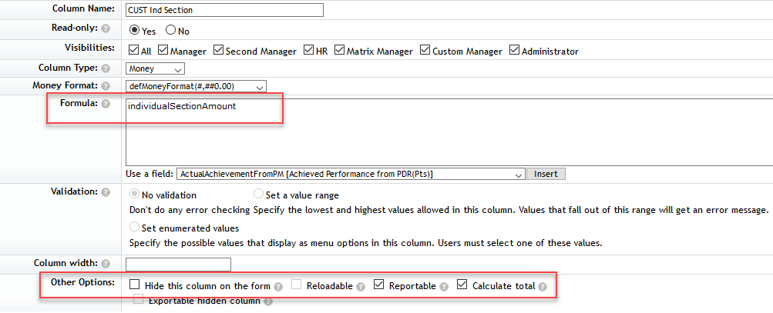
TEAM Section column – Make sure you have “calculate total” & “Reportable selected”.
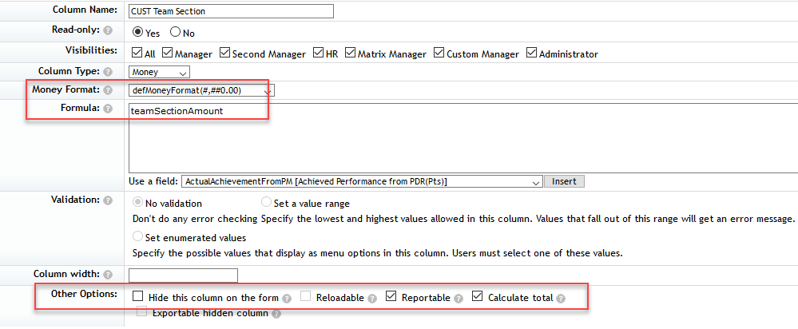

Next create the following columns as ASSIGNMENT level.
Individual Assignment – Make sure you calculate total, set reportable and aggregate the field created coming from IND Section.
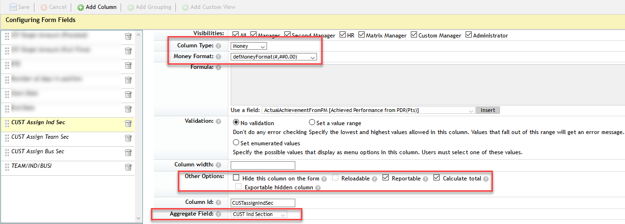
Team Assignment – Make sure you calculate total, set reportable and aggregate the field created coming from TEAM Section.
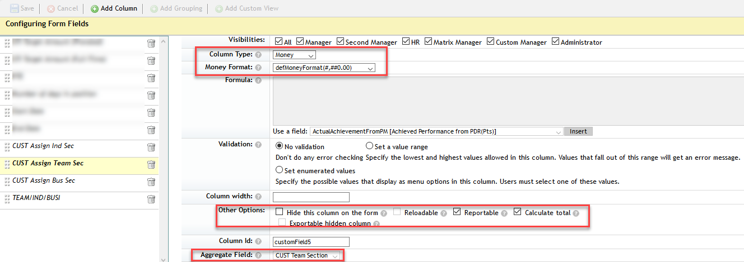
After this, create a new column to add the two custom assignment level fields.
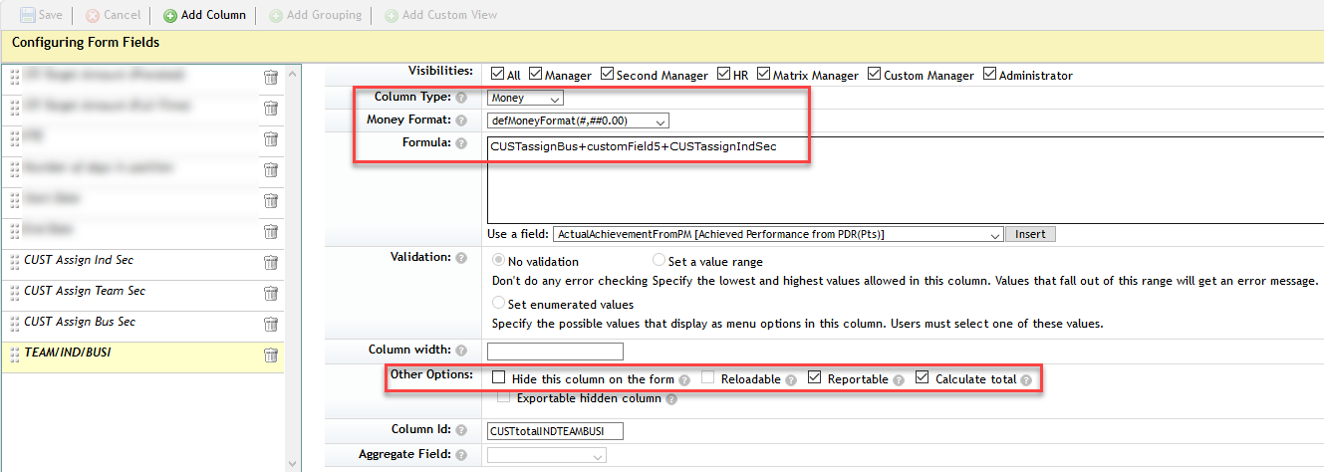
The last thing here would be to create two columns in ENTRY level. One to pull in the ASSIGNMENT level field and one to take this field from ENTRY level and calculate the pay-out %.
AGGREGATE Assignment level at ENTRY level
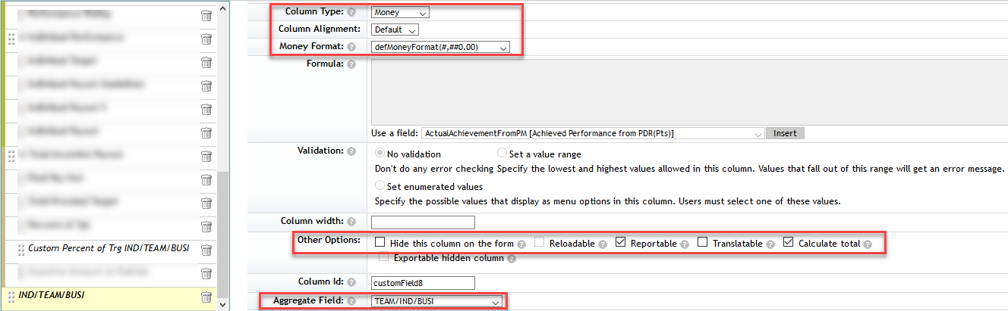
Pay-out at ENTRY level using the above new ENTRY level aggregated field. Set this to be reportable.
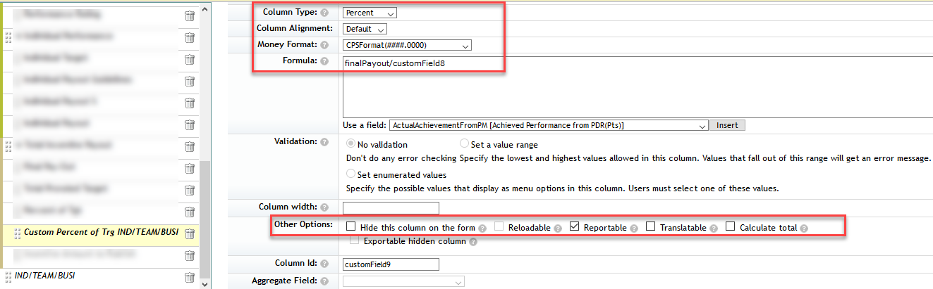

Launch a new worksheet and the calculation shows as follows

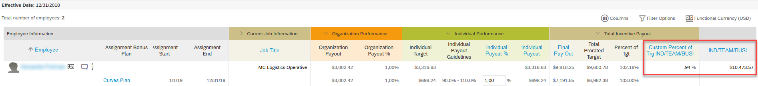
The “custom Percent of Trg IND/TEAM/BUSI” takes the formula which would be finalPayout/ assignmentTargetAmountTotal which in this case would be 9810.25/10473.57=0.936667 (0.94% in the UI)

