WFA – Invalid Reporting Path in Report Distributor

NOTE: WFA Admin access required for the following.

If you have a report bundle that is showing [Invalid] for a particular email recipient below are steps to try, to help to resolve the issue.

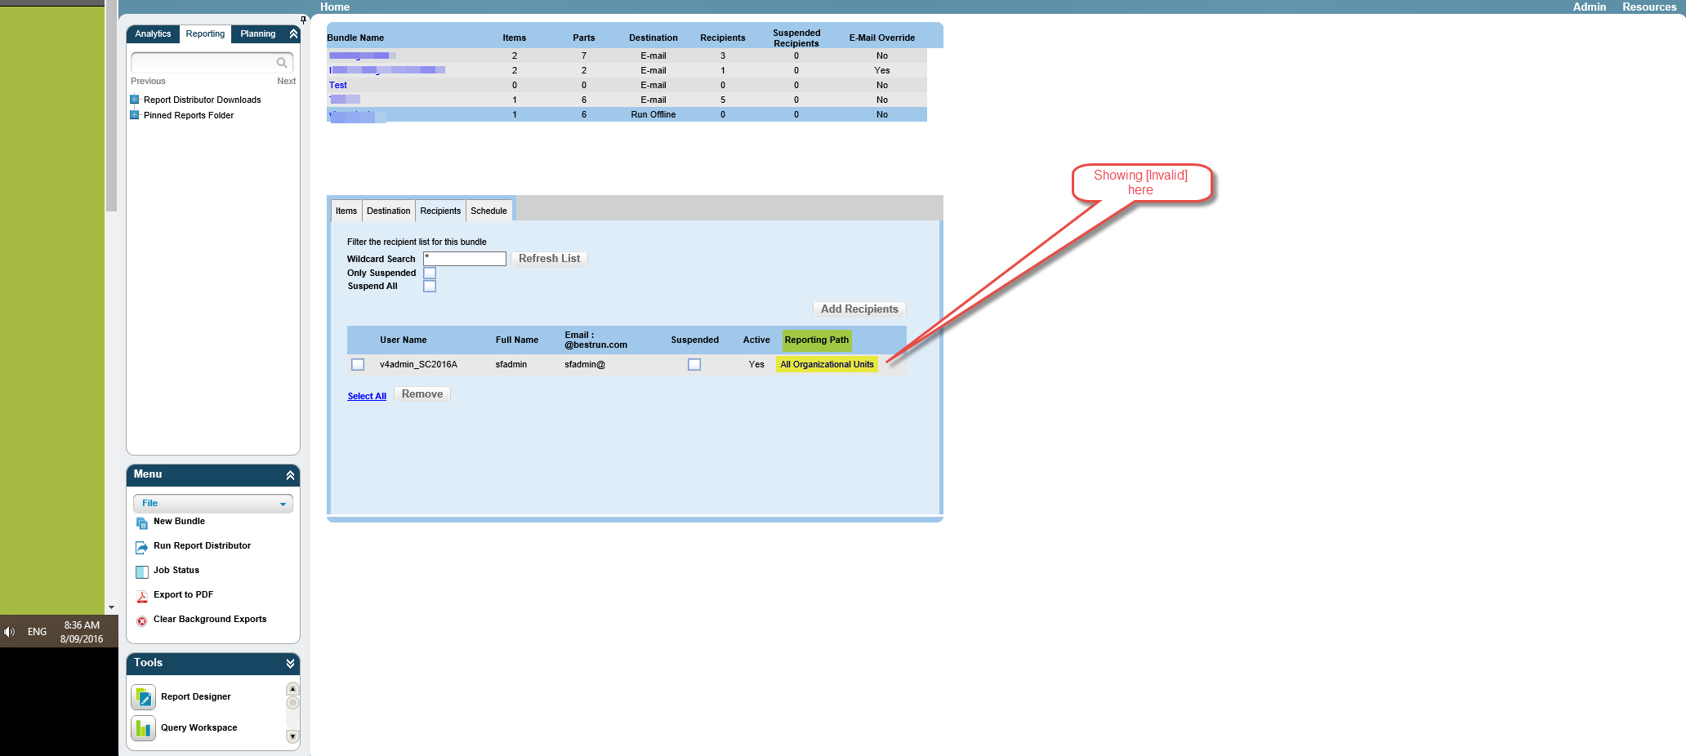

Understanding how the reporting path is assigned.
Reporting paths are assigned to WFA cube users, by default, when they are added to a report bundle.
What the reporting path defaults is based on the following steps:
1 – User Tree Security
2 – Role Tree Security
If no Tree Security applied, it defaults to the primary Structural dimension, normally All Organisation Units.

Resolution steps
- Check the Tree Security settings for both Userl and Role. Make sure they are logical and correct.
- Run Role and User Validator also, in the WFA Admin Menu
- Run Reporting Paths Validator – See WFA Admin Menu >Instance Validation> Reporting Paths

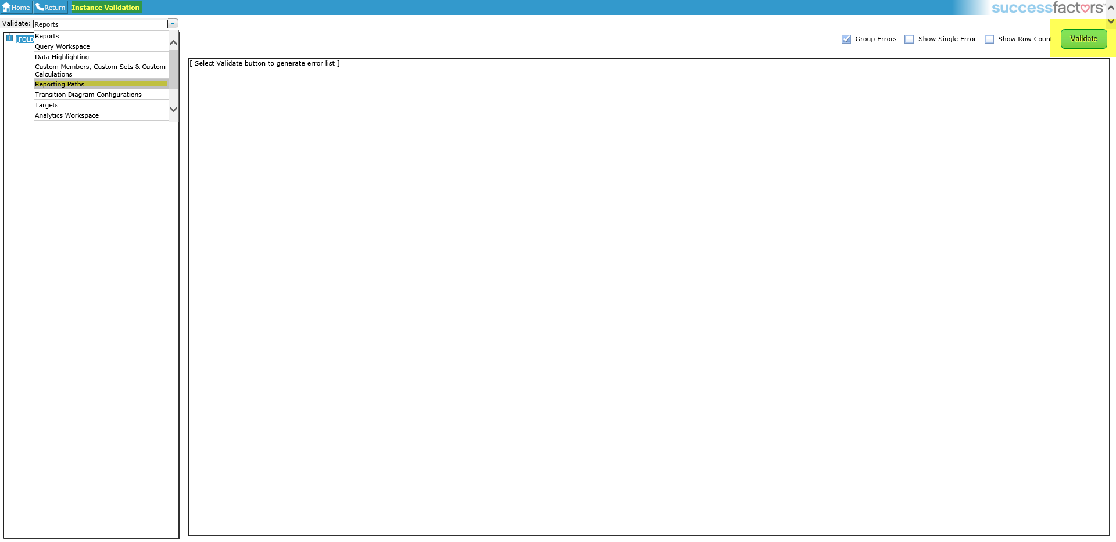

If these steps do not work, please log an incident with Support for further investigation.

