Login as Admin
Navigate to System Admin > Environment > click Choose file
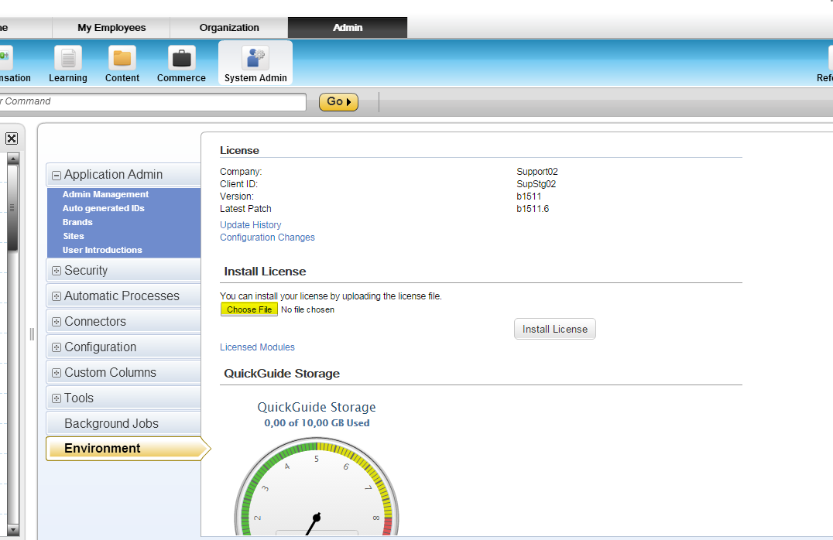

Select file with the extension as “plateau.license” without quotes. 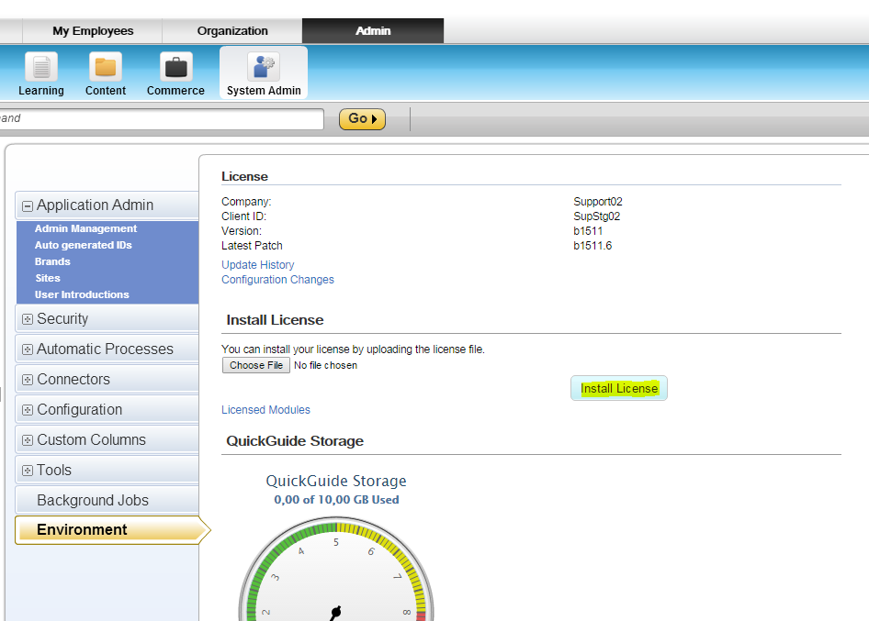
After selecting the plateau.license click on install License button as shown in above screen.
Logout and login again admin to make changes effective.

