Workaround to show the sum to Ordered Quantity for PO:

1 ) create a new key figure:
- go to WoC Business Analytics
- go to the view New Key Figure
- fill out the mandatory fields,
- type a name for the Key figure
- select the data source: "Purchase Order Items with Extended Tracking Details"
- click on Next

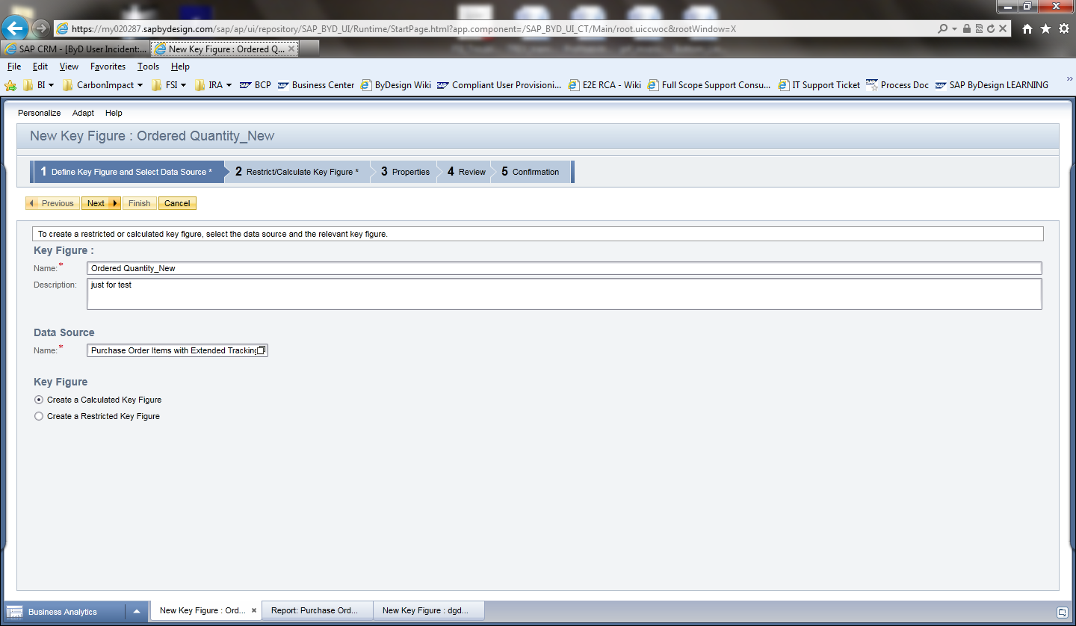
- In the Key Figure Name box, double click on the KF named: "Ordered Quantity"
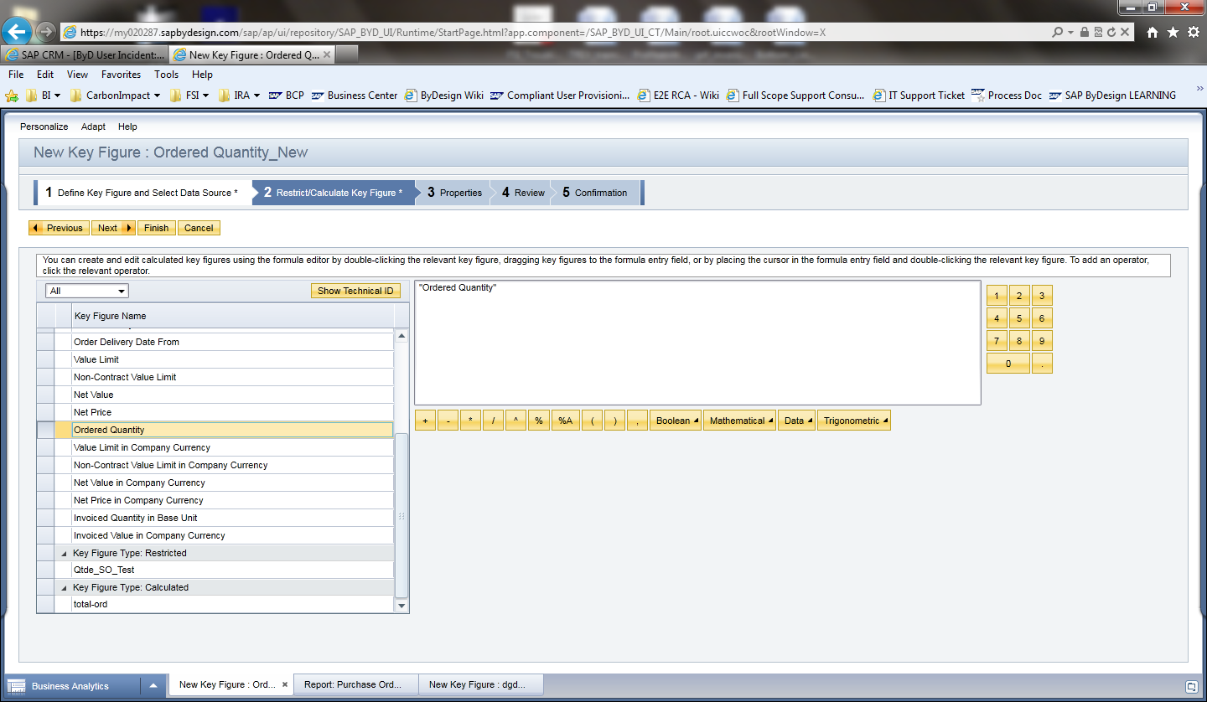

- In the step 3, drop down the field: "Calculate Result As" and select "Total"
- Click on Close button

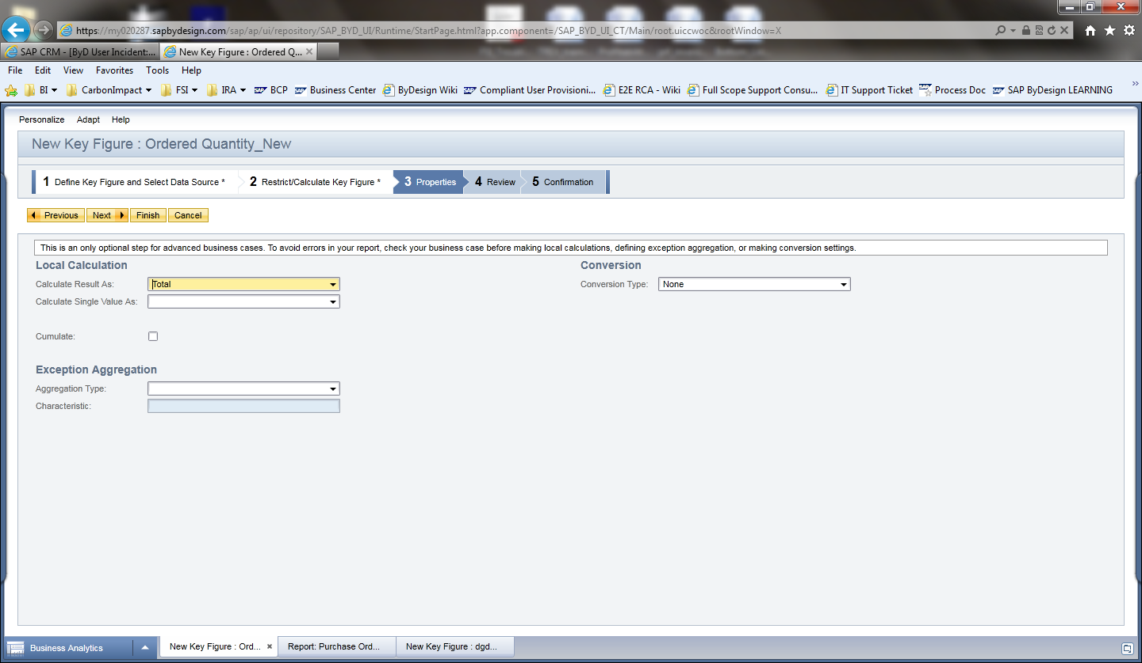
2 ) create a new report as copy:

- go to WoC Business Analytics
- go to the view Desing Reports
- select the report "Purchase Order History" and click on New > Report as Copy
- go to step 2 and select the following Key figures (as desired):
- delivery quantity in base unit
- delivery Quantity
- order delivery date to
- invoiced value in company currency
- "Ordered Quantity_New" ==>> select the new key figure that you have created on the step before.
- complete the wizard setup
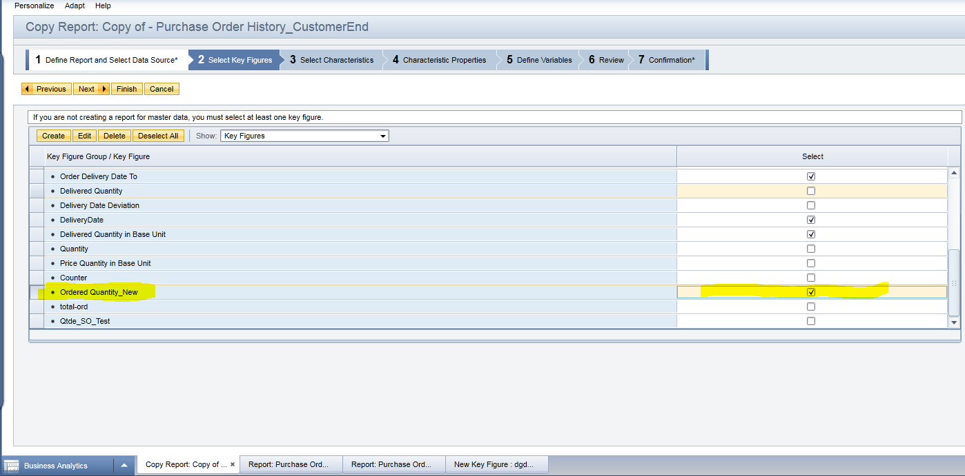

3 ) To setup te report:
- in the key figure columns, click on the right box;
- in the Select Key Figures screen, move to the left "Ordered Quantity (Base UoM);

