- Use Case :
Need to filter multiple field values from a customfield with non filterable property. Using just calculated filter you are limited with the number of if/then/else statement you can put. Hence, using Value LookUp Table is much more robust and efficient.

Note: custom field(s) with non filterable property is standard behavior for Odata APIs, in integration center the requirement can be achieved using post query processing feature of the tool available.

- Step by step Solution:

- Requirement :
Use Case : I want to filter out records with ‘BestRun France (2200)’,’ BestRun USA (3000)’ and ‘Null’ records from Custom Field 5 of User entity in the report.

Remarks
1.1 User Entity > Custom Fields are hardcoded not filterable.
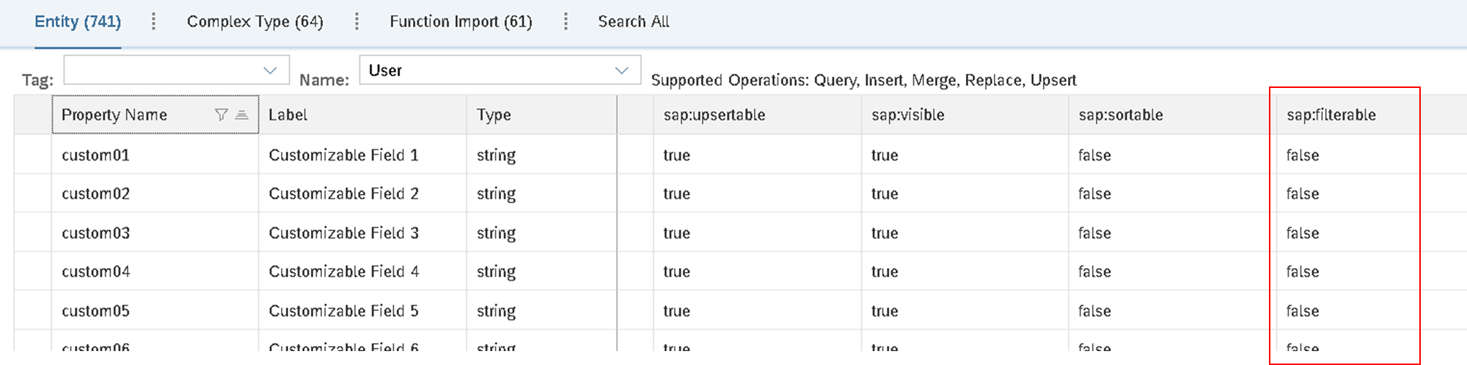
1.2 First,see Original Output of Report without Value Look Up Table – Calculated Filter, ‘BestRun France (2200)’,’ BestRun USA (3000)’ records are showing.
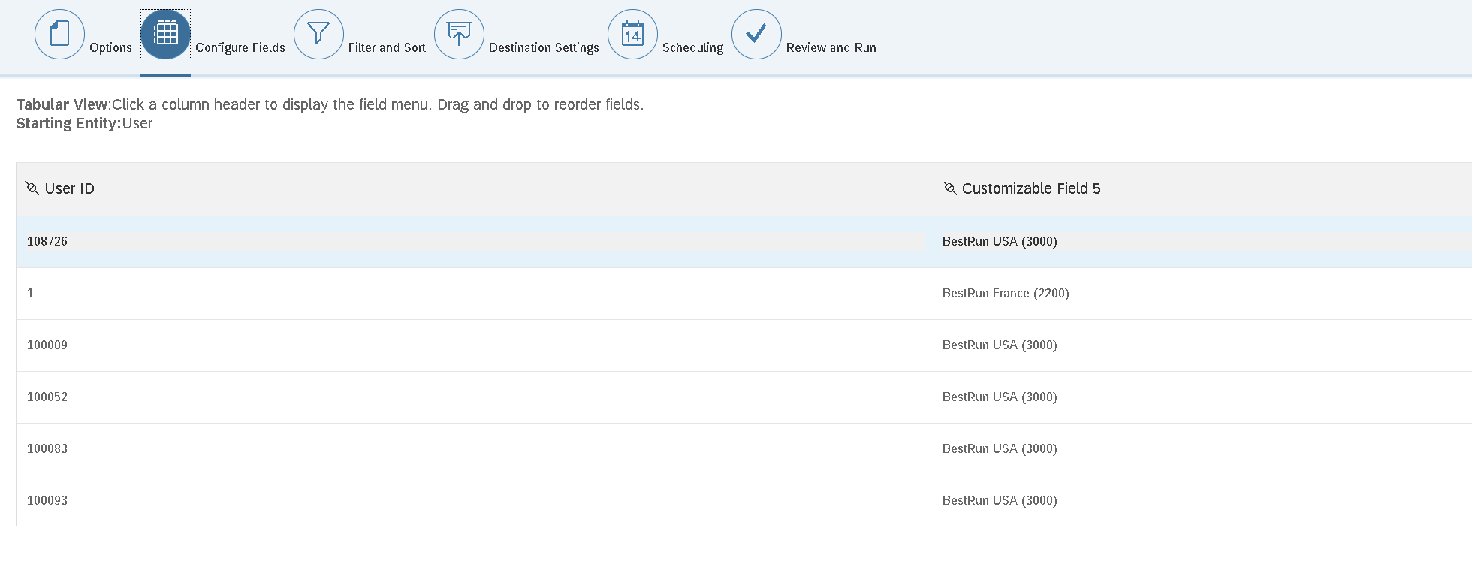
- Applying Value Look Up Table – Calculated Filter
  - Go to Filter and Sort Tab > Advanced filter > Calculate filter
Select Field Value > Select your Custom Field you wish to apply the filter to
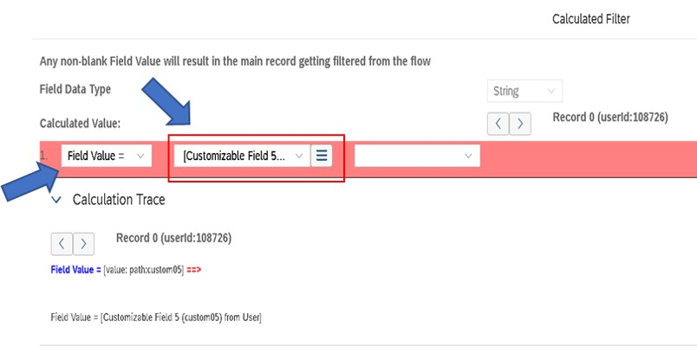

  - Then the values I don’t want in my report I will put in the table.
Items in screenshot ‘NULL’ records and ‘BestRun USA and France’ will be removed in the final report
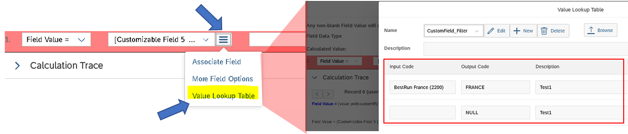

Note : Calculated filter is defined as a negative filter logic
https://help.sap.com/viewer/60ba370328e0485797adde67aee846a0/1905/en-US/79938b0493c54bf39408441c8637798c.html

  - See Sample Output Below.
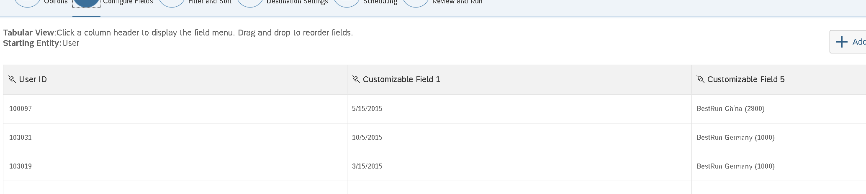

Records are filtered from the report satisfying the requirement, working around the limitation for if/then/else statement allowed to be put in the calculated filter.

Note : Max Value Look Up table items is restricted up to up to 300 via CSV upload file using the Upload Sample CSV or Manually you can enter values up to 1000.

