Build a report using the data source – CODPRODUCT.
In the Report Wizard, in step 4, select the characteristic: Competitor Product and set the Value Selection as using Variable:
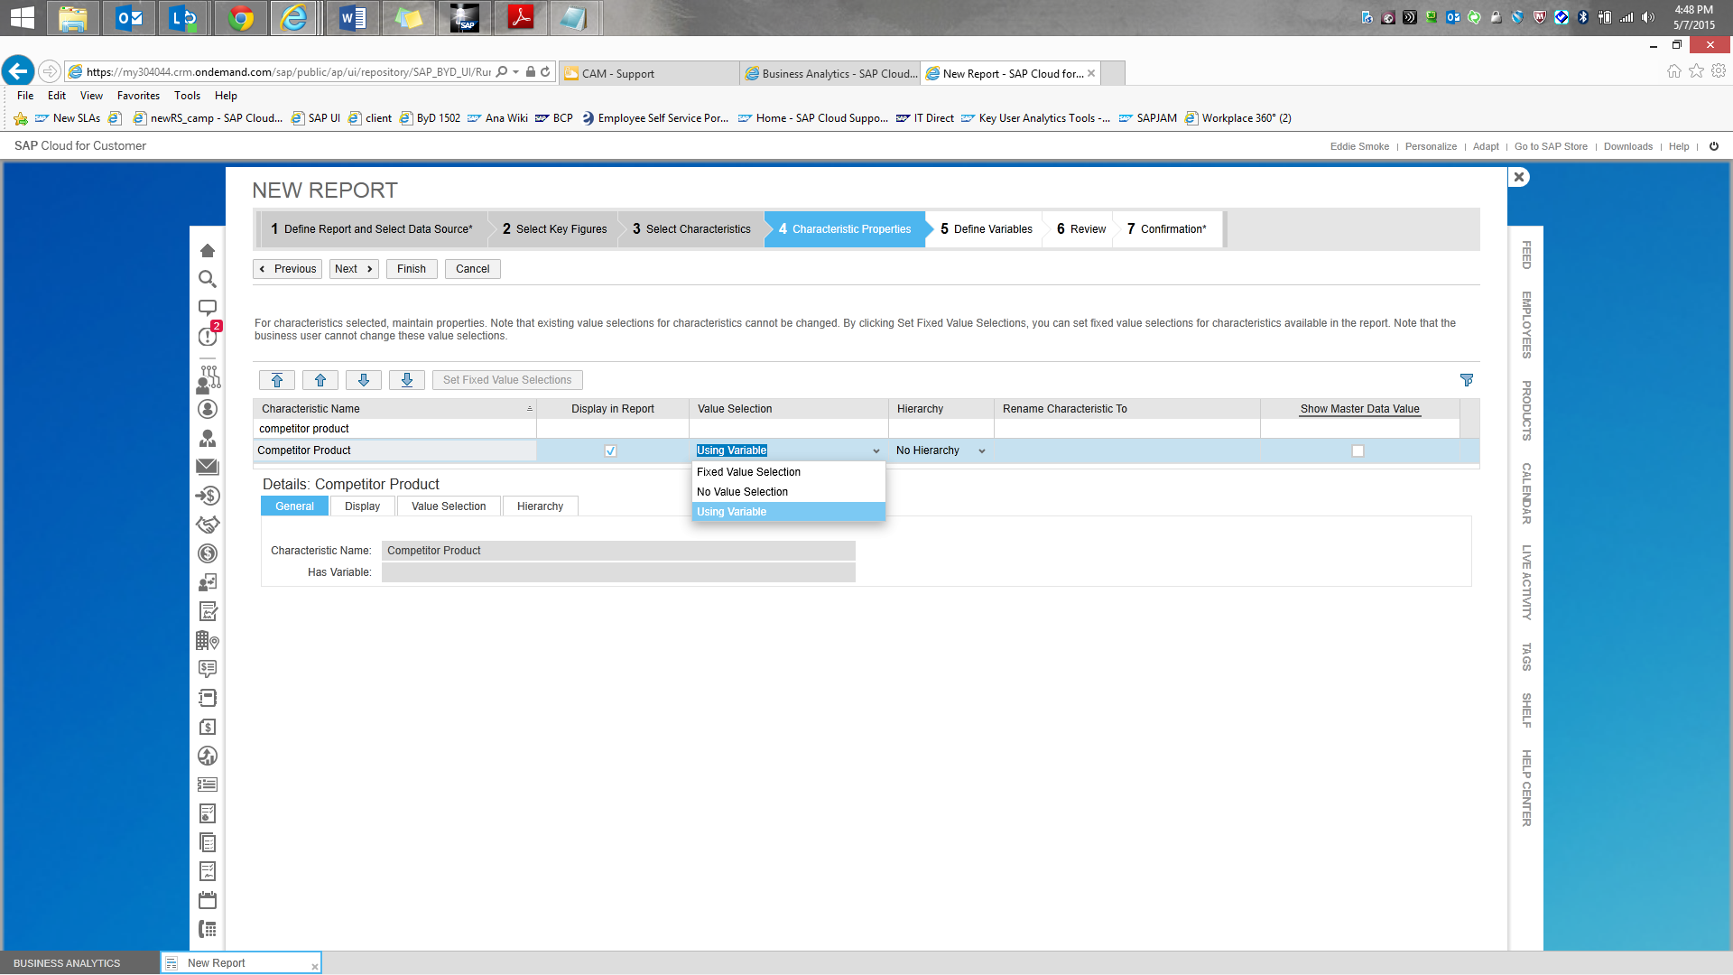

In Step 5, for ‘Competitor Product’ click on Maintain Default Values, and maintain the default value as X:
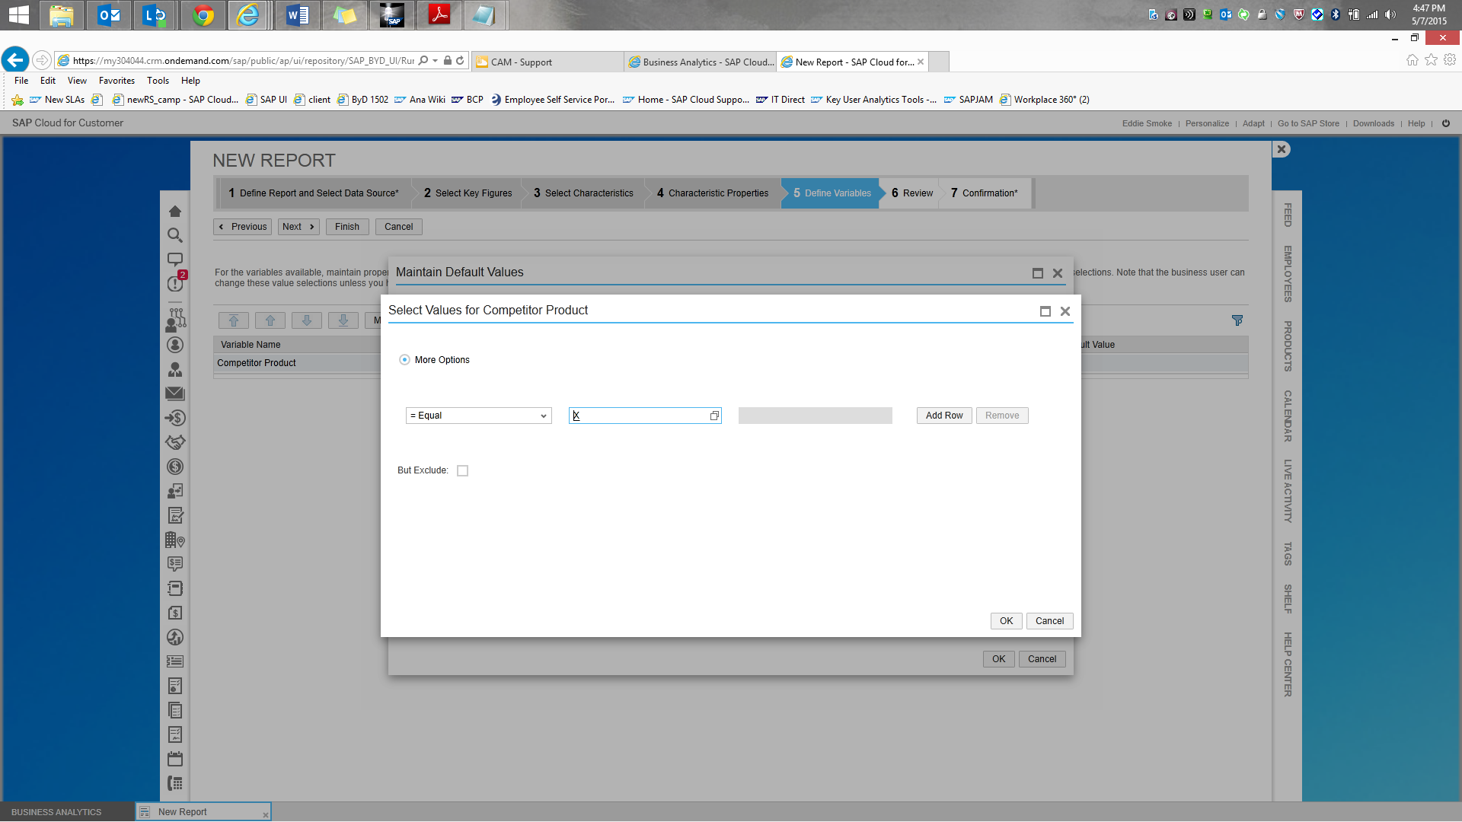

Now finish the report and execute it. The report now pulls only the competitor product data:
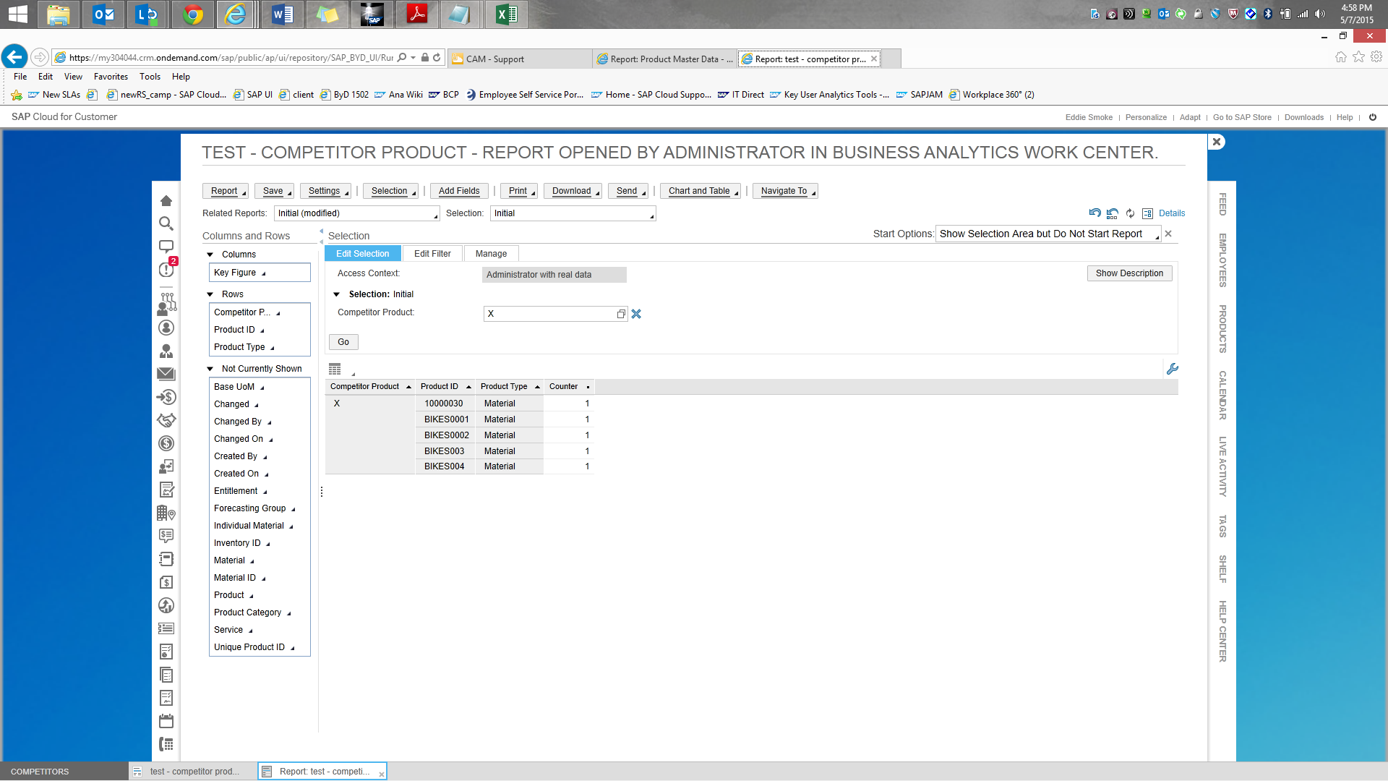

Competitor Product:
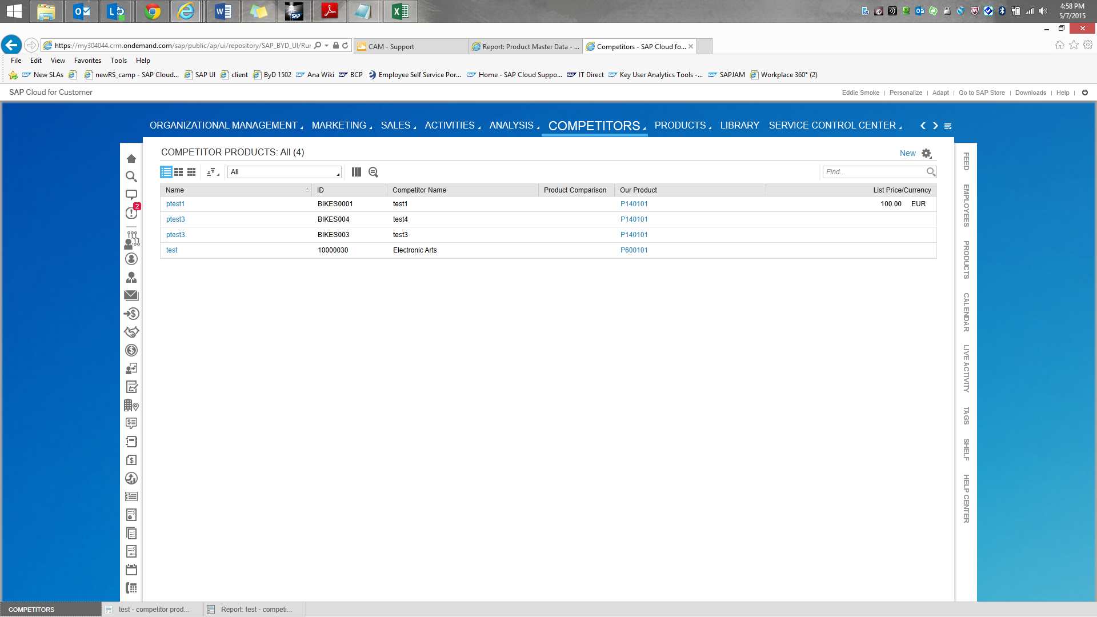

Please note that all other fields in the data source will correspond to the Competitor Products

