Step 1
Please logging to the Agency portal

Step 2
You can see all the forwarded candidate listed here

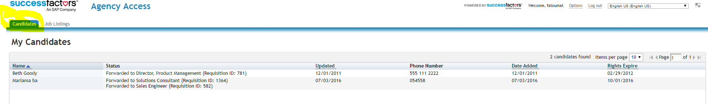

Steps 3
All the job are listed here, click any job that you want send the candidate too or use an existing candidate.

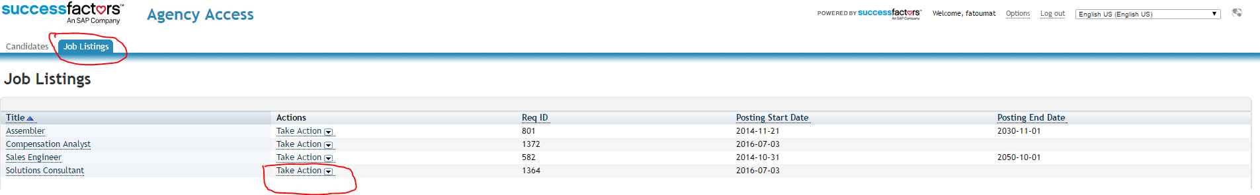

Steps4
In this steps you can submit a new candidate or submit an existing candidate

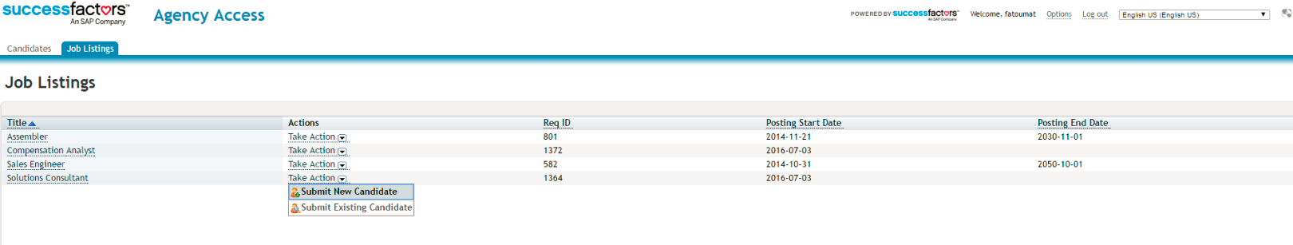
Fill in all the required filed with the exact detail that you created in the Agency
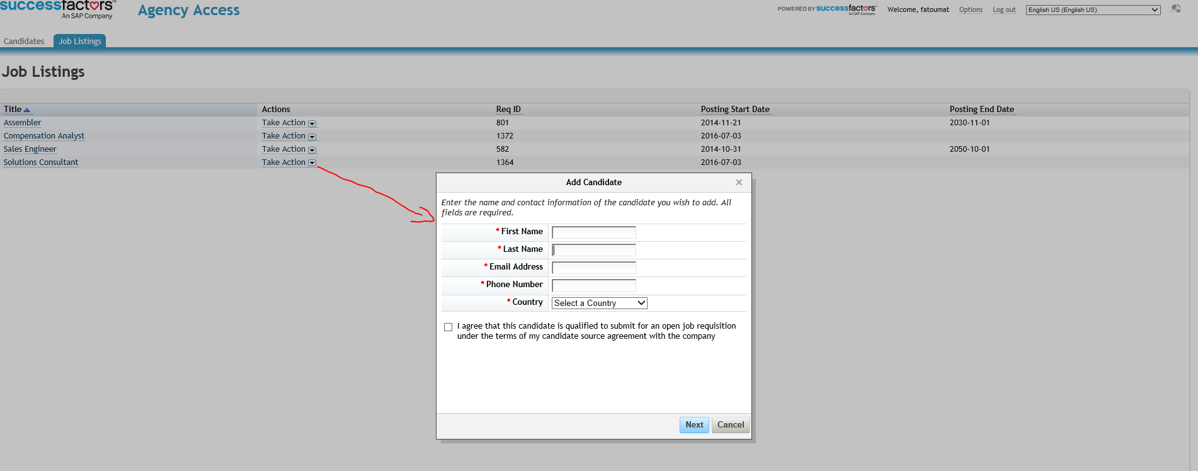
Same user details as bellow

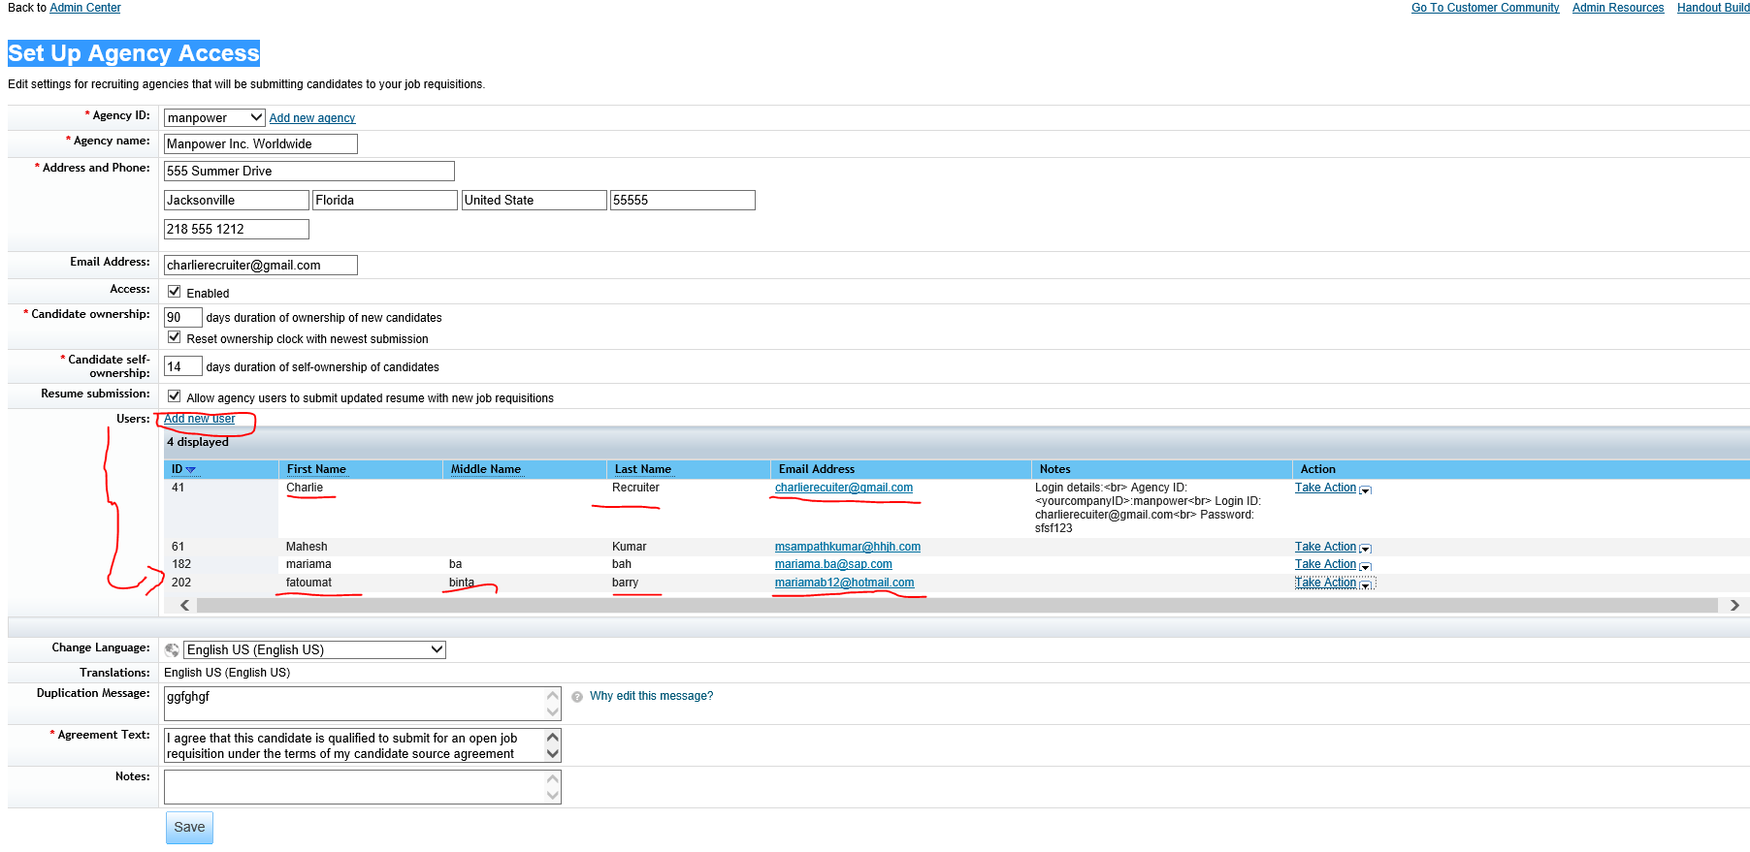

Step 5
Submitting candidate as a new candidate
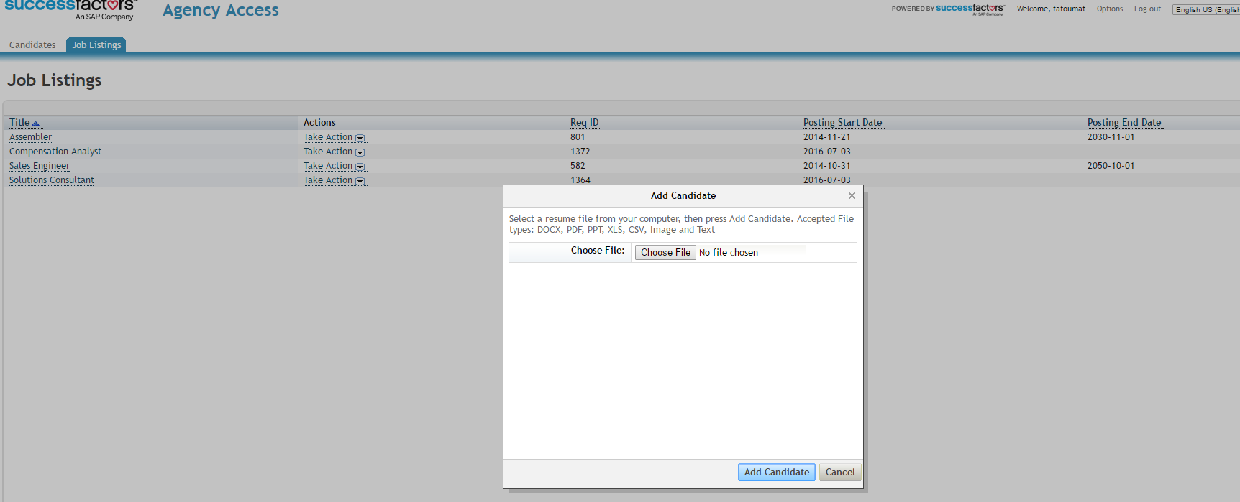
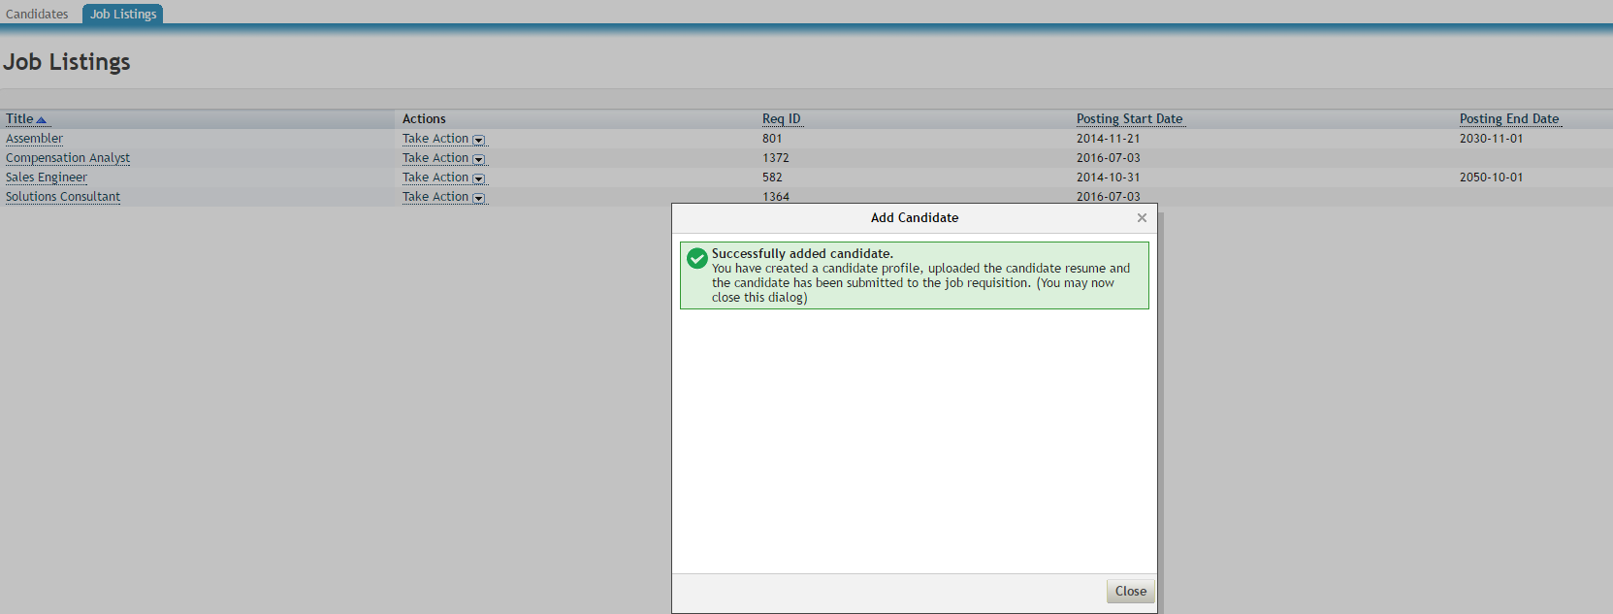

Submitting candidate as an existing candidate
Select the job you want add the candidate to
Go to action and select submit existing candidate select the name of the candidate and then upload latest resume of that candidate
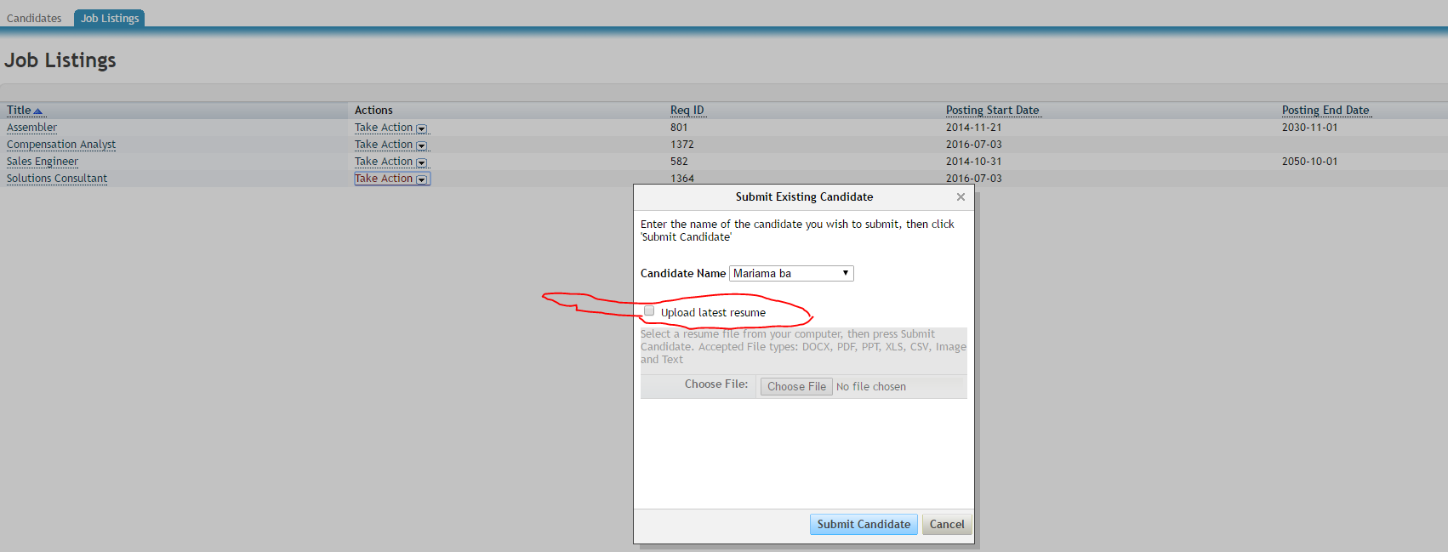

A confirmation saying that the candidate resume have been updated and that the candidate have been forwarded to the job requisition
