Scope the Question:
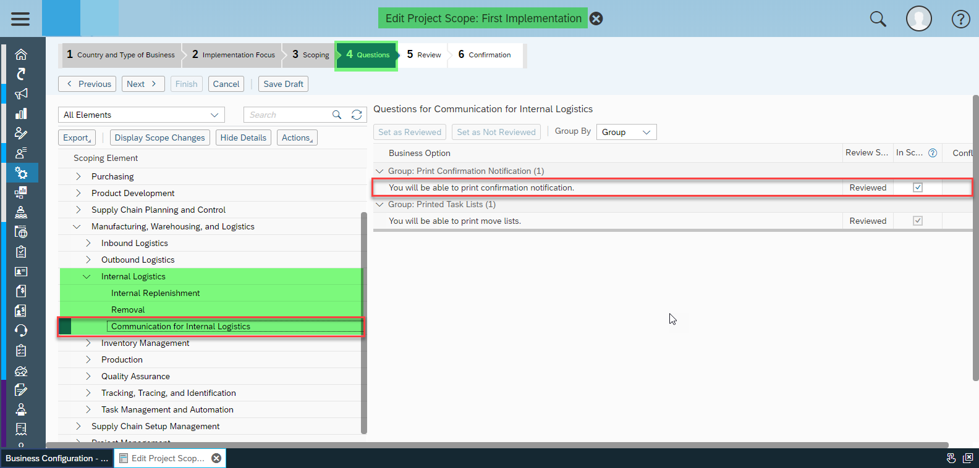

Confirmation Notification now visible in Form Template Selection:
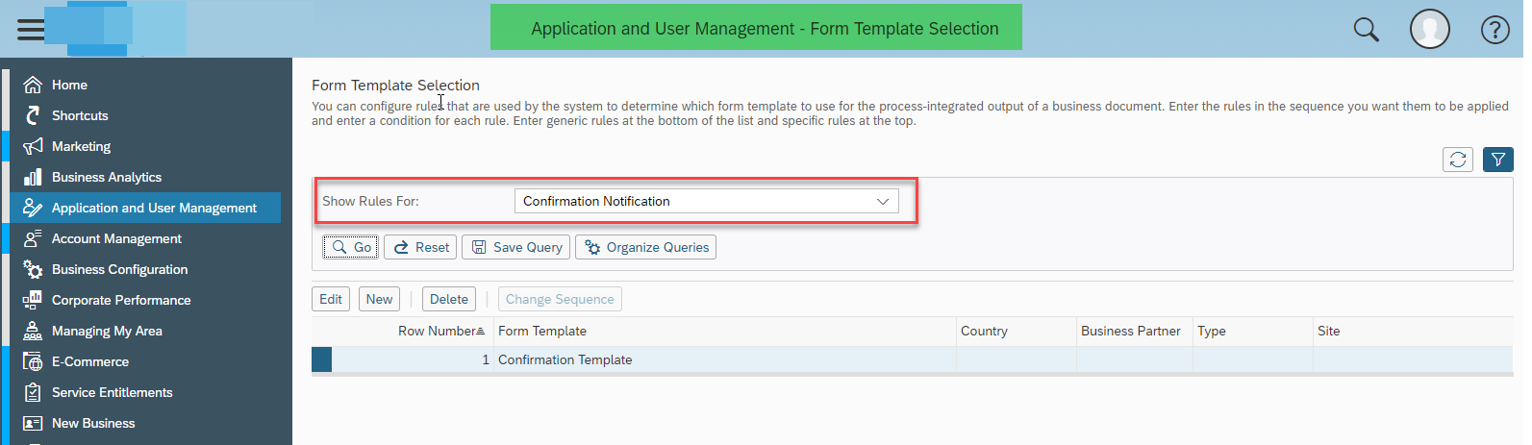
Now you check and publish the Confirmation Template of your choice as per your requirement.:
