SAP SuccessFactors Employee Central  Document Version: 1.0 – 2016-08-26 | customer
User Guide for Russian Privacy Data Law

Document History
Version | Date | Change
1.0 | 2016-08-26 | First Release.
Overview of Russian Data Residency Solution
The Russian Data Residency Solution is used by the global customers who have employees in Russia. The Personally identifiable information (PII) data is captured in Russian Data Center (DC) and then written to the Global DC. The post time of both operations are recorded and can be reported on.
This solution
- Provides compliance with the Russian Privacy Data Law (RPDL) and transparency to the administrator or an end user.
- Captures the PII into Employee Central (EC) to meet the RPDL requirements.
Enabling the Russian PII Feature from Provisioning
Prerequisites:
- The DB Link should be set up between Global DC and Russian DC.
- Master and Slave schema should be set up for the company.

Steps:
- Enable the Reside PII in Russia from Provisioning to start using the Russian DC feature.
- Setup the RBP permission to view the Log object.
This permission is required to generate the custom ODS report. For more information, see section Assigning RBP Permission for PersonDataResidencyLogRecord.
Data Maintained in the Russian Data Center
The following entities are supported in Q4 2015.

- Person (Date of Birth, Country of Birth)
- Personal (Marital Status, Gender, Nationality)
- Global Information
- Email Information
- Phone Information
- Social Account Information
- National Id Card Information
- Address Information

The following entity is supported in Q3 2016.

- Work Permit Information Without Attachment
Accessing the Reports
Assigning RBP Permission for PersonDataResidencyLogRecord
Steps:
- Go to Admin Center -> Manage Role Permissions.
- Select the system administrator role.
- Select Permission.
- Go to User Permissions -> Miscellaneous Permissions.
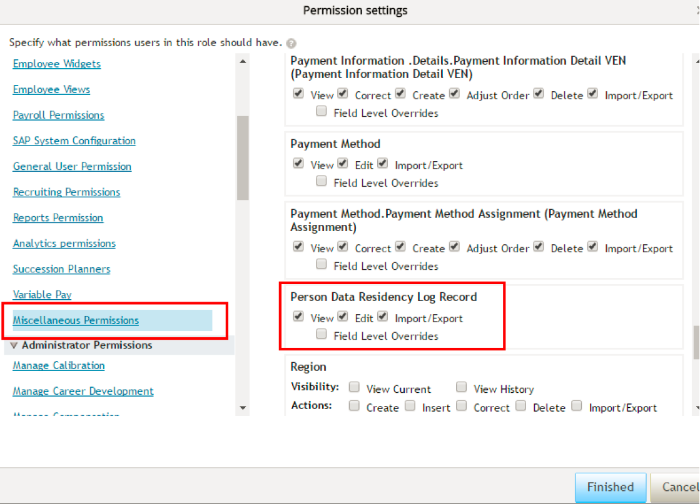
- Enable View, Edit, Import/Export for Person Data Residency Log Record.
Generating the Custom ODS Report
The transactions done on Russian PII records are logged in Person Data Residency Log object and can be reported on by configuring and generating a custom ODS report.
The log captures following information.
- Person ID
- Date of Change
- Timestamp of change in Russian data center
- Timestamp of change in global data center
- Information whether it was an insert or update or delete
- Changed entity (EC object level)
- Entity Identifiers to uniquely identify record that was changed

The following table lists Unique Identifiers for each entity. These identifiers are captured in the logs.
Entity | Unique Identifier for a record
Person | Person ID External | - | -
Personal Info | Person ID External | - | Effective Date
Person Global Info | Person ID External | Country | Effective Date
Address | Person ID External | Address Type | Effective Date
Email Info | Person ID External | Email Type | -
Phone Info | Person ID External | Phone Type | -
Social Account Info | Person ID External | Domain | -
National Id | Person ID External | Card Type | Country
Work Permit | Person ID External | Document Type | Country

The report can be generated by applying various selection criteria one or multiple:
- Date range of change date
- One or multiple employee ids
- Object type changed etc.
Prerequisite:
ODS reporting should be enabled for the company instance.
Steps:
- Log in to the company instance.
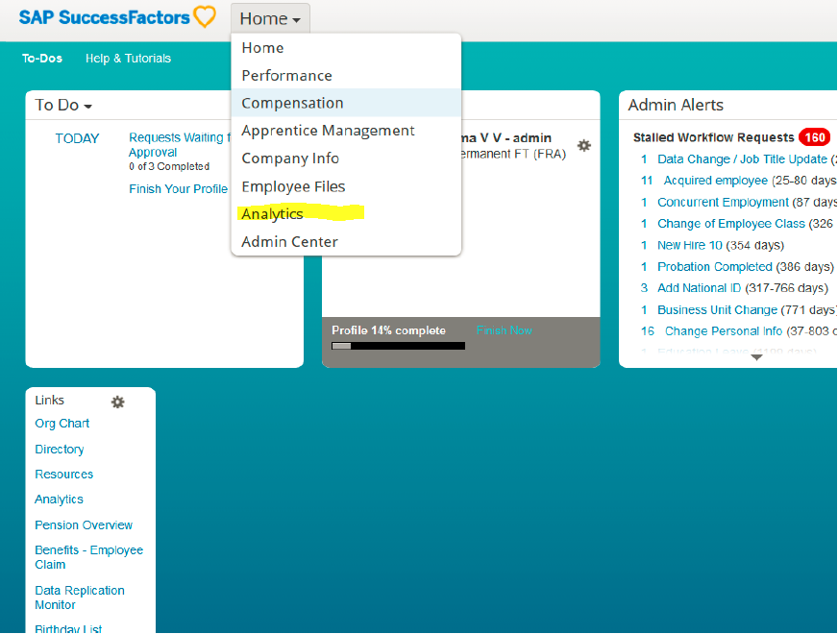
- Go to Analytics.
- Select Detailed Reporting.
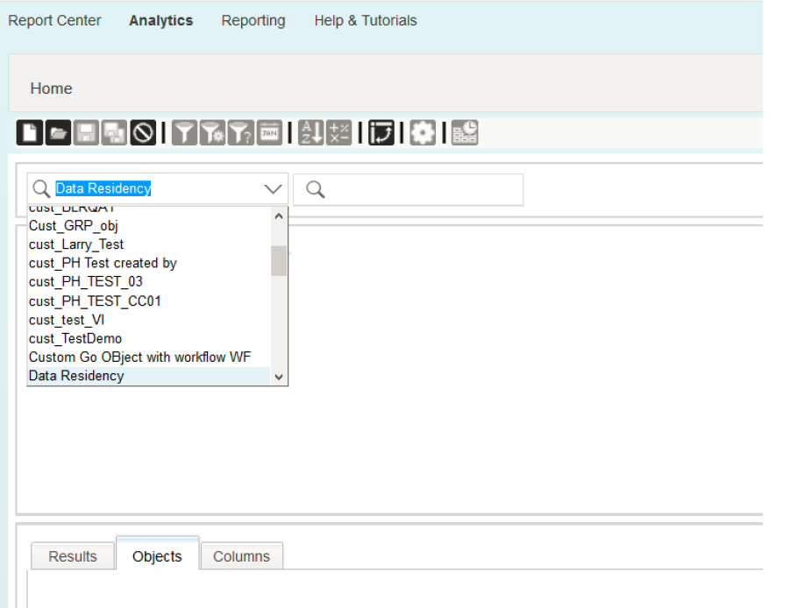
- Select Data Residency realm, and select Person Data Residency Log.
- Select the columns and objects required to be reported and save the query as custom report.
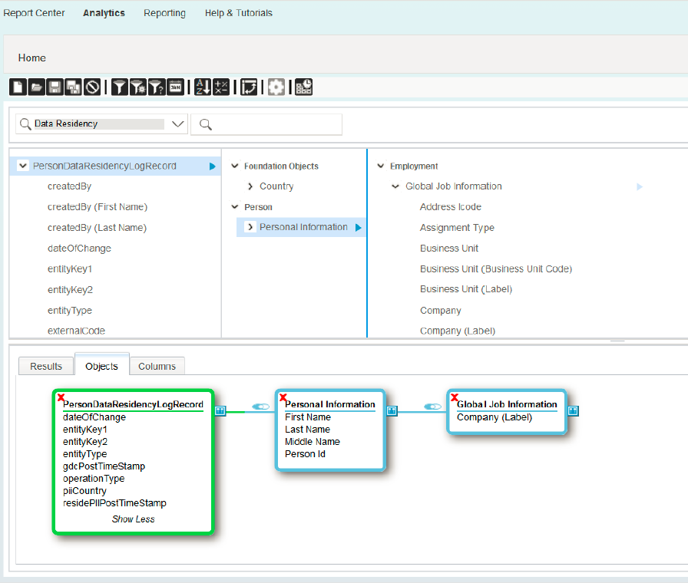
Exporting Person Data Residency Log Records
NOTE: The log records can alternatively be downloaded using Export Data in raw format.
Steps:
- To export the complete report of PersonDataResidencyLogRecord, choose Import and Export data link from Admin Center.
- Select the action to perform : Export.
- Select Generic Object : PersonDataResidencyLogRecord.
- Select Export.
- Go to Admin Center and click Monitor Job link.
- Download the complete report of PersonDataResidencyLogRecord from the monitor job page.
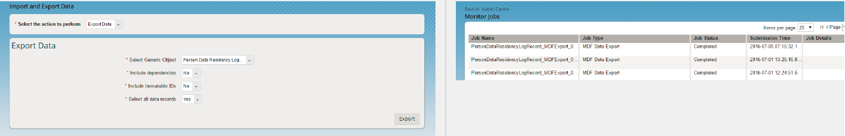
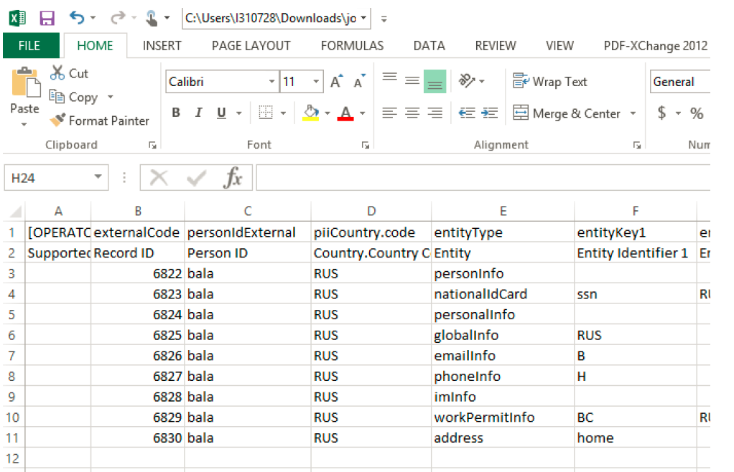
The following image shows the records Person Data Residency Log Records generated in system.

NOTE: Customers can use MDF Export to export the Person Data Residency Log records alternatively.
Test Scenarios for Customers
Scenario | Expected Behavior
Add new hire in Russian Legal Entity. | The PII records for hired employee are saved to RDC first and then to GDC. This could be validated by checking the Person Data Residency Log Record.
Re Hire in Russian Legal Entity. | All PII records of the rehired employee would be saved to RDC data store and then to global data store.
Inserting, updating or deleting PII data for existing user employed with Russian Legal Entity using Employee Self-service, Imports or API saves the record to RDC data store and then to global data store. | All PII records should be saved to RDC first and then to GDC.
Adding new hire and re hire records for a user associated with Russian Legal Entity through Imports or API also saves the records to Russian data store first and then to Global data store.  NOTE: Adding new hire or re hire using import should be done in the following order only:  - 1. Basic User Information  - 2. Employment Information  - 3. Job Information  - 4. The Person Entities in any order | All PII records should be saved to Russian DC.

www.sap.com/contactsap
© 2016 SAP SE or an SAP affiliate company. All rights reserved.
No part of this publication may be reproduced or transmitted in any form or for any purpose without the express permission of SAP SE or an SAP affiliate company.
SAP and other SAP products and services mentioned herein as well as their respective logos are trademarks or registered trademarks of SAP SE (or an SAP affiliate company) in Germany and other countries. All other product and service names mentioned are the trademarks of their respective companies. Please see http://www. sap.com/corporate-en/legal/copyright/index.epx#trademark for additional trademark information and notices.

