WFA/ORD/Advance Reporting – Deleting a Report from the Reporting Menu
Analytics>Analytics (if logging in via Performance Manager URL)
From Landing Page
Go to Report Designer (Tools Menu, left of page)
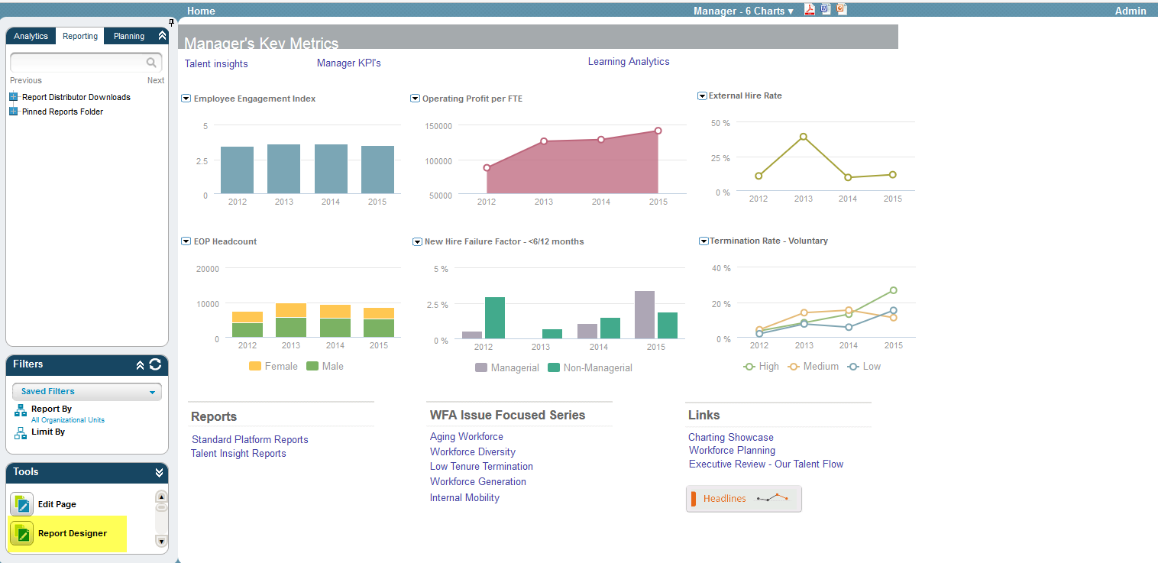
Under the Manager Reports menu
Select File
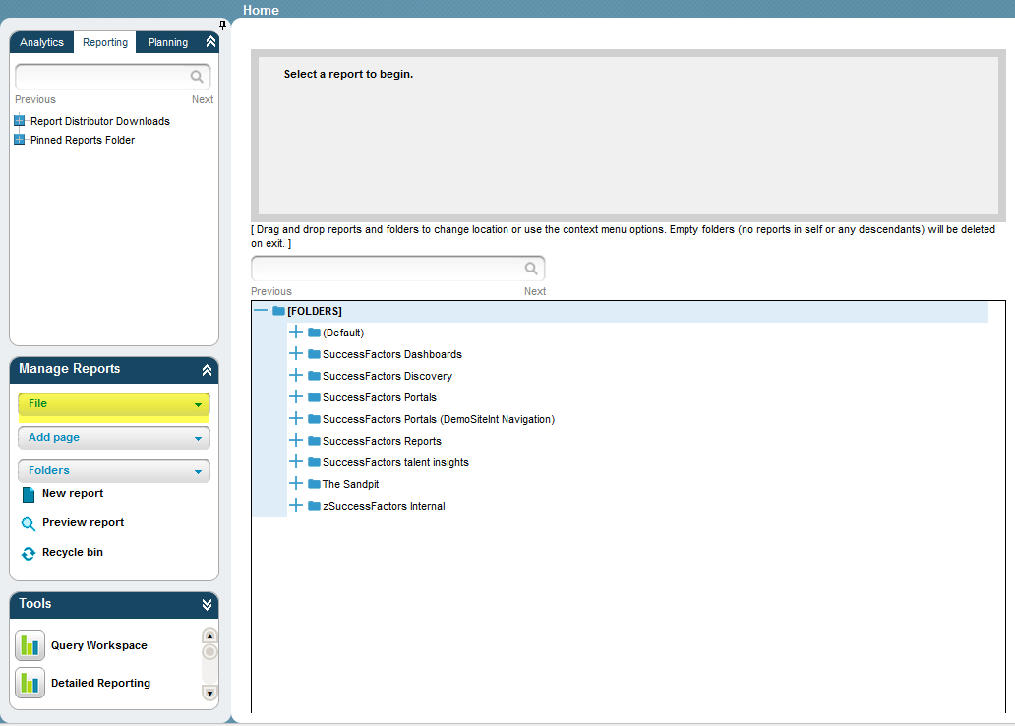
Add to menu
Report Menu Editor will pop up
Select Report to be deleted, and click on Delete button.
