Generating SSO Internal/BizX User LMS Direct Links
(Assumes SAML 2.0 being used by customer)

Production BizX User LMS SSO direct links can be broken down into two distinct parts:

- SSO RelayState URL with the SuccessFactors LMS App Redirect
- URL Encoded LMS Destination URL

SSO RelayState URL with the SF LMS App Redirect: (green indicates customer-specific variables)

https://<customer_authentication_server_url>/affwebservices/public/saml2sso?SPID=<company_specific_SPID>&RelayState=/sf/learning?destURL=

This portion of the direct link will be used in all Production BizX User LMS SSO direct links.

URL Encoded LMS Destination URL:

This portion of the direct link will change depending on the LMS destination page. This part of the direct link is taken from the string generated by the LMS Direct Link tool.

Steps to Generate URL Encoded Destination URL:
- As an LMS admin, navigate to System Admin -> Tools -> Direct Links
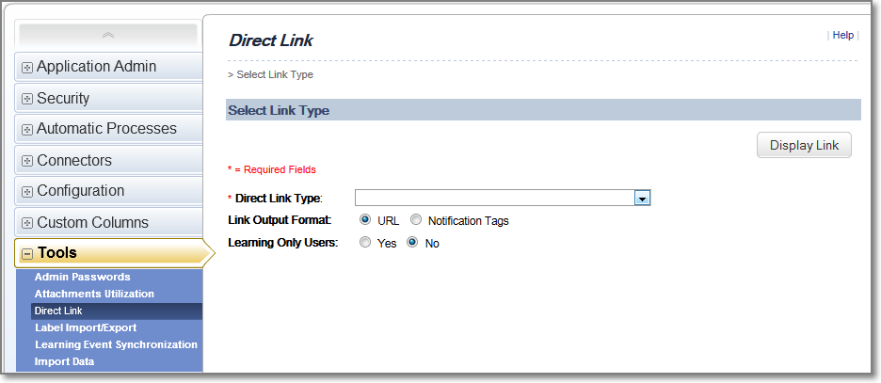

- In the Direct Link Type field select the type of direct link you wish to generate
Home Page – generates a link to the user’s LMS homepage
Item Details – generates a link to a specific item record in the course catalog accessible to users.
- (Not always required.) Some direct links will require additional information. The administrator should use the search filtering provided to set these fields. If the Direct Link requires additional parameters, set them now.
For example, an Item Details direct link requires setting a specific item record.
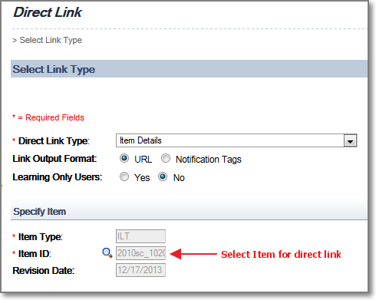
- Set the Link Output Format setting to URL
- Set the Learning Only Users setting to No
- Click the Display Link button
The URL generated by the LMS will be displayed. For example, the Home Page direct link will be formatted as:
https://performancemanager4.successfactors.com/sf/learning?destUrl=https%3a%2f%2f<company_specific>%2eplateau%2ecom%2flearning%2fuser%2fdeeplink%5fredirect%2ejsp%3flinkId%3dHOME%5fPAGE%26fromSF%3dY&company=<company_name>
The main piece of this URL needed is everything that occurs after the destUrl parameter:
https://performancemanager4.successfactors.com/sf/learning?destUrl=https%3a%2f%2f<company_specific>%2eplateau%2ecom%2flearning%2fuser%2fdeeplink%5fredirect%2ejsp%3flinkId%3dHOME%5fPAGE%26fromSF%3dY&company=<company_name>
The value of the destUrl parameter needs to be URL Encoded before it can be added to the SSO RelayState URL with the SF LMS App Redirect.
- Copy the destUrl value from the LMS Direct Link tool generated link
- URL Encode the destUrl value string
The destUrl value string needs additional URL encoding before it can be used.
Before additional URL Encoding:
https%3a%2f%2f<company_specific>%2eplateau%2ecom%2flearning%2fuser%2fdeeplink%5fredirect%2ejsp%3flinkId%3dHOME%5fPAGE%26fromSF%3dY&company=<company_name>
After additional URL Encoding:
https%253a%252f%252f<company_specific>%252eplateau%252ecom%252flearning%252fuser%252fdeeplink%255fredirect%252ejsp%253flinkId%253dHOME%255fPAGE%2526fromSF%253dY%26company%3D=<company_name>
There are many free URL Encoding tools available online that you can use to accomplish the additional URL Encoding.
Final Direct Link (LMS Homepage):

Append the URL encoded destUrl value string to the end of the SSO RelayState URL with the SF LMS App Redirect string.
https://<customer_authentication_server_url>/affwebservices/public/saml2sso?SPID=<company_specific_SPID>&RelayState=/sf/learning?destUrl=https%253a%252f%252f<company_specific>%252eplateau%252ecom%252flearning%252fuser%252fdeeplink%255fredirect%252ejsp%253flinkId%253dHOME%255fPAGE%2526fromSF%253dY%26company%3D<company_name>

The color-coding in the url string above helps you to see the final URL you will use, in its two parts:
- SSO RelayStateUrl with SF LMS App Redirect
- URL Encoded LMS DestinationUrl

Item Deeplink Example Links:
Course - WBT WBT_TEST (Rev 1 - 11/26/2013 09:00 AM America/New York)

https://<customer_authentication_server_url>/affwebservices/public/saml2sso?SPID=<customer_specific_SPID>&RelayState=/sf/learning?destUrl=https%253a%252f%252f<customer_specific>%252eplateau%252ecom%252flearning%252fuser%252fdeeplink%255fredirect%252ejsp%253flinkId%253dITEM%255fDETAILS%2526componentID%253dWBT%255fTEST%2526componentTypeID%253dWBT%2526revisionDate%253d1385474400000%2526fromSF%253dY%26company%3D<company_name>

