WFA - Loading/Re-loading Templates and No Access to Analytics Area.

(Application Error)

If you load/reload a set of Employee Central Standard Templates and then your users can no longer log into the Analytics>Analytics area, you need to check the “Start Page” for their role. You will see the error in the screenshot below.
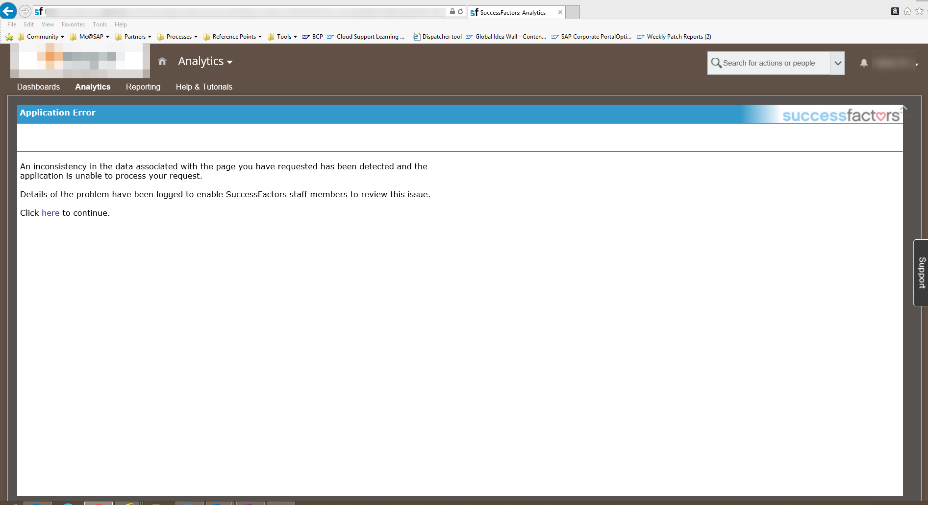

You will need to reassign the “Start Page: Report Book”. You will also need to reload any EC Standard Template reports that are on the Reporting Menu Tab.
You will know that a reload /re-alignment is required because the Report Book will show (Undetermined), as per screenshot below.
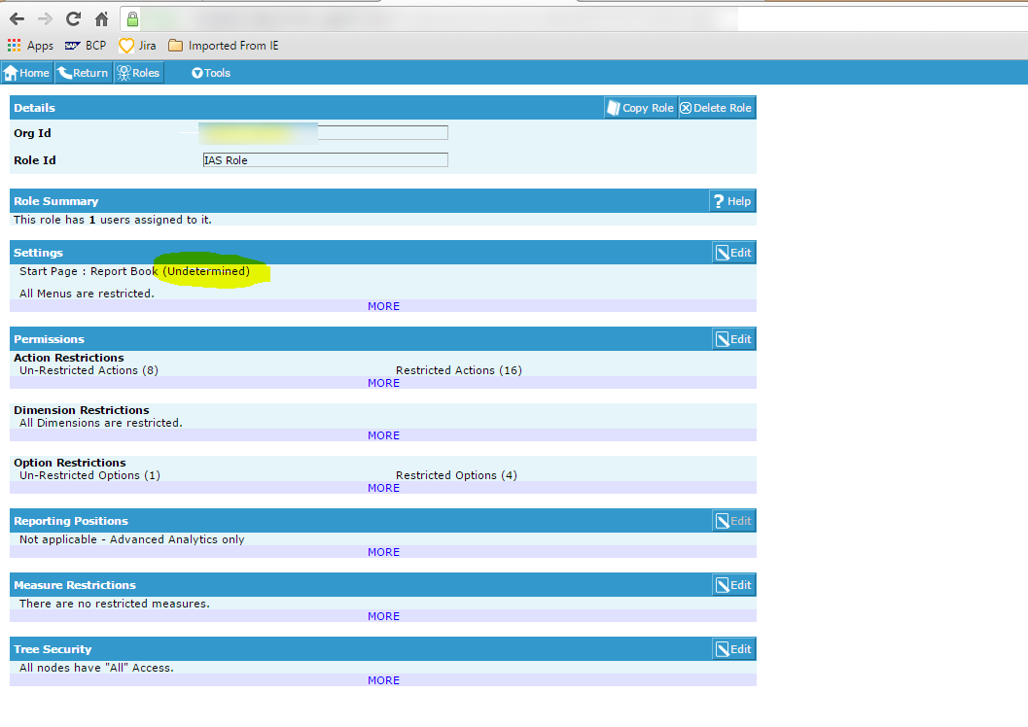

This will need to be completed, via the Analytics Admin Menu, Roles Maintenance>Tools>Edit Current Role. Once the report is aligned with the role, the user should then be able to log in again. If this is not the case, please log a ticket with support.
