SYMPTOMS:
Document Generation - Application error is thrown on Generate Screen if the Document contains tokens mapped to Work Permit Info.
ENVIRONMENT:
EMPLOYEE CENTRAL: DOCUMENT GENERATION

REPRODUCING THE ISSUE:
- Create a template with tokens (within or outside the table) to hold Work Permit Info fields.
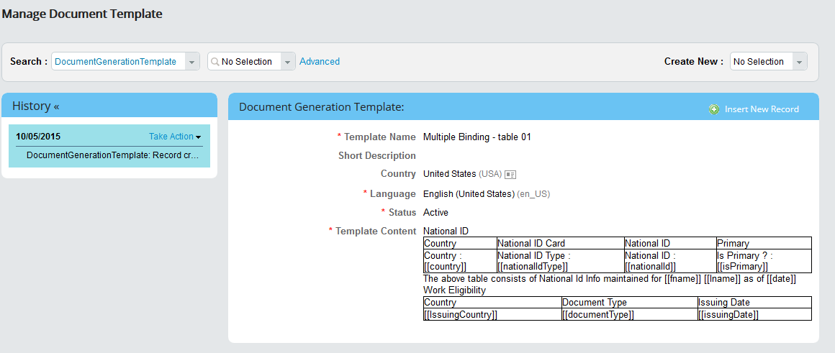

- Map the tokens accordingly to Work Permit Info entities.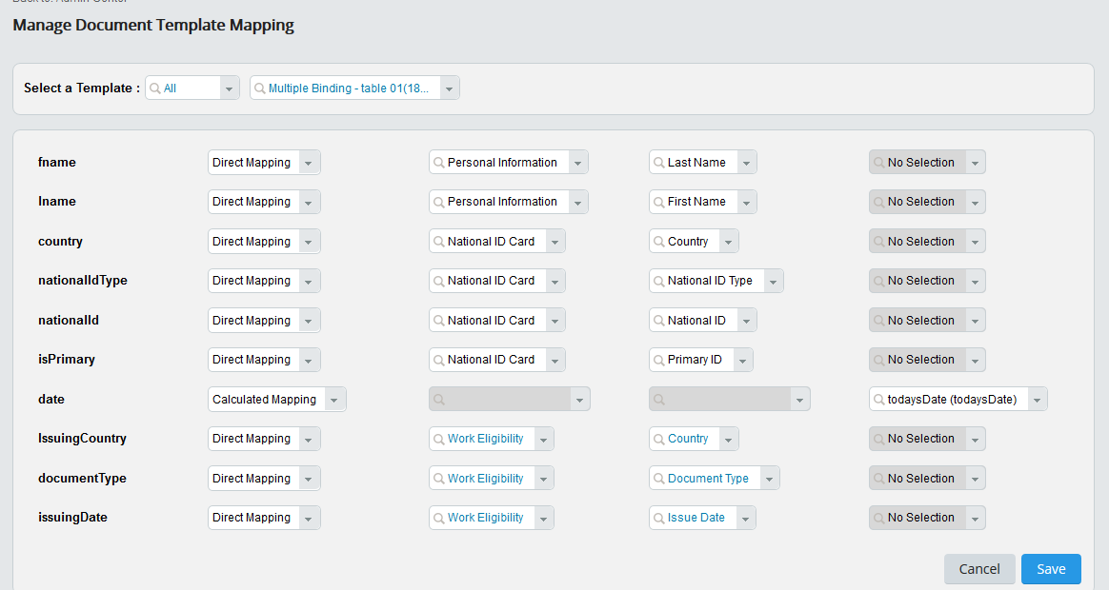
- Navigate to Generate Screen, select the above created template, user and choose to download or generate and email.
- Application error is thrown.
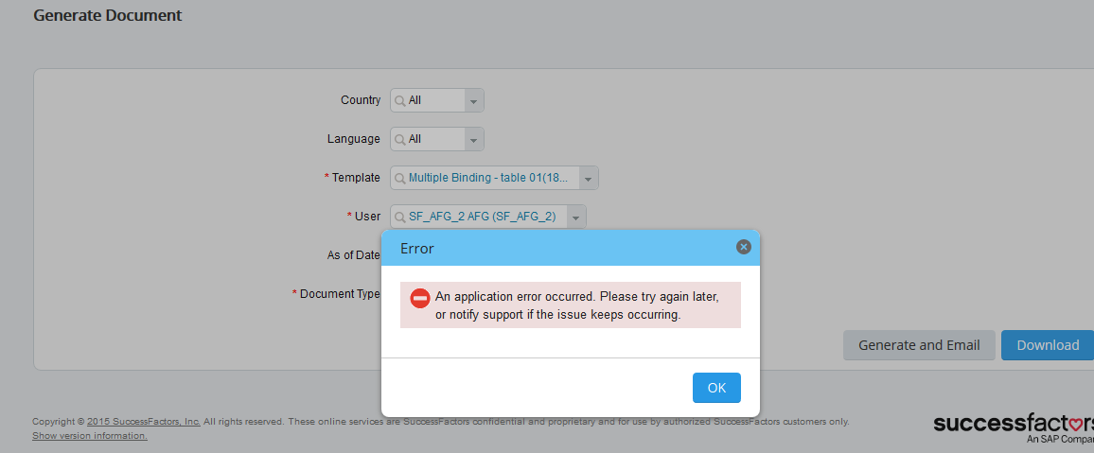
Expected Results:-
Either of the following should be an expected result for the above scenario.
- Appropriate Warning message should be displayed if the tokens were not resolved, in case the corresponding data was not maintained for the selected user
- Resolve the tokens properly with selected user data and download or generate and email the document.

CAUSE:
The mapping of the Work Permit Info portlet data is not supported as of b1508 release.
RESOLUTION:
The mapping of the work permit info portlet data would be available from b1511 release. There after the data available for the user can be used in generation of document. If the selected employee does not have data, you can go ahead with null values or (blank(s)) in the generated document.

