- Login to provisioning and navigate to the source instance page. Click on ‘Manage Scheduled Jobs’ link:
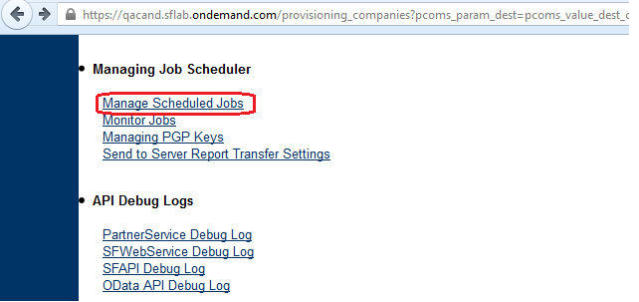

- A new page will come up. Click on ‘Create New Job’ link:
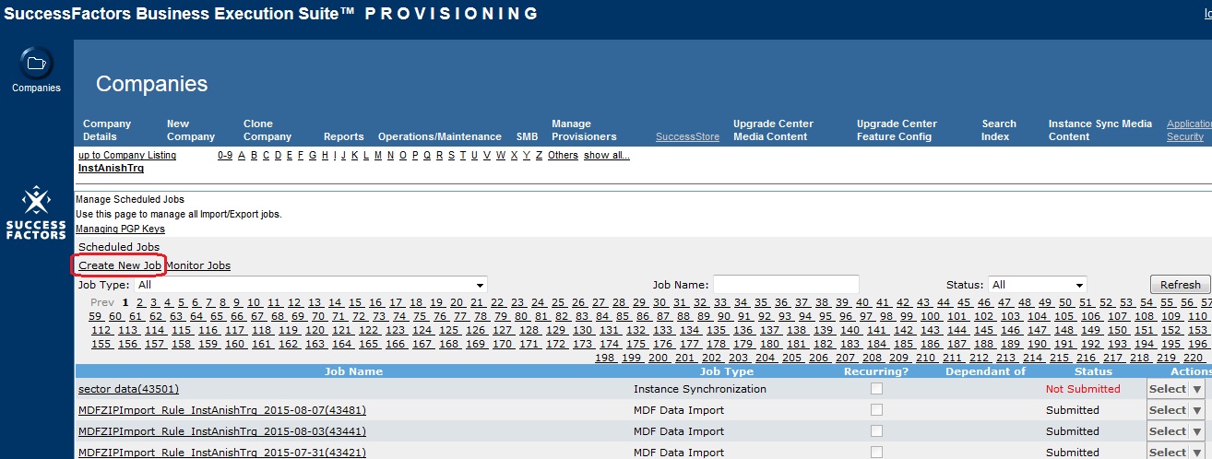

- ‘Create New Job’ page should come up. Enter the following details:
Job Name: any value
Job Owner: IST admin for source instance
Job Type: Instance Synchronization

Upon selecting the job type, the list of available sync jobs to be submitted will show up.
Choose the required sync job using the radio-button as seen below:
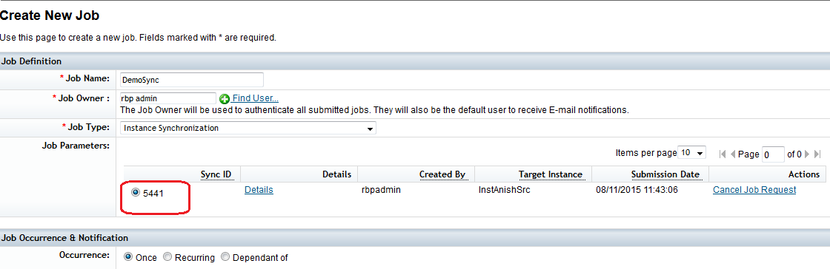

- Hit the ‘Create Job’ button.
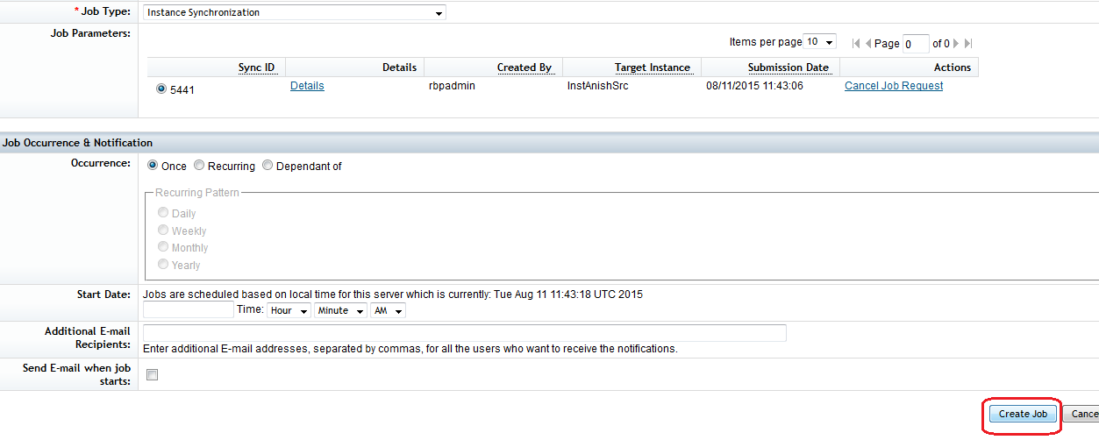
- User will be taken to a new page. The newly created job should appear:
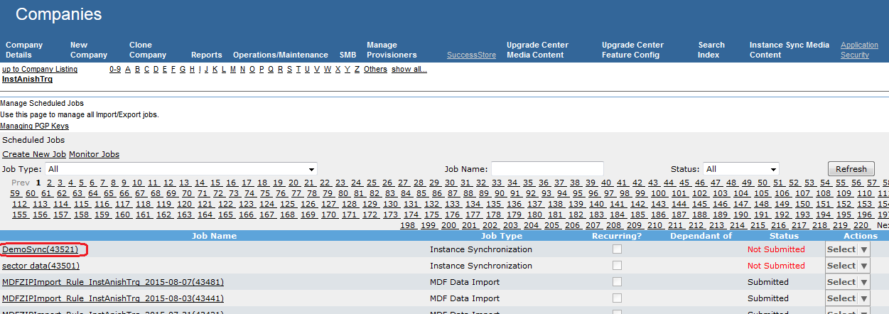

- Click on the ‘Select’ button corresponding to the job and choose the ‘Run It Now’ option:
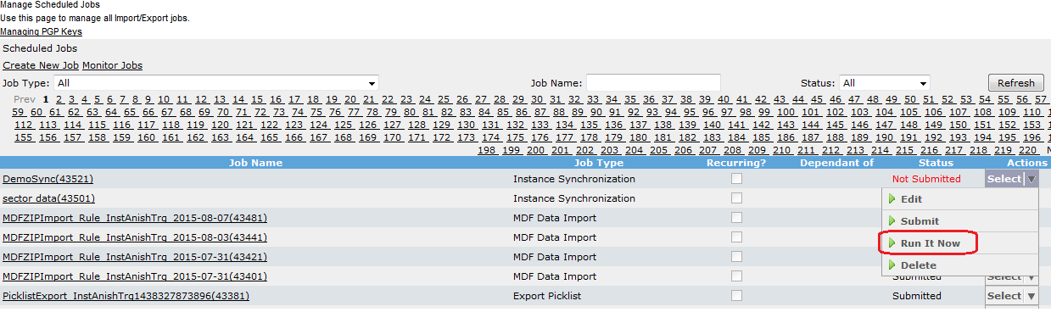

- Navigate to Monitor Jobs page by clicking on ‘Monitor Jobs’ link to view the latest status of the job:
