PDF mapping – best practices.

- Onboarding application uses only textboxes and checkboxes controls for PDF mapping.
- We recommend to use PDF version 1.5 or less

Textbox mapping - examples:
- Simple text e.g. candidate’s name
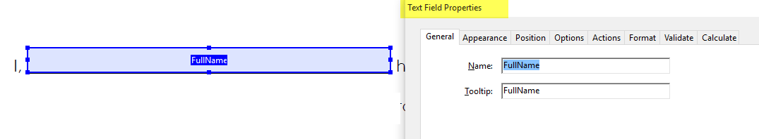
In Super Admin site the mapping loos like
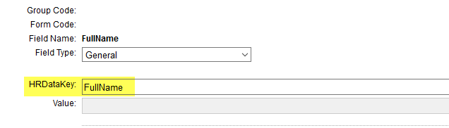
Or
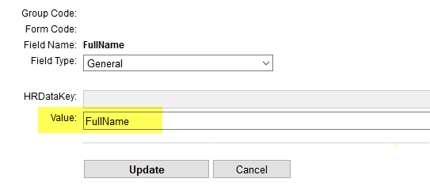

- Mapping by symbols
Variant 1:
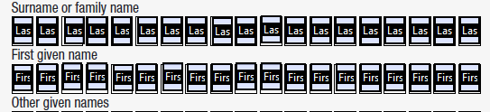

Create few textbox controls with name “LastName1”, “LastName2” and etc.
Mapping in Super admin site
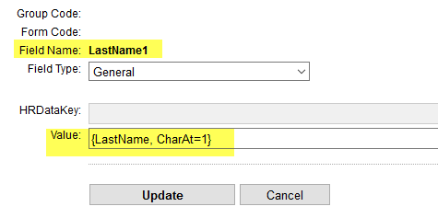

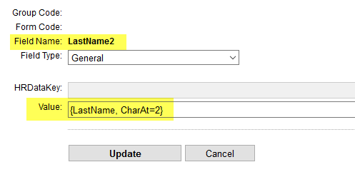

Variant 2:
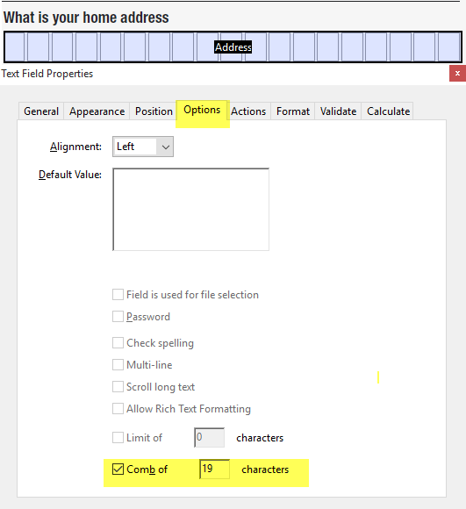

In this case mapping in Super admin site will be the same as for simple text

- Dates mapping

Variant 1:
As simple text.

Variant 2:
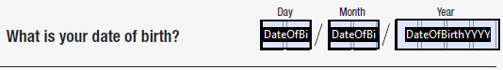

Fields: DateOfBirthDD with property “Combo of” = 2
DateOfBirthMM with property “Combo of” = 2
DateOfBirthYYYY with property “Combo of” = 4

Mapping in Super admin site
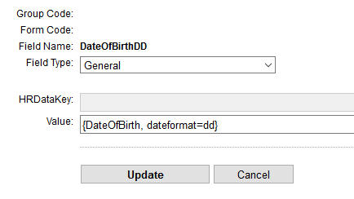
For the field “DateOfBirthMM” value must be {DateOfBirth, dateformat=MM}
For the field “DateOfBirthYYYY” value must be {DateOfBirth, dateformat=yyyy}

- Dates mapping with different locales

Variant 1:
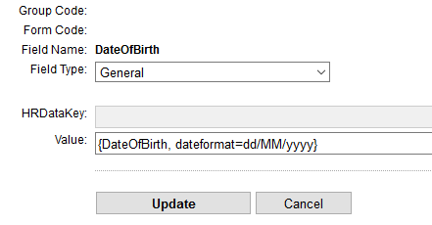

Variant 2:
In Onboarding application/Settings/Pdf Forms
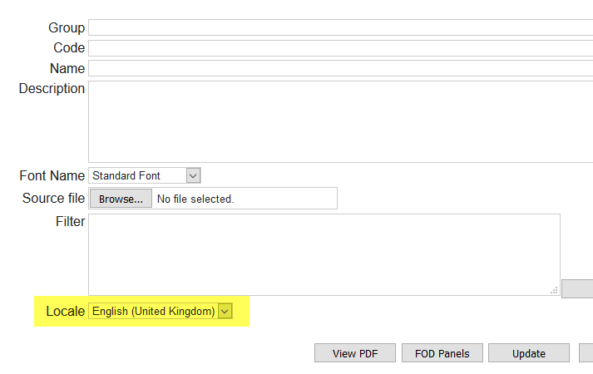
In Super Admin site
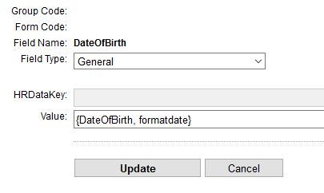

- User’s name mapping

e.g. Hiring Manager name

In Super admin site - value must be “{user:HiringManager, objattr=firstname} {user:HiringManager, objattr=lastname}”

- Signatures

Employee signature:
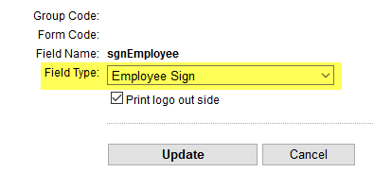

Manager signature:
Please use

Translator signature (used for US I9 form)
Please use

Checkbox mapping

Create few fields with the same name e.g. “title”
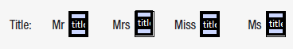

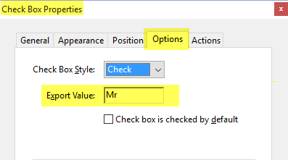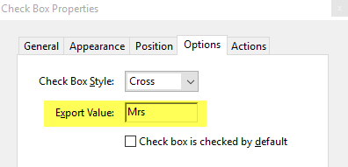

In Super admin site mapping as for simple text. But the key which is used must have values “Mr”, “Mrs” (the same which do you use in the “Export value” property).

