How to change HIRE DATE of an employee if hire date and first record on job history have different dates.

Environment: EMPLOYEE CENTRAL: EMPLOYEMENT DETAILS

Scenario:

- First record i.e. new hire record date on job history

- HIRE DATE

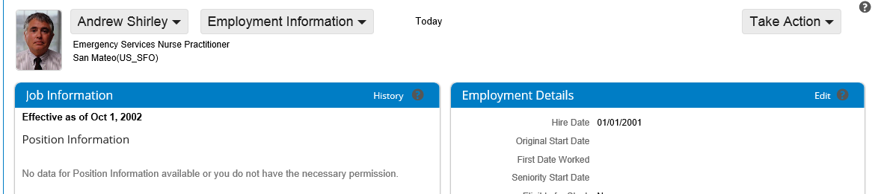

To change the HIRE DATE for an employee, HIRE DATE and first record on job history Portlet should have the same date. And then changing the first job history record event date will reflect the changes in hire date.

Resolution: -

- Go to JOB HISTORY of the employee
- On the first hire record Make correction change the event date to match the hire date of employee.
- Again change the date of this record as per the desired date and then this will reflect in employment details HIRE DATE for the employee.

