Symptoms: System behavior on TimeStamp Configuration for Adhoc Report.
Environment:
EMPLOYEE CENTRAL: Adhoc Report
Reproducing the Issue:
How to activate/deactivate timestamp configuration for Date/Timestamp related fields?

Resolution:

- Activate TimeStamp Configuration.
While running the Adhoc Report and defaulting the different date fields to populate the value in Time Stamp format, even though the field is of Date Type, please configure the following through provisioning.

- Logon on to respective data center provisioning and click on the company associated.
- Navigate to Company Settings link and search for “Enable Legacy Date/Time Rendering in Ad hoc Reports”.
- Check the field and click on Save Features.
- Click on Save button to save the configuration changes made.

Start-Date is in Time Stamp while End-Date is in Date format.
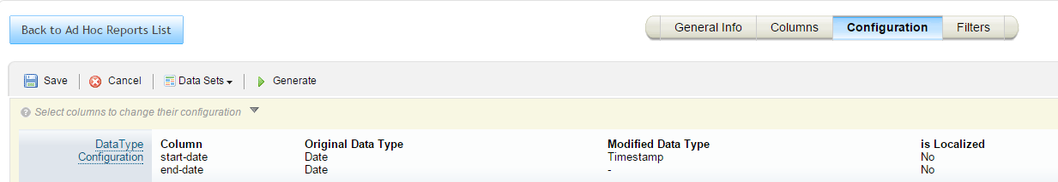
The Start-Date and End-Date both the fields display in Time Stamp format.
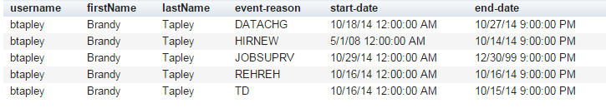

- Deactivate TimeStamp Configuration.
While running the Adhoc Report, the different date fields to populate the value in Time Stamp/Date format, depending on the Time Stamp type/Date Type under the configuration tab, please configure the following through provisioning.

- Logon on to respective data center provisioning and click on the company associated.
- Navigate to Company Settings link and search for “Enable Legacy Date/Time Rendering in Ad hoc Reports”.
- Uncheck the field and click on Save Features.
- Click on Save button to save the configuration changes made
Date of Birth and End Date are in Time Stamp format while Event Date is in Date format. 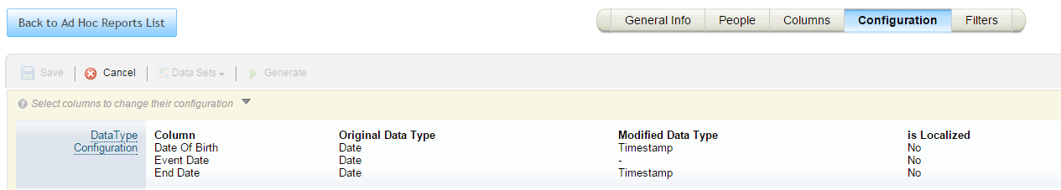

Date of Birth and End Date displayed in Time Stamp format while Event Date in Date format.

NOTE: Please raise a support ticket to make the required changes in the backend.

